Date: June 17, 2022
Start time: 7:45 a.m. depart from office End time: 11:15 a.m. return to office
Monitor(s): Georgia Vasey & Gregg Berggren (Carson City)
Persons Attending Inspection (landowner or others): N/A
Current Landowner(s): Carson City Open Space
Mailing Address: 3303 Butti Way Building #9, Carson City, NV 89701
Easement Address: APNs 010-28-104, and the southern portion of 010-12-101. Located approximately 0.8 miles past the intersection with Snyder Avenue on Golden Eagle Lane.
Easement size: 900 acres Parcel size: 2 parcels, 530.48 and 369.52 acres respectively.
On-site land use(s): Recreational. Primarily motorized, but the site is open to non-motorized recreation as well.
Surrounding land uses(s): On west, the property is bordered by Nevada Division of State Lands property which is leased and managed by the Northern Nevada Correctional Center (NNCC). To the north, the lands are under public ownership by Carson City Open Space and the lands are managed for non-motorized recreation. Across the Carson River to the east, the land is owned and managed by the Bureau of Land Management (BLM) and consists of undeveloped, dispersed recreation. To the south, the lands are under private ownership and are used for agricultural purposes.

Introduction:
The purpose of this photo-monitoring document is to track changes over time in the southern section of the Prison Hill Recreation Area, while also providing updates and guidance for future needs. Off-highway vehicles (OHV’s) have been permitted in this area for many decades. While under management of the Bureau of Land Management, motorized travel was unrestricted, resulting in a proliferation of roads and trails, soil erosion and loss, and vegetation/wildlife impacts. Following conveyance of the property to the Carson City Open Space Division, a cultural resource monitoring review was completed with the Nevada State Historic Preservation Office, and a plan was devised to actively manage motorized travel and implement improvements in this section. Such improvements include adding signage and maps, decommissioning unsafe and unsustainable trails, rehabilitating and constructing preferred designated routes, and designing more family-friendly features such as a Tot Lot. By developing a thorough monitoring protocol, the Open Space Division aims to measure the success of these improvements and apply adaptive management strategies when necessary for upholding long-term goals of sustainability, quality user experience, and conservation.

Monitoring Categories:
- Resource Protection
In the summer through fall of 2021, staff worked with consultant Resource Concepts, Inc. to assess the durability of ephemeral channels that are being used as rock crawler routes, as well as three open rider areas. The final results were summarized in a geomorphology report completed in March of 2022, which concluded that there is limited resource impact since the area is predominantly bedrock and therefore not as compromised by OHV use. Additionally, the ephemeral channels do not host species of concern. These findings help support Open Space staff in future planning decisions for the PHRA OHV area.

Photo Point: The photo is of the 2022 Geomorphic Review.

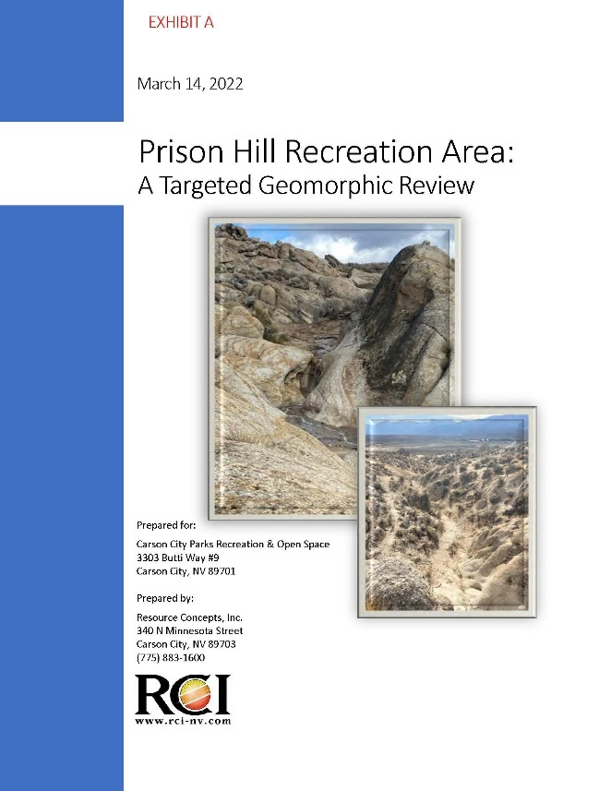

- Signage and Education
- Several new wayfinding signs have been installed, particularly at trail junctions with Toad Rock Loop, East Summit Loop, and West Summit Loop by Trails Coordinator, Gregg Berggren, and Nevada Off-Highway Vehicle Commission interns.
- Since June of 2021, Carson City has closed the OHV area at PHRA during red flag warning days (e.g. winds greater than 15 mph, relative humidity less than or equal to 25%, and temperature greater than 75 degrees). Park Ranger, Tyler Kerver, designed a new flyer that is posted to the website to notify visitors.
- Since May of 2022, a new Prison Hill OHV Trail System map was published online, reflecting updates such as the addition of new trails, trail closures, and the motocross (MX) sand training area.
(2A) Photo Point: The photo of the new wayfinding signage at trail junctions.

2022 Condition, photos taken December 2, 2021 and June 29, 2022
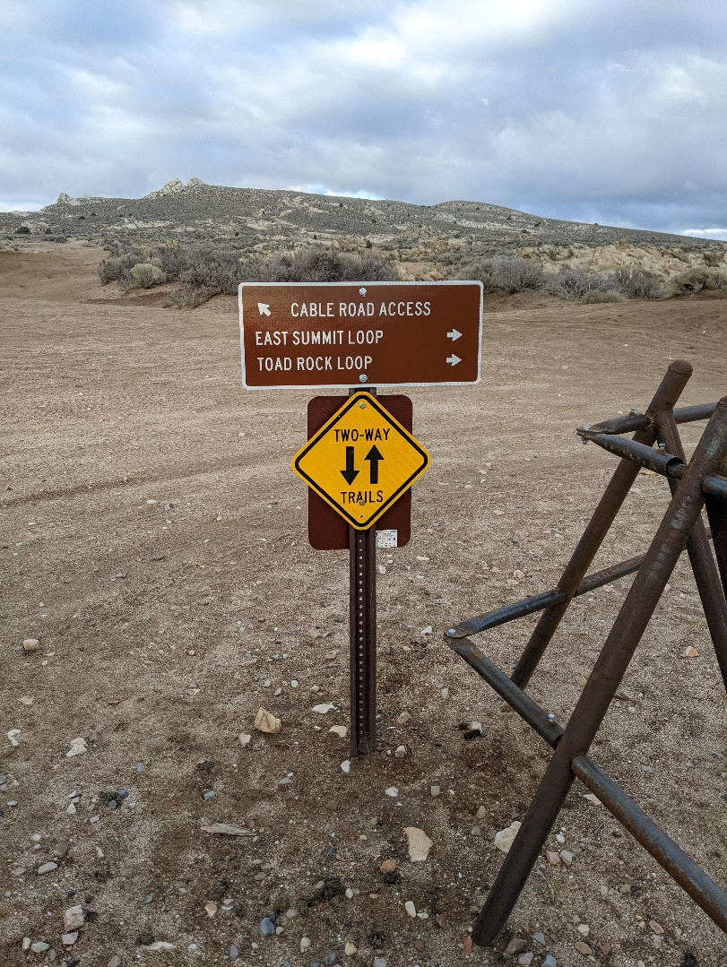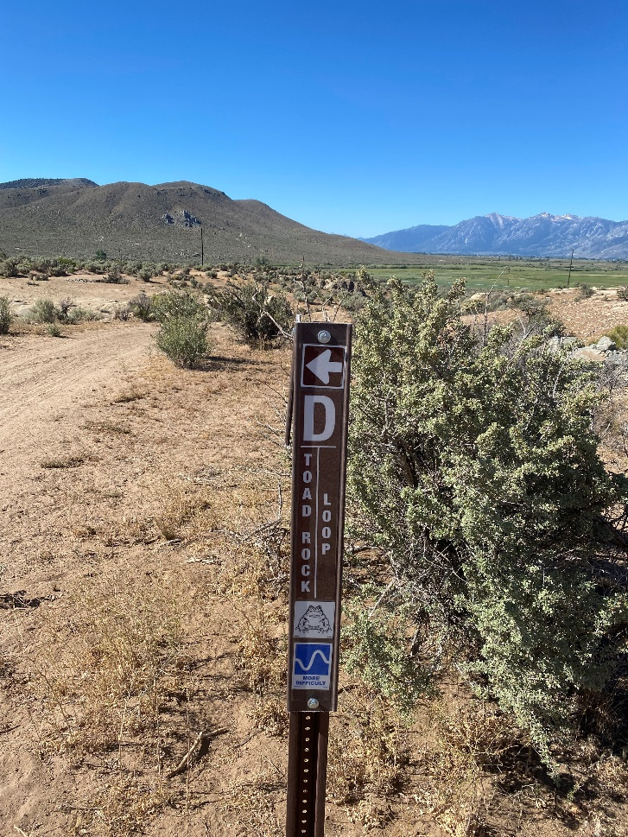

(2B) Photo Point: The photo shows the new flyer for red flag warning days.

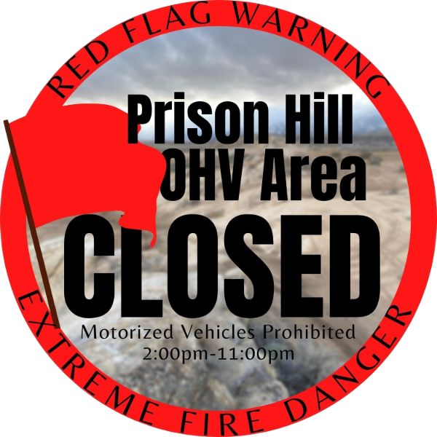

(2C) Photo Point: The photo shows the new map with a QR-code to use in Avenza Maps.
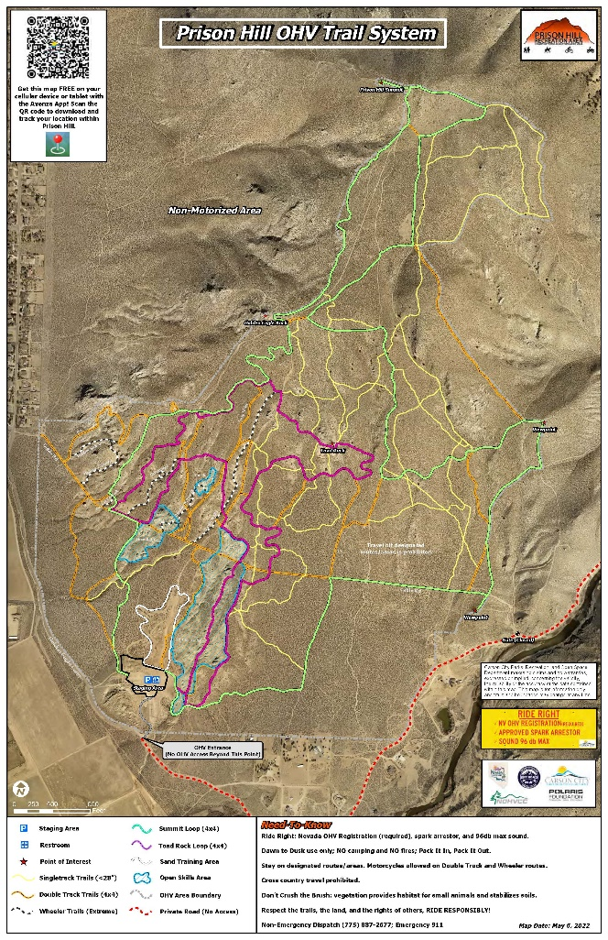

- Construction (e.g. closure and rehabilitation of damaged areas, filters, check dams, etc.)
Carson City contracted Horizon Construction, Inc. for the Prison Hill OHV Improvement and Stabilization Project from November, 2021 to April, 2022 (Appendix, Figure 2). In total, 15 areas were decommissioned, which included ripping and scarifying, broadcast seeding, and installing vertical mulch. In addition, 50 check dams, two rock-lined ditches, 12 lead-off ditches, four earthen containment basins, and multiple water bars (i.e. rolling dips) were constructed at regular intervals throughout the site to reduce the velocity and volume of potential erosion. Lastly, two filters were installed in challenging wheeler routes (Gunslinger and Death Walls) to prevent novice riders from entering with underequipped vehicles.
Goals listed under the “Summary – Main Objectives” section of the 2021 Report were completed, including:
- West Summit Loop – closure/rehabilitation, route reconstruction, and new route construction to create a continuous and sustainable trail.
- Mailbox Canyon and Once is Enough – closure/rehabilitation of certain specific locations to support sustainability.
- Gunslinger and Death Walls – filter installation in challenging wheeler routes.
- Toad Rock Loop – route reconstruction, new route construction, and some closure/rehabilitation to create a new continuous and sustainable loop trail.
In addition:
- Lead-Off Ditch and Rolling Dip – example to show constructed lead-off ditches and rolling dips.
- Check Dams – using Class 300 and Class 900 rock, check dams were built to slow flow in drainages and at trail intersections.

(3A) Photo Point: The photo shows former erosion on West Summit Loop near Golden Eagle Rock that was decommissioned to prevent further erosion and make the road narrower.

2021 Condition, Pre-Construction
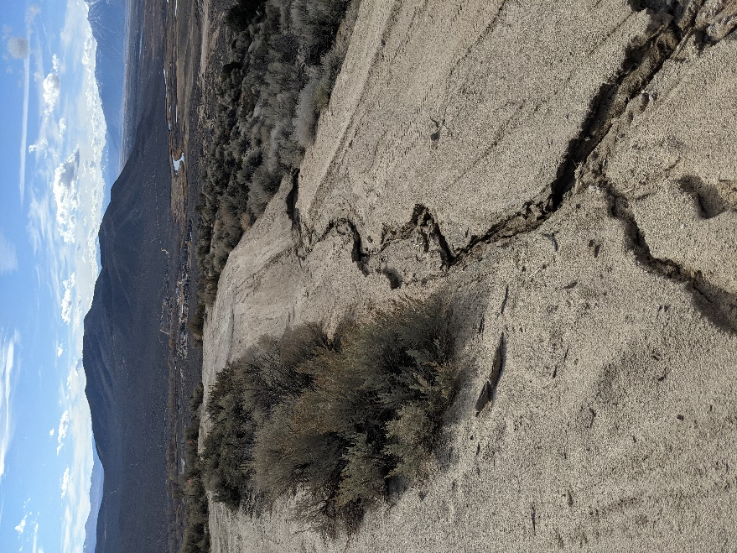
2022 Condition, Post-Construction
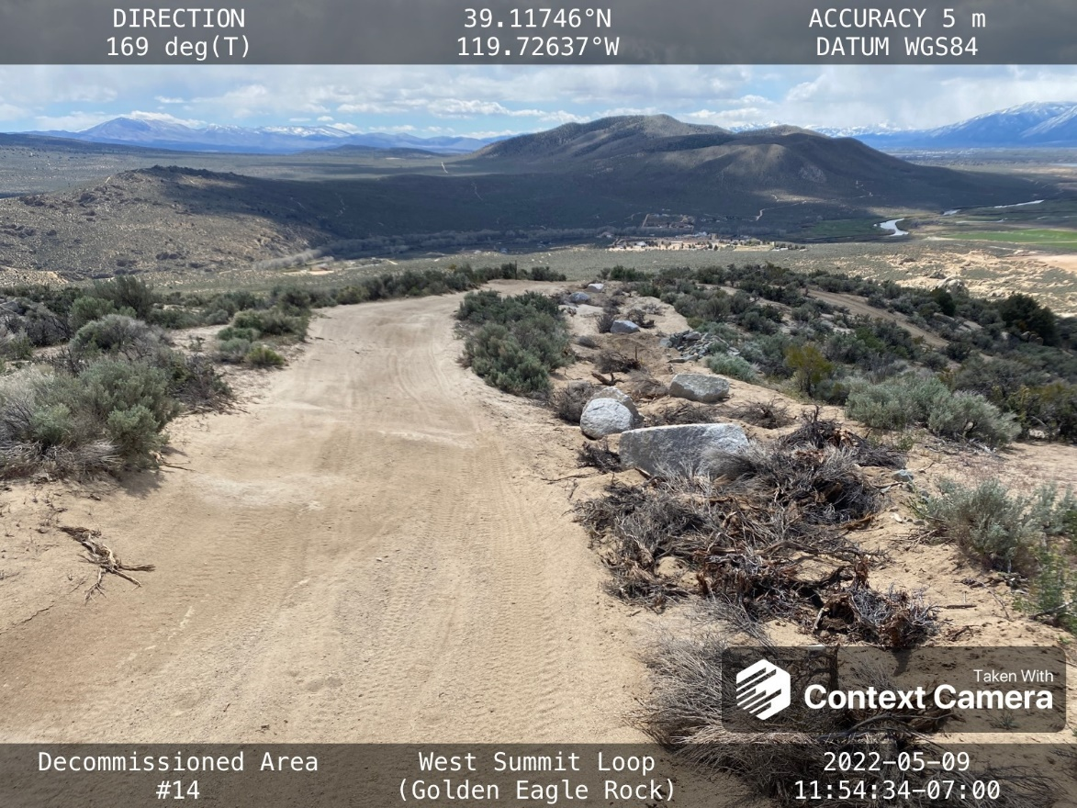

(3B-1) Photo Point: The photo shows the decommission and rehabilitation of spur roads at Mailbox Canyon (View West).

2021 Condition, Pre-Construction
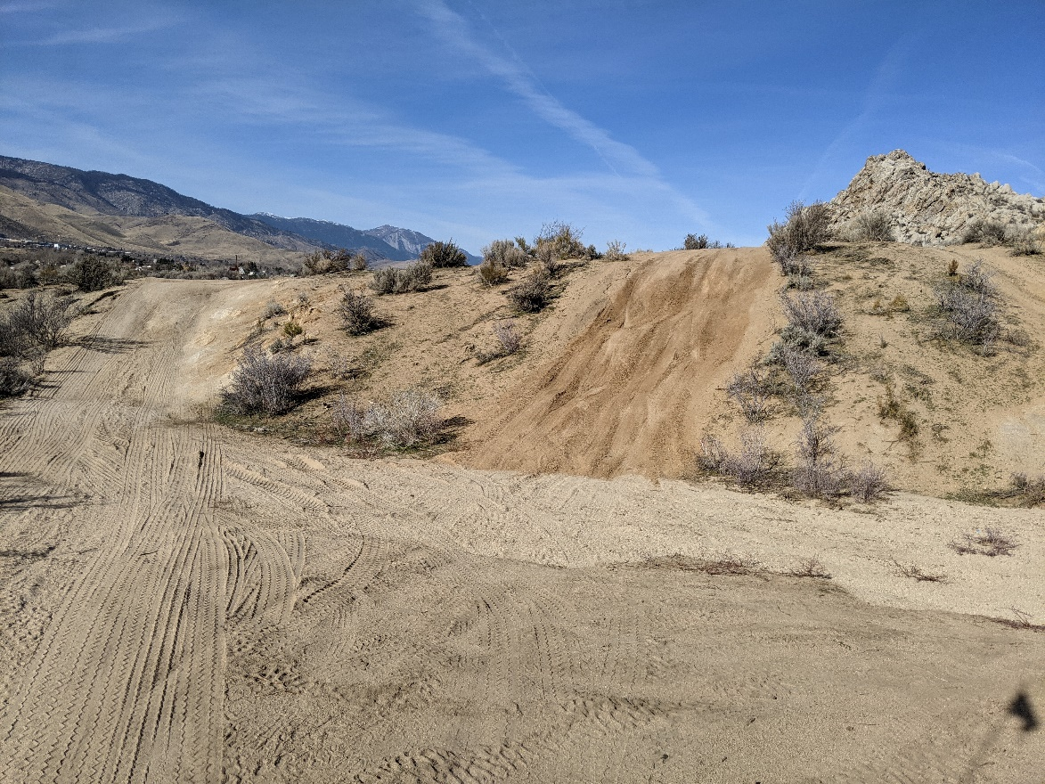
2022 Condition, Post-Construction
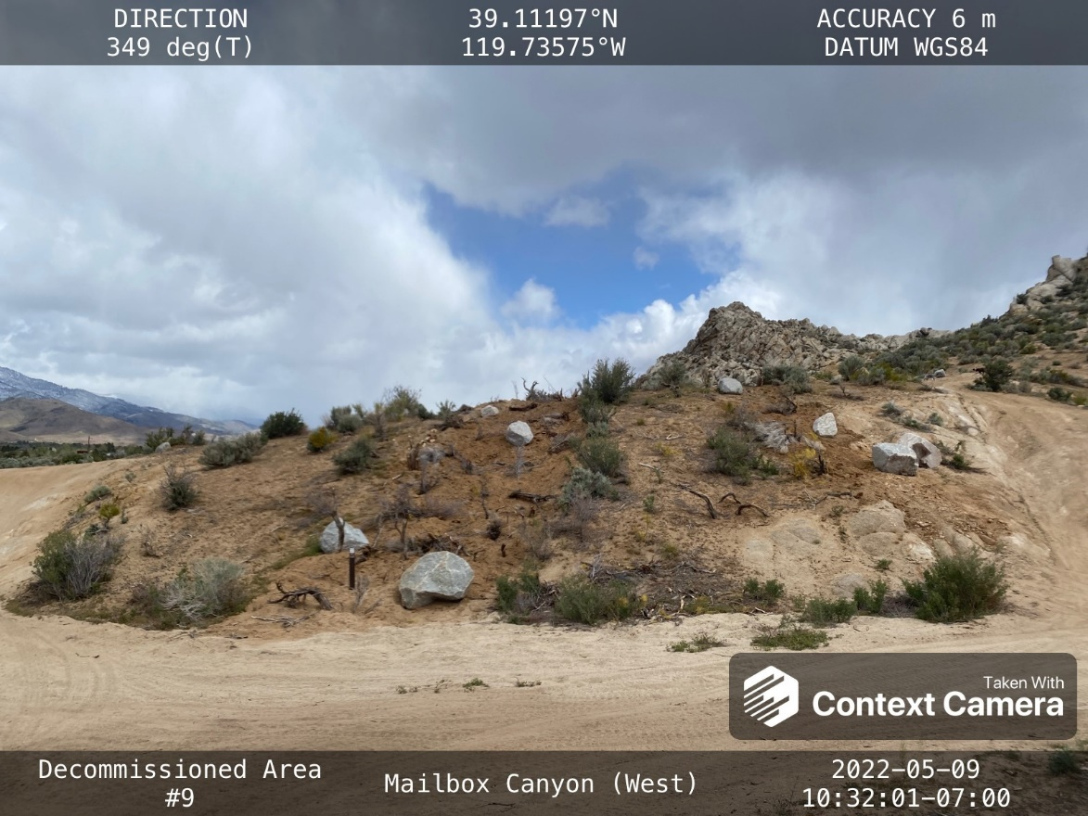

(3B-2) Photo Point: The photo shows decommissioned and rehabilitated spur roads at Once is Enough (View West).

2021 Condition, Pre-Construction
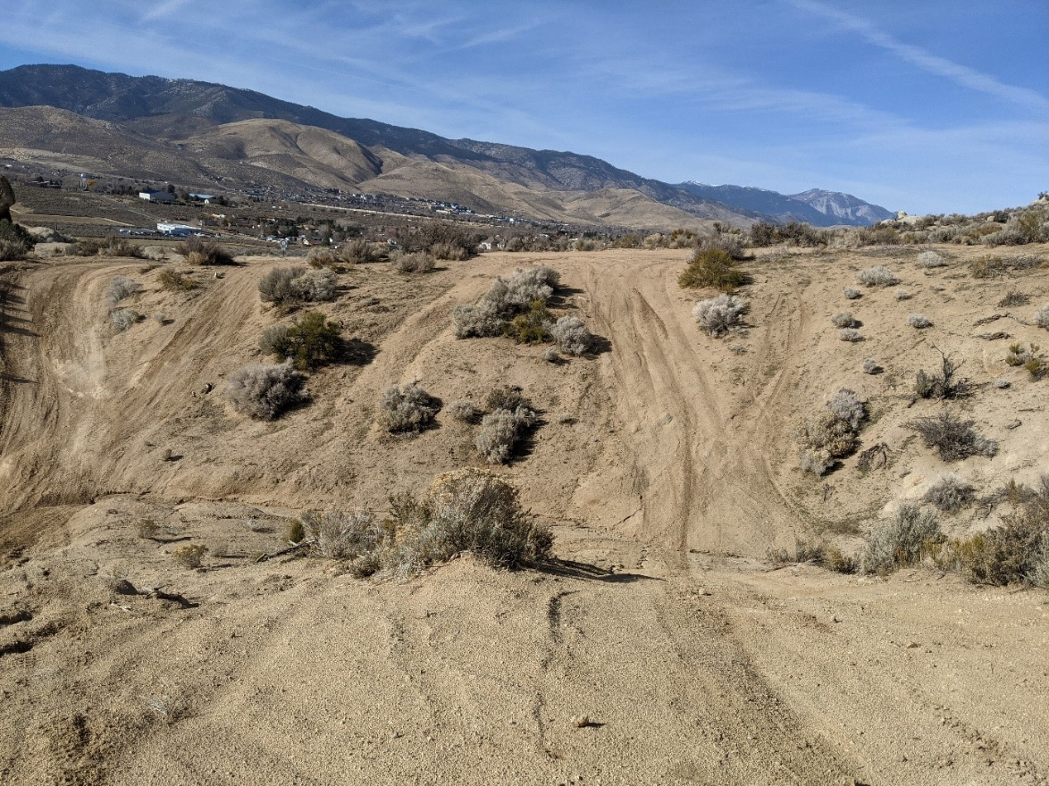
2022 Condition, Post-Construction
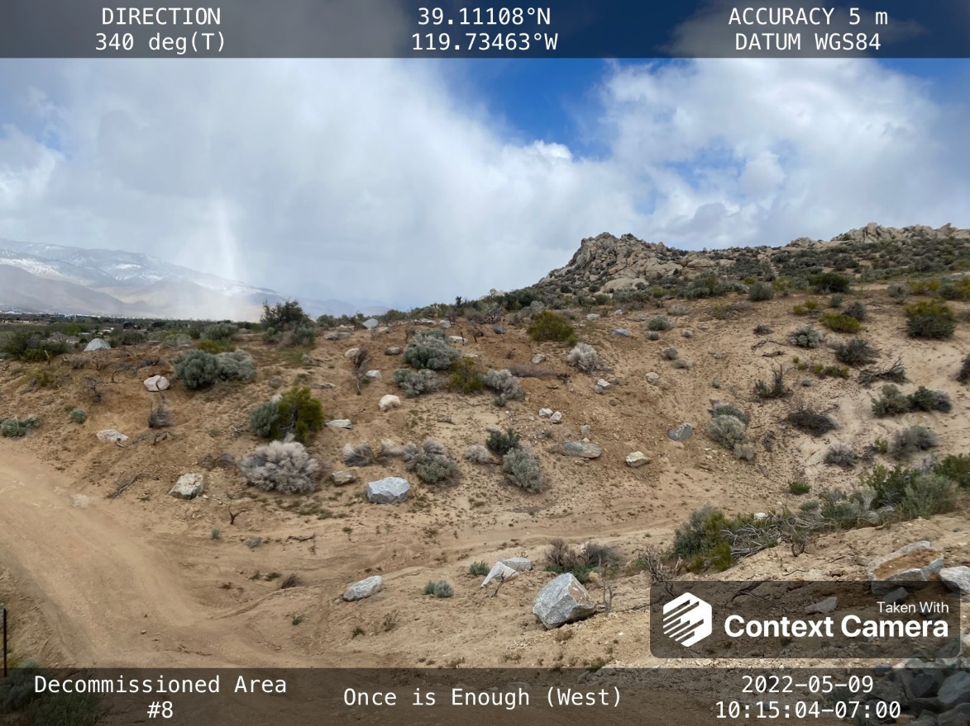
(3C-1) Photo Point: The photos show necessary materials and equipment for construction of filters in November, 2021.

November 12, 2021 -- Rocks being delivered to Staging Area
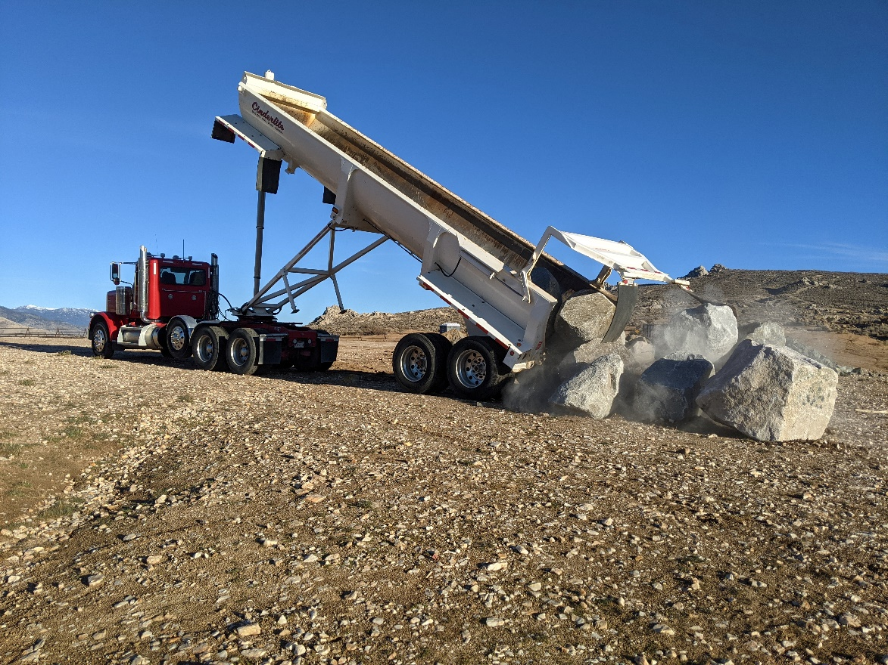
November 20, 2021 – Filter Installation
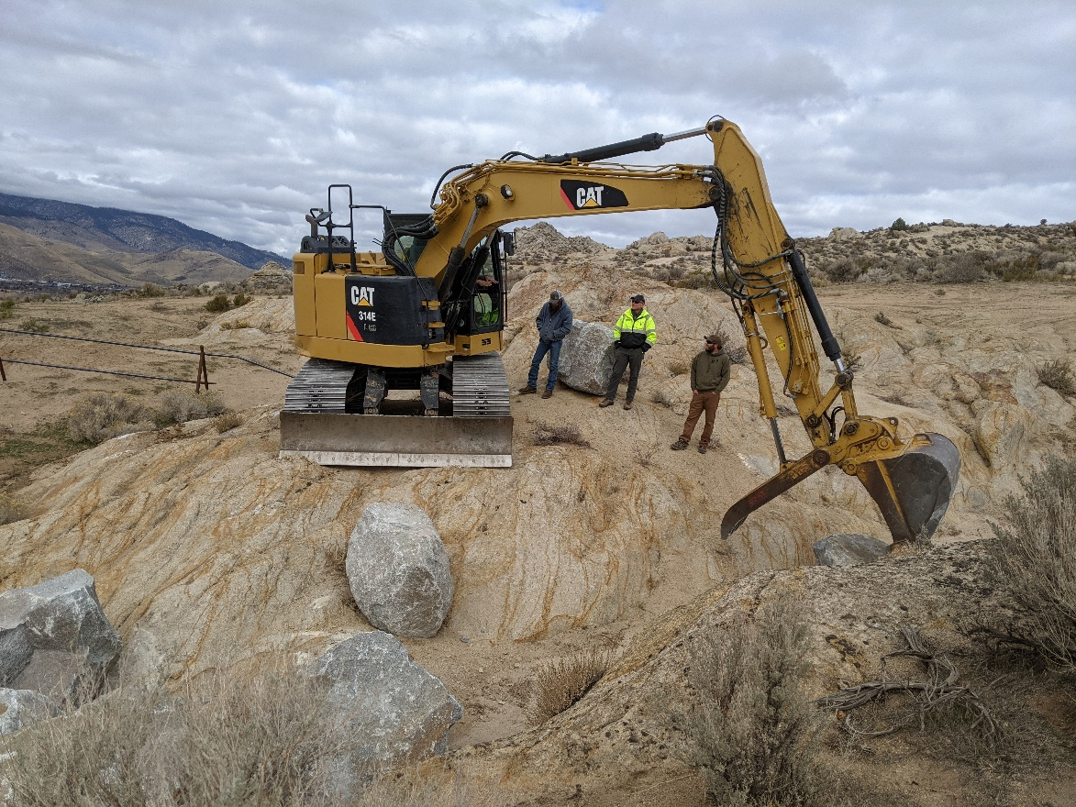

(3C-2) Photo Point: The photos show the two completed filters post-construction in 2022.

2022 Condition, Post-Construction – Gunslinger
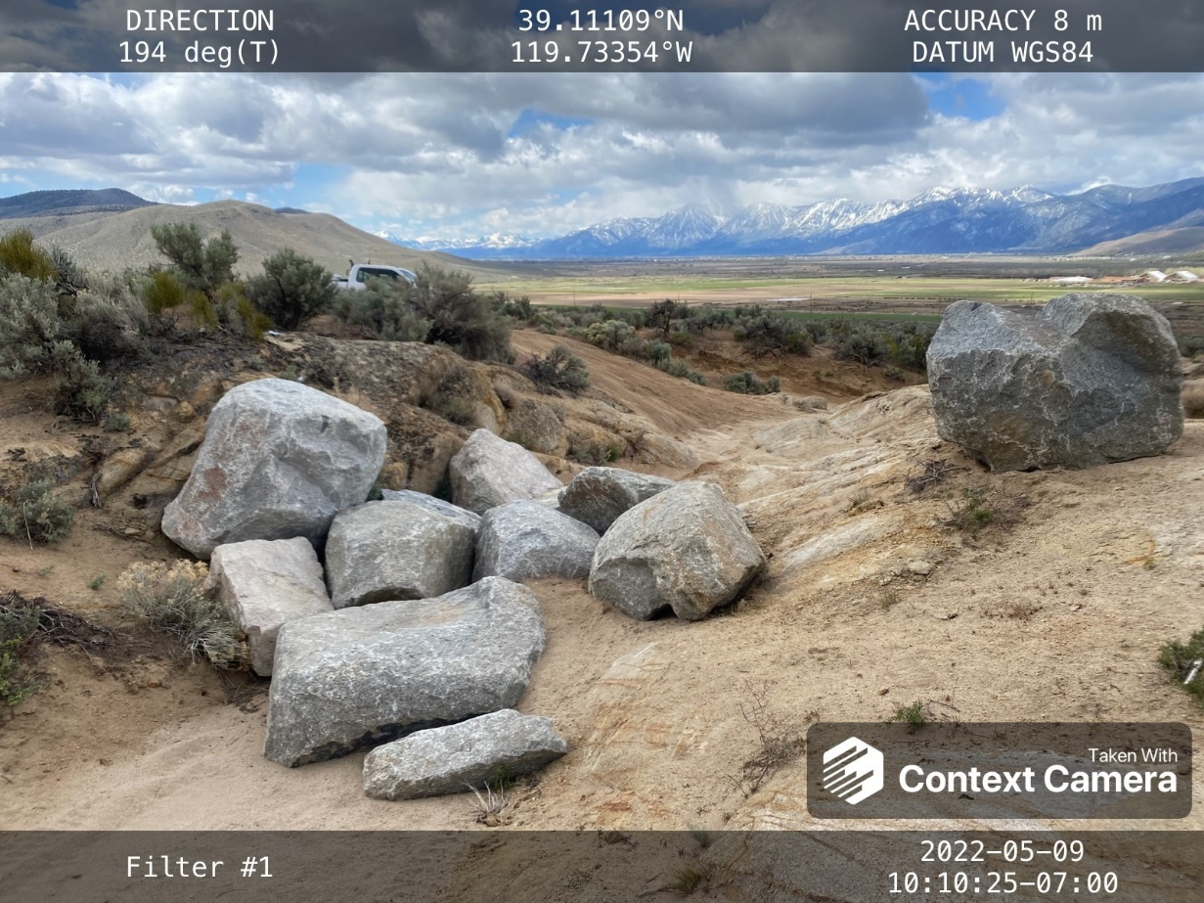
2022 Condition, Post-Construction – Death Walls
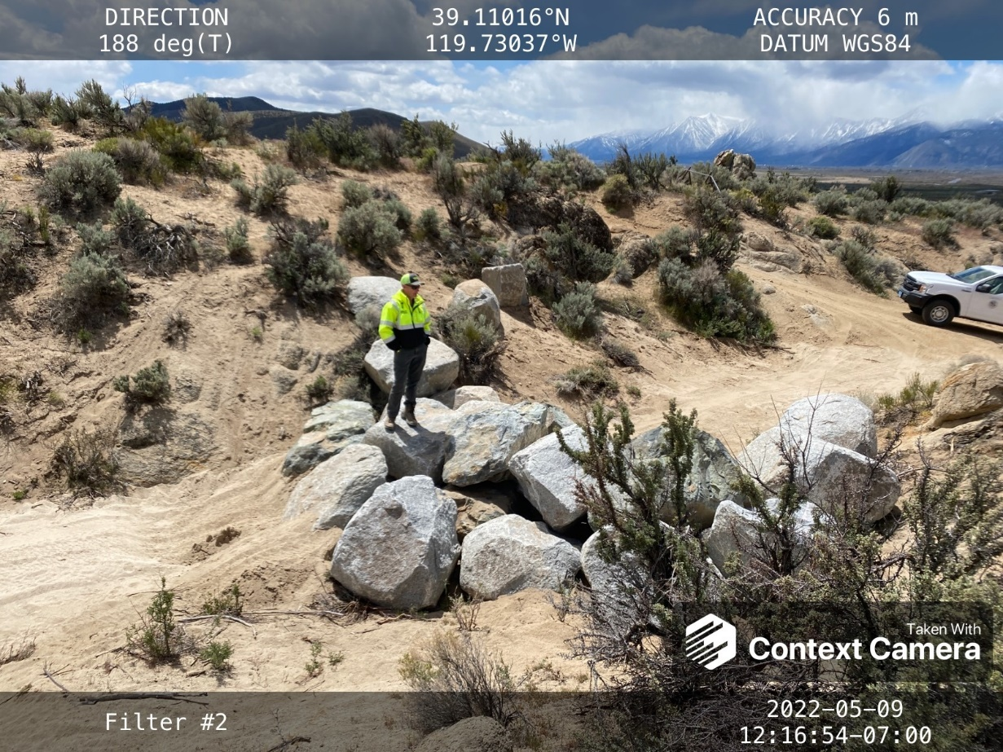
(3D-1) Photo Point: The photo shows a decommissioned fall-line road to reroute Toad Rock Loop (View South).

2021 Condition, Pre-Construction
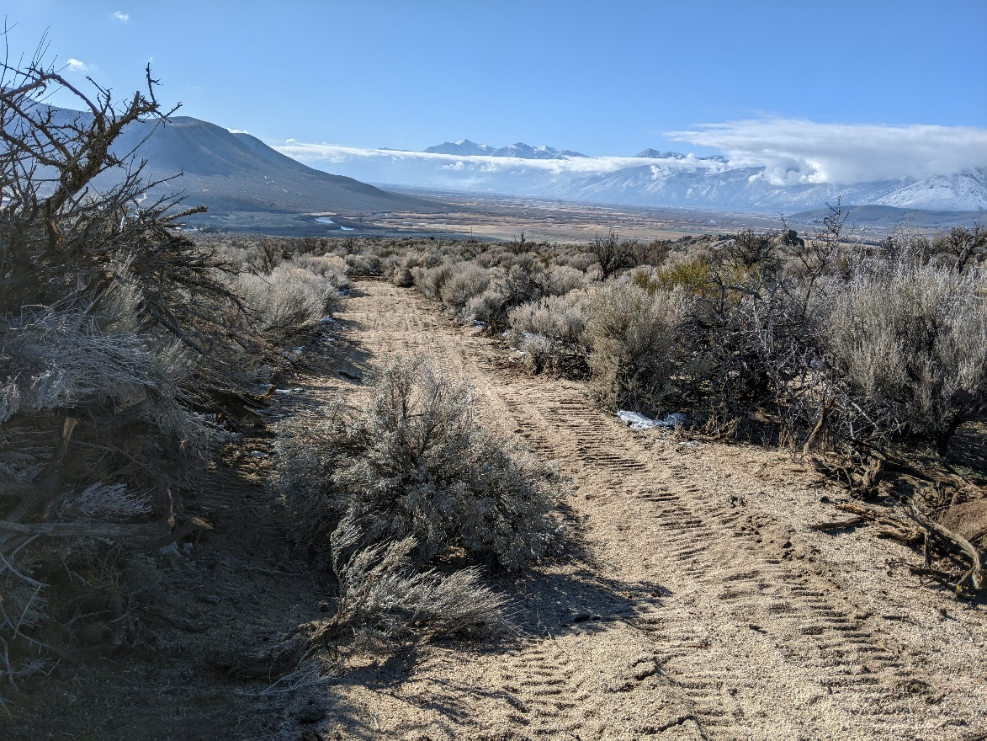
2022 Condition, Post-Construction
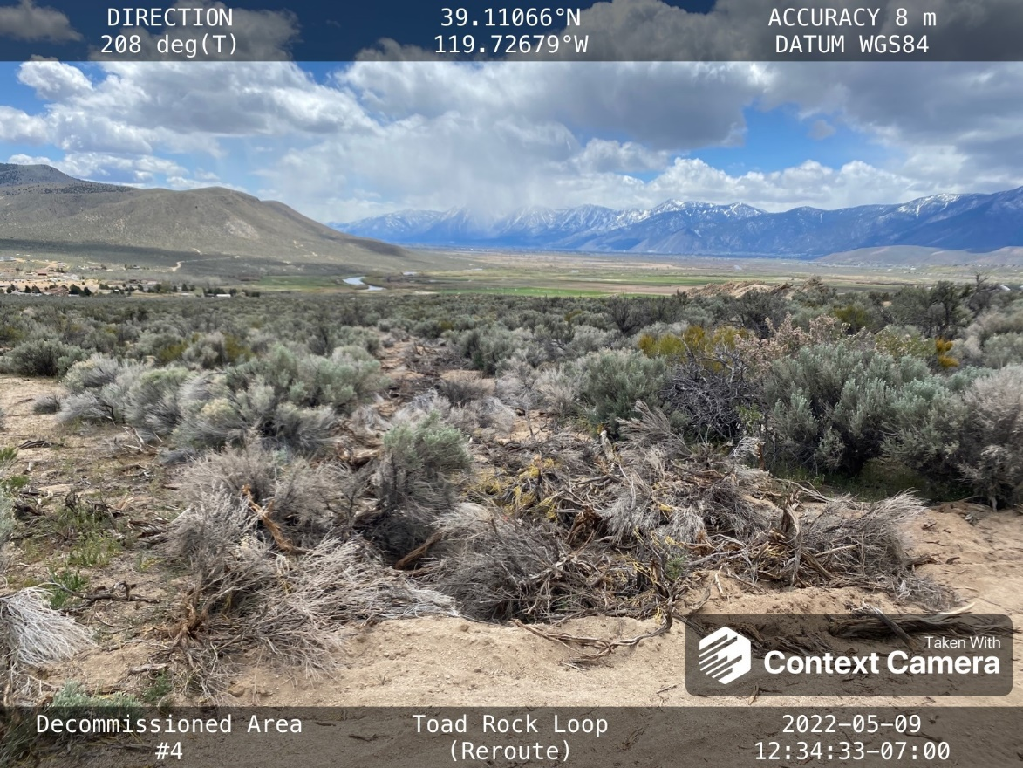

(3D-2) Photo Point: The photo shows the construction of a new segment of route for Toad Rock Loop, making the road more sinuous.
2021 Condition, photo taken November 24, 2021
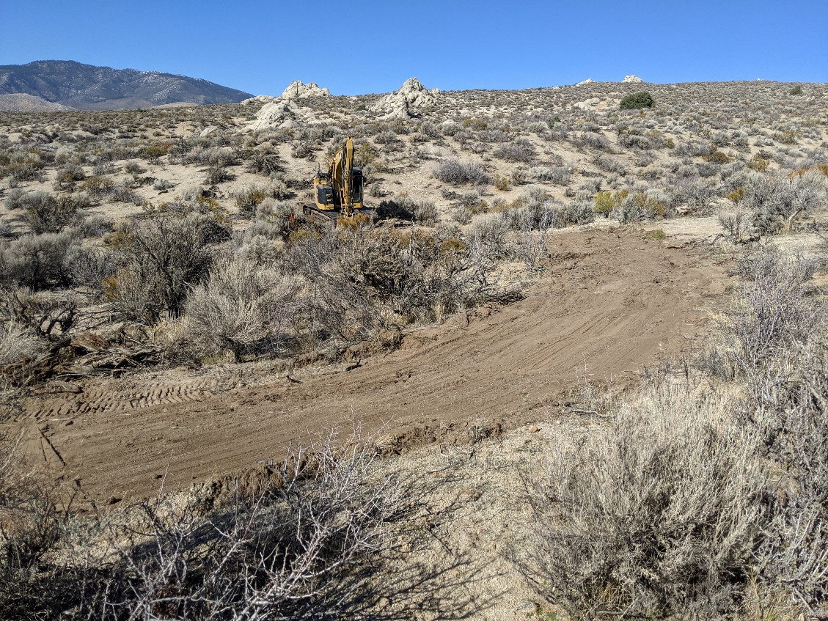
(3E) Photo Point: The photo shows an example of constructed lead off ditches and rolling dips using finer rock “reject” material to manage high flows during precipitation events.
2021 Condition, photo taken November 24, 2021
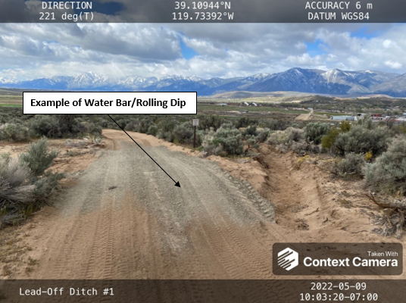
(3F) Photo Point: The photos show examples of two out of the 50 check dams installed.

2022 Condition, Post-Construction
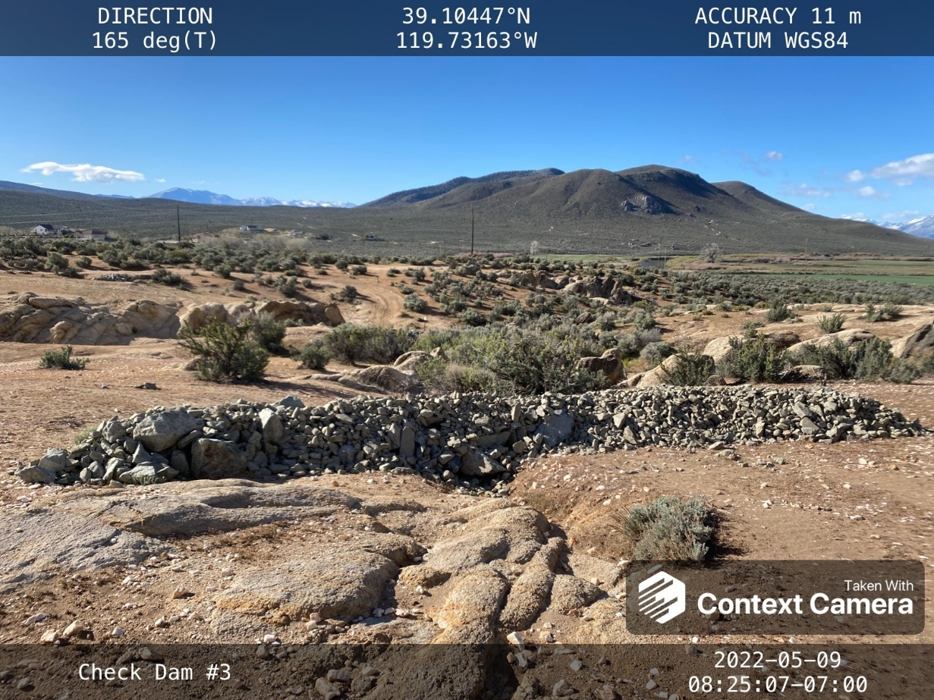
2022 Condition, Post-Construction
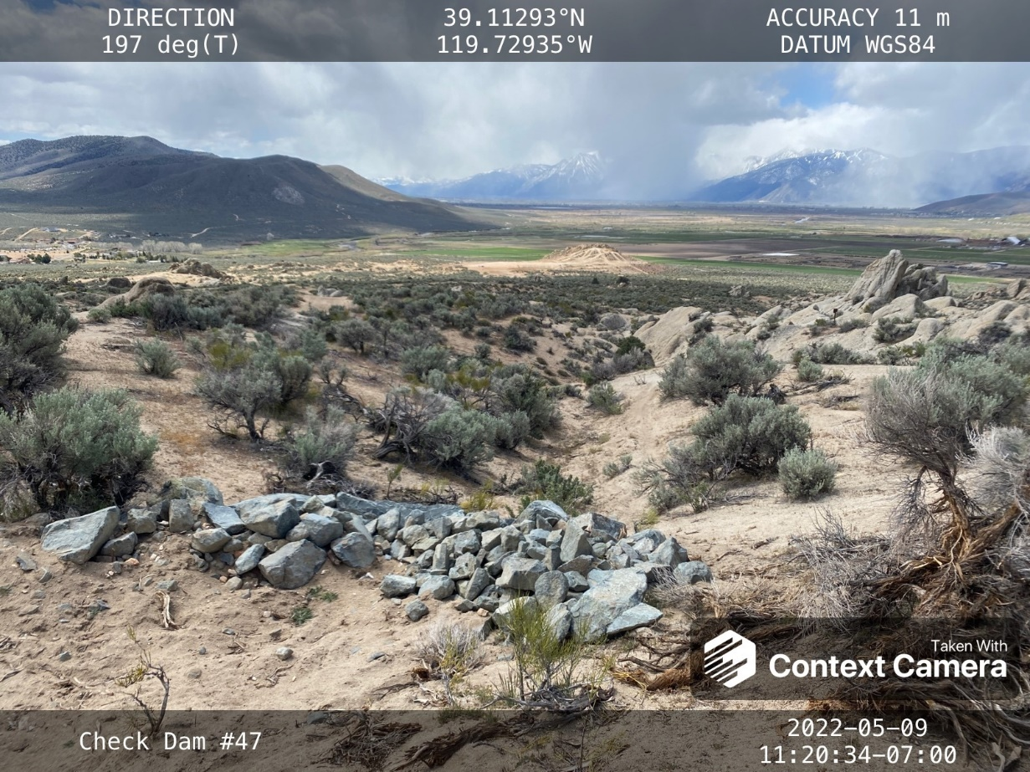

- Erosion and Soil Degradation
Several of the construction objectives with Horizon Construction, Inc. on the Prison Hill OHV Improvement and Stabilization Project addressed erosion and sediment-runoff concerns. Major gullies that were formed during storm events were regraded and lined with permeable rock to prevent erosion from occurring in future large rainfall events. In addition, fifty check dams were installed in various drainages to slow sediment runoff. Lastly, the berms that were built up and compacted with sand in the motocross (MX) sand-track area act as natural earthen containment basins to catch water and sand during winter weather.
Photo examples include:
- Rock-lined ditch at the bottom of Center Road by the Staging Area
- Runoff down the drainage in “Off the Trailer” that will be slowed in future events with one of the many constructed check dams
- Earthen containment basins built by increasing the berms in the sand-track area.

(Photos on next page)

(4A) Photo Point: Photo of gully at the base of Center Road (near the Staging Area) that was lined with rocks to prevent future erosion.

2021 Condition, Pre-Construction
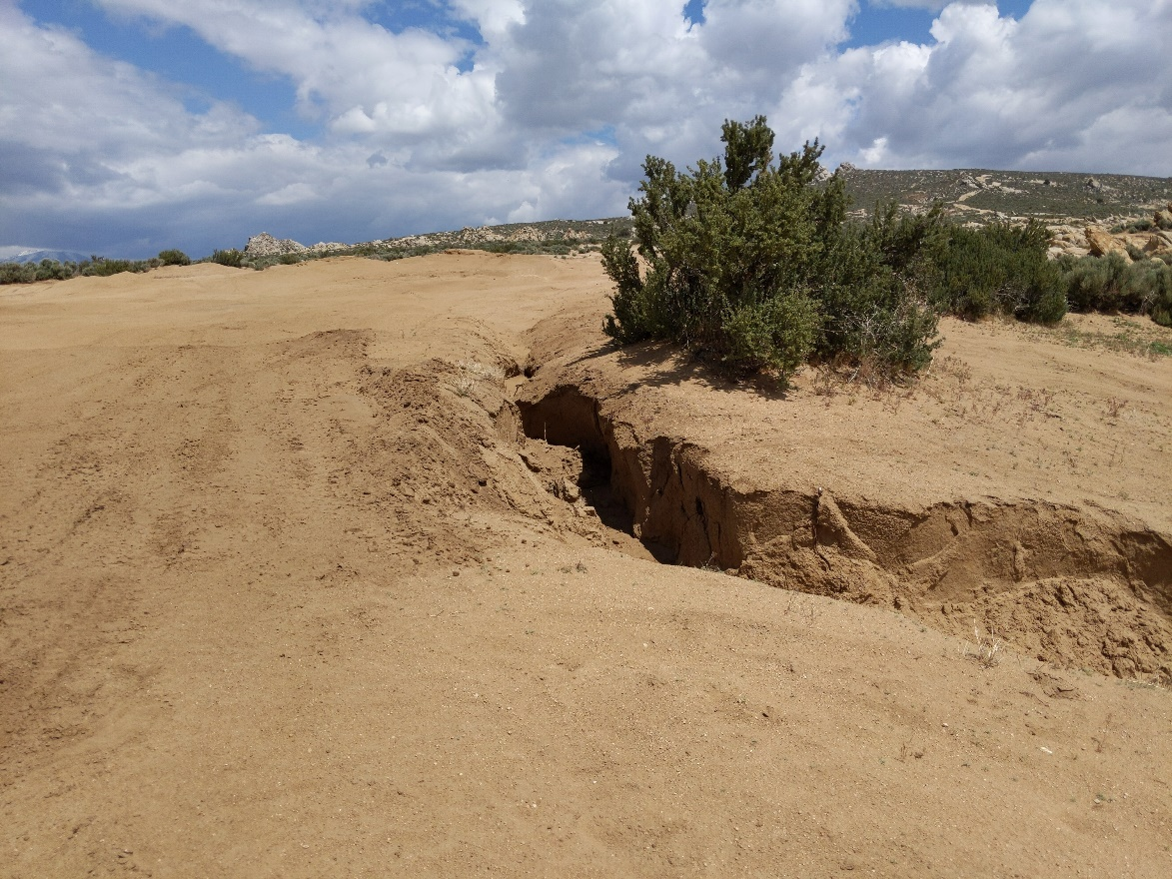
2022 Condition, Post-Construction
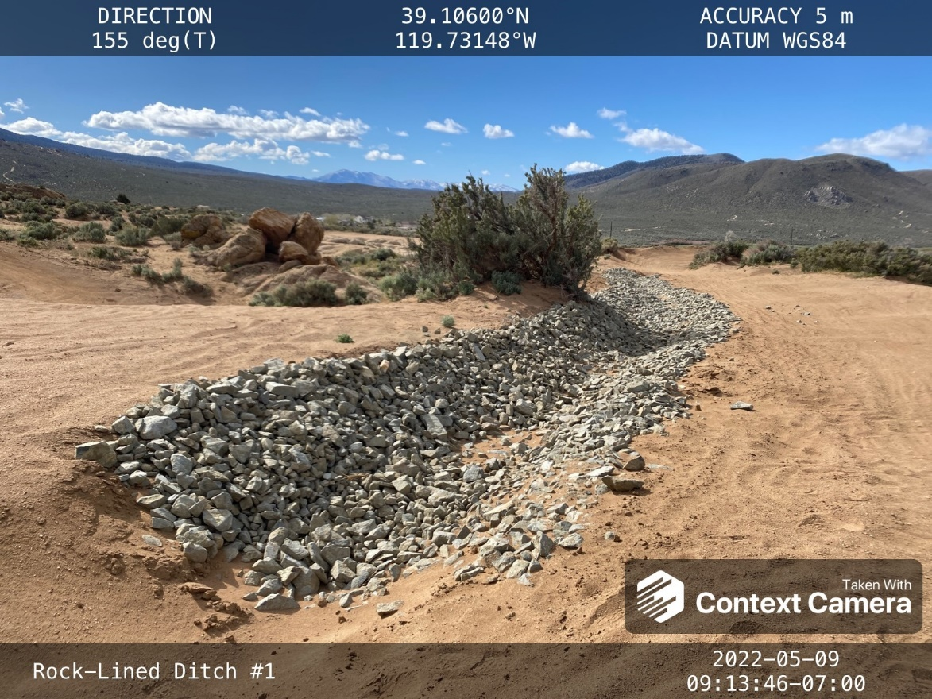

(4B) Photo Point: Photo of erosion and sediment runoff during a 2021 storm event that will be slowed in future weather with the installation of check dams.

2021 Condition, Pre-Construction – Winter storm runoff
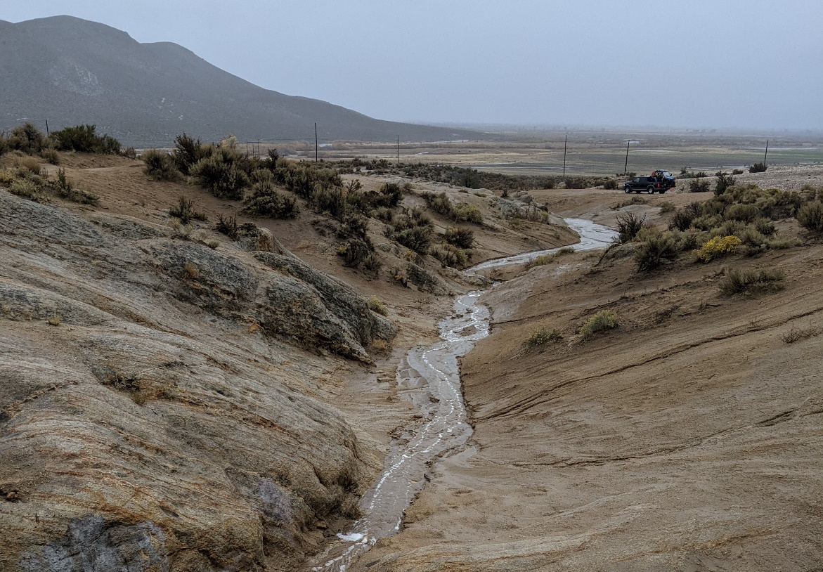
2022 Condition, Post-Construction – New check dam to slow flows
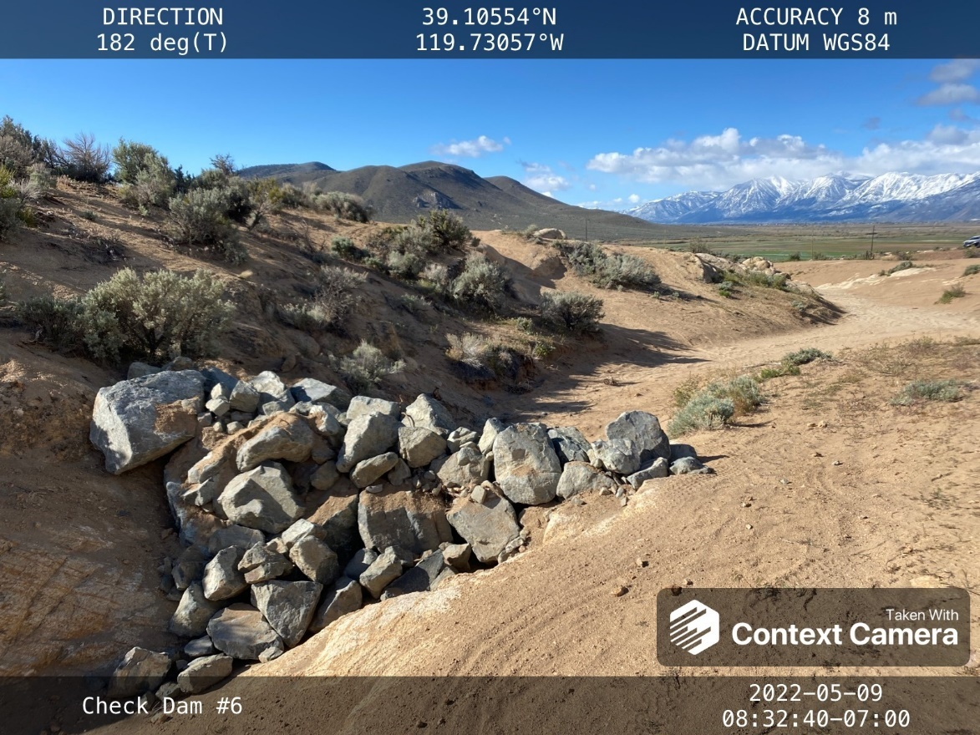

(4C) Photo Point: Photo of the motocross (MX) sand-track area just uphill of the Staging Area that has improved bank turns which created earthen containment basins to further catch erosional sedimentation into the Tot Lot, Beginner Area, and Staging Area.

2021 Condition, Pre-Construction
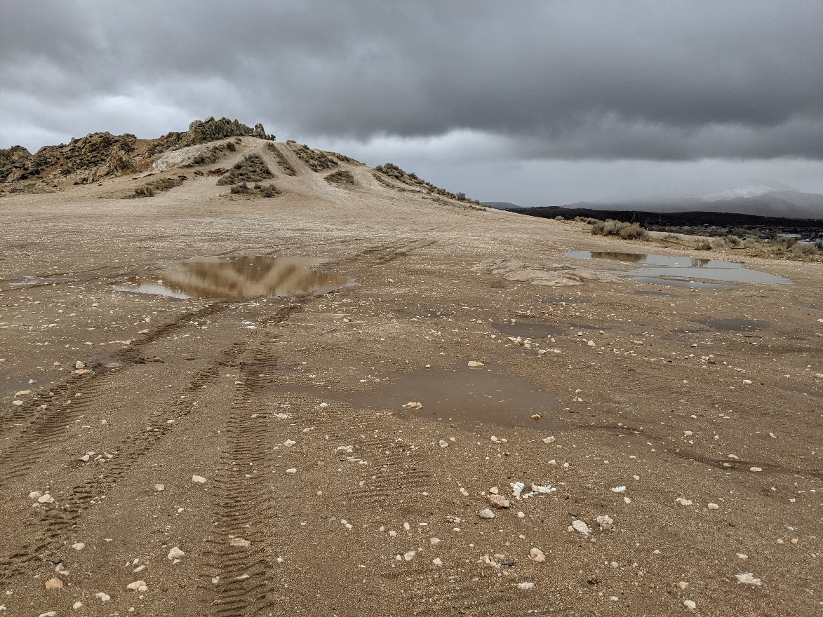
2022 Condition, Post-Construction
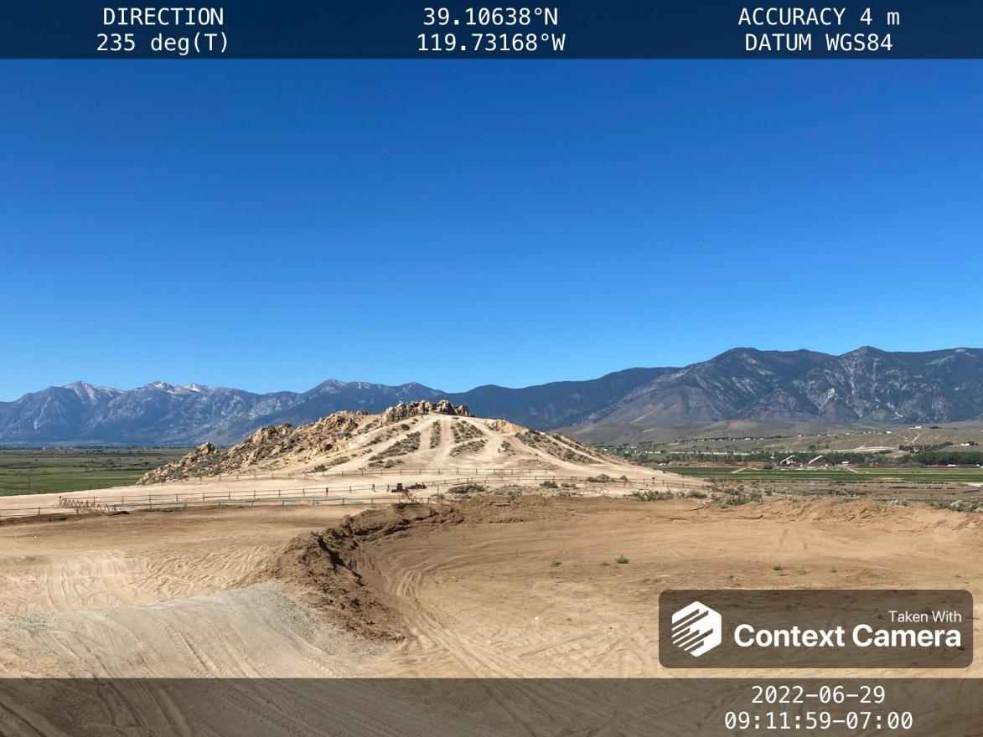

- Graffiti and Vandalism
No change. The area has remained graffiti-free and unvandalized.
- Trails (e.g. trail widening, trail braiding, ineffective trail drainage, breaching of fences)
Improvements to West Summit Loop and Toads Rock Loop, as explained in the “Construction” section.

- Dumping and Littering
No change.

- Recreation and Events
- The Tot Lot and Beginner Area are now complete, covering approximately two acres. Jackrail fence surrounds the perimeter, and tracks within the areas are reinforced with finer rock “reject” material to define the course. This is a great family-friendly area for recreation.
- Four areas of the motocross (MX) sand-track area, which is just up from the Tot Lot/Beginner Area, have built up berms that are now actively used by motorcyclists. These berms also act as containment basins to slow flows during precipitation events, and prevent sand moving from downhill into the Staging Area, Tot Lot, and Beginner Area.
- On the first weekend of June in 2022, the Sacramento Pacific International Trials Society (PITS) hosted the largest event yet at the Prison Hill OHV Area. For context, motorcycle trials are a non-speed event on specialized motorcycles. There were 94 riders on both days of the competition, as shown by the several cars parked in the Staging Area. The event was a huge success, and they hope to repeat the event in future years.

(8A-1) Photo Point: The photo shows the finished construction of the Beginner Area (left) and Tot Lot (right) shown from a distance (looking North).
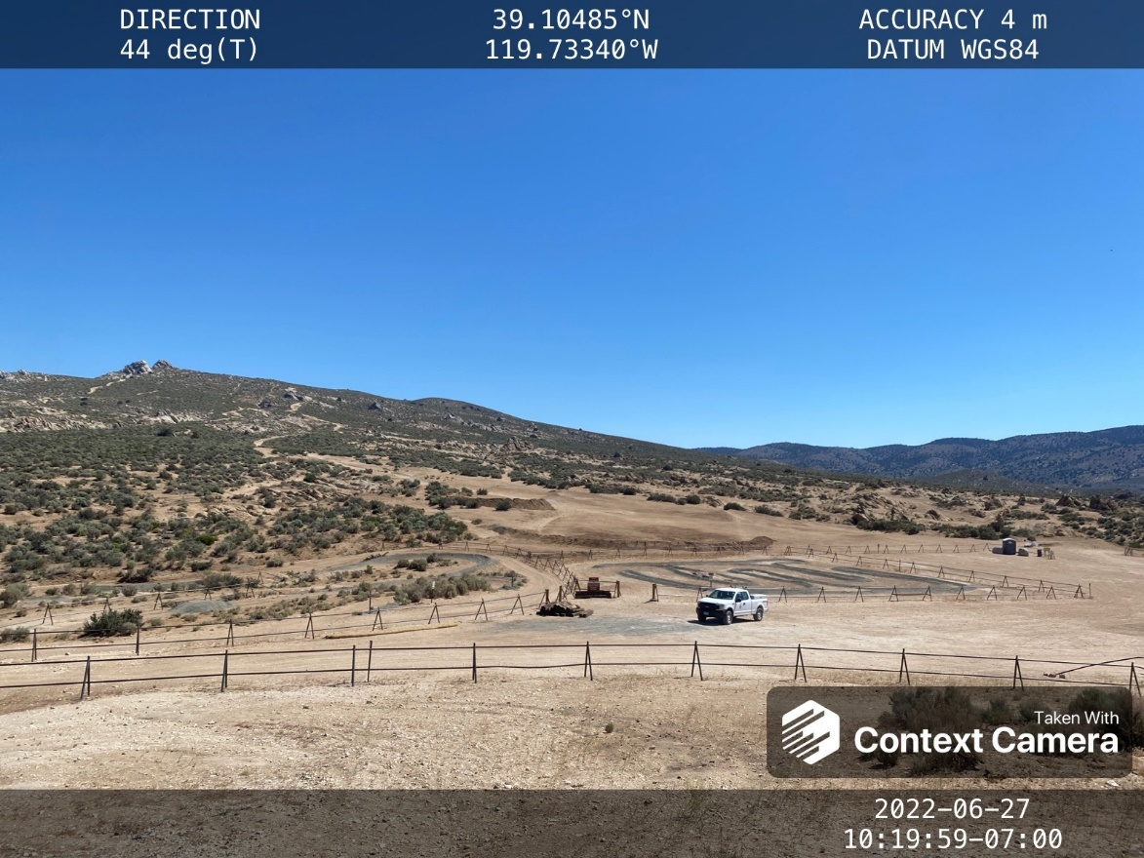
(8A-2) Photo Point: The photo shows a close-up view of the Tot Lot, with improved signage and reinforced tracks with finer rock “reject” material.
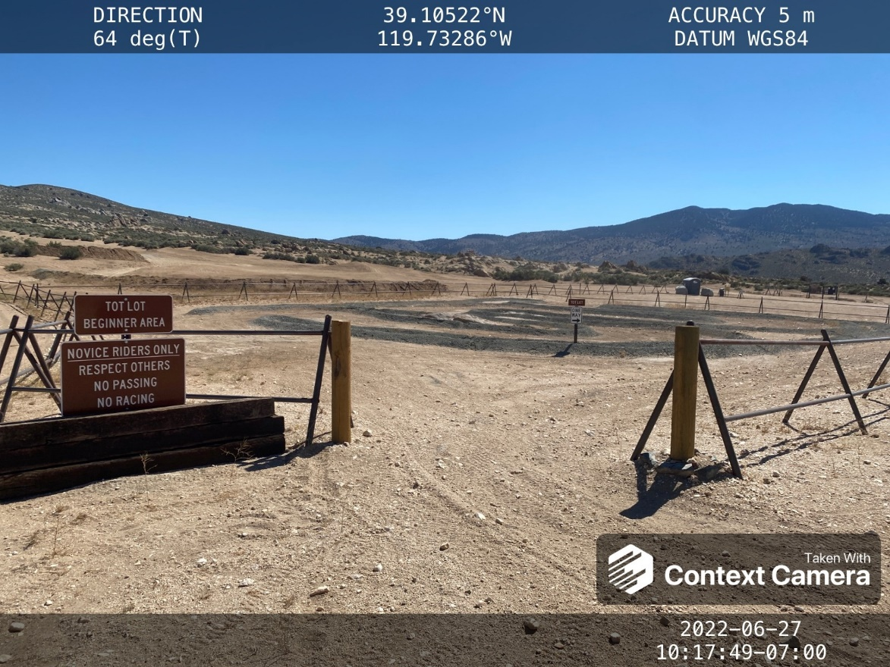

(8B-1) Photo Point: The photo shows motorcyclists using the berms when they were initially constructed in 2021.
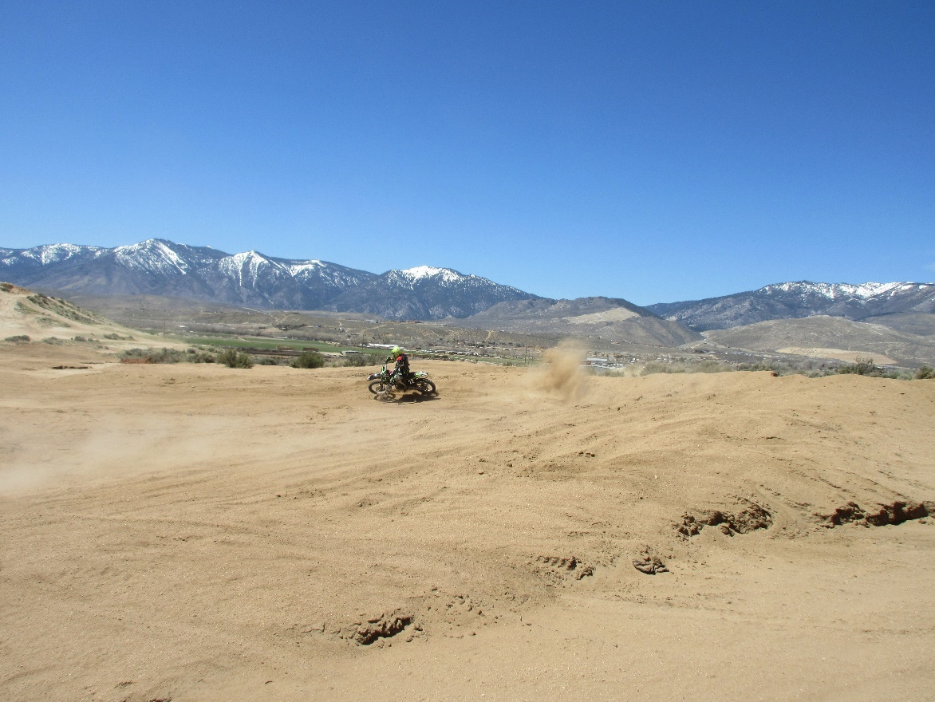
(8B-2) Photo Point: Another berm now exists to the right of the motorcyclist pictured, which enjoy riding the high turns.
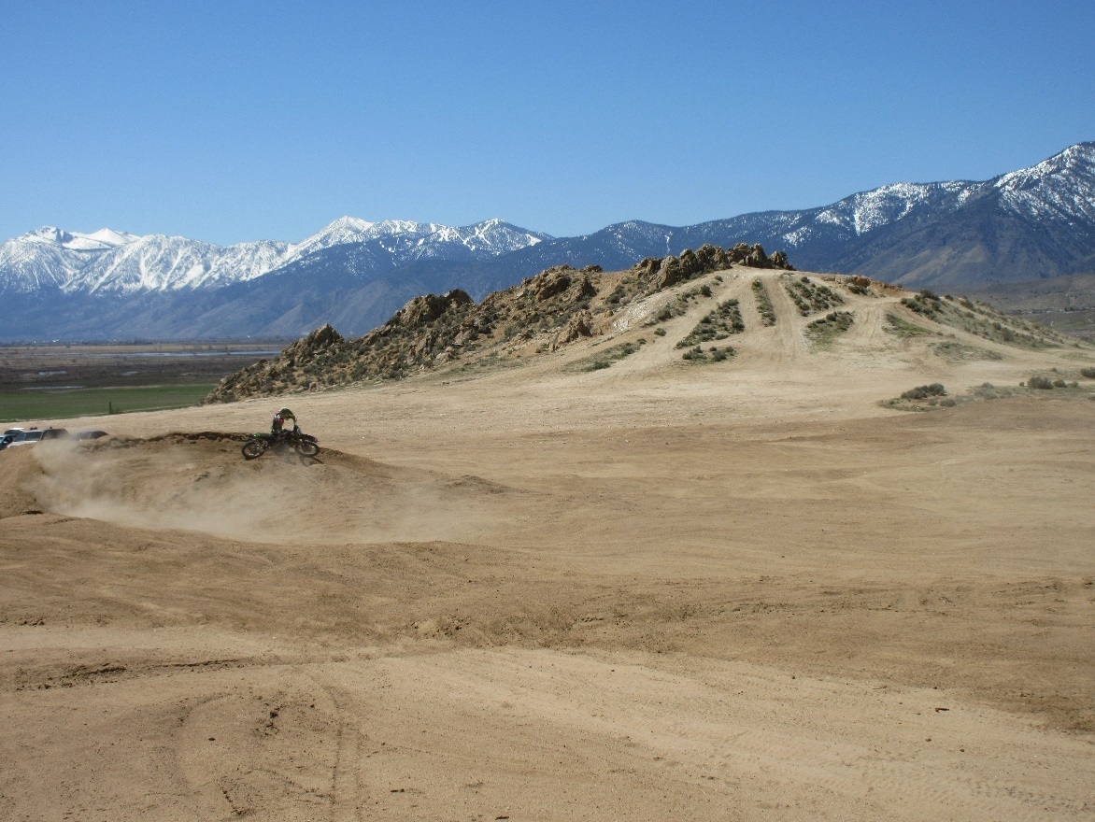

(8C-1) Photo Point: The photo shows the first PITS Event at Prison Hill in the granitic bedrock areas.

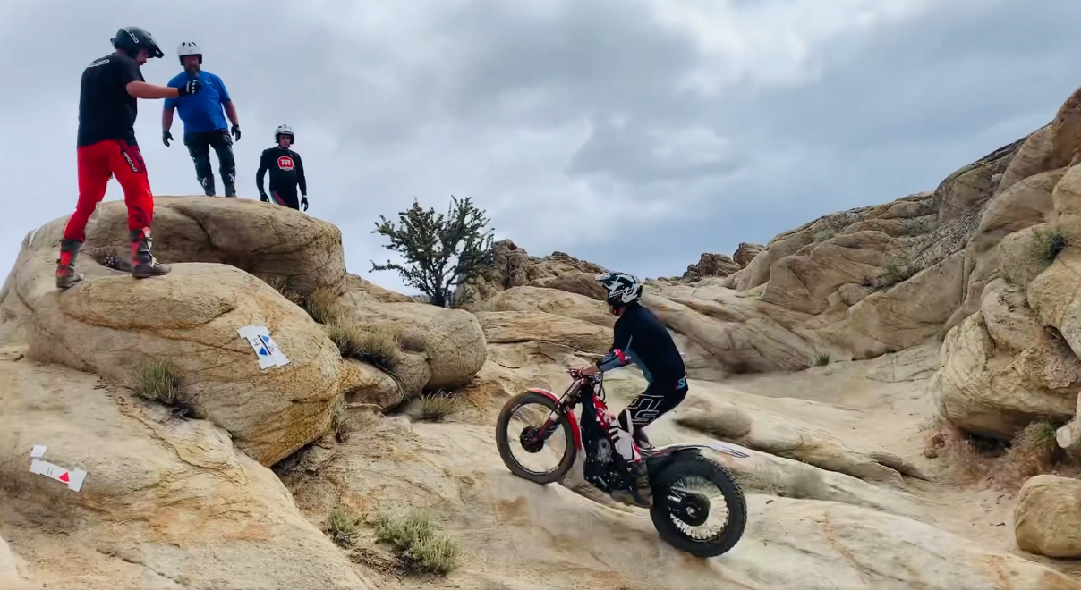

(8C-2) Photo Point: The photo shows the full parking area at the PITS Event in June, 2022.
2022 Condition, photo taken June 6, 2022
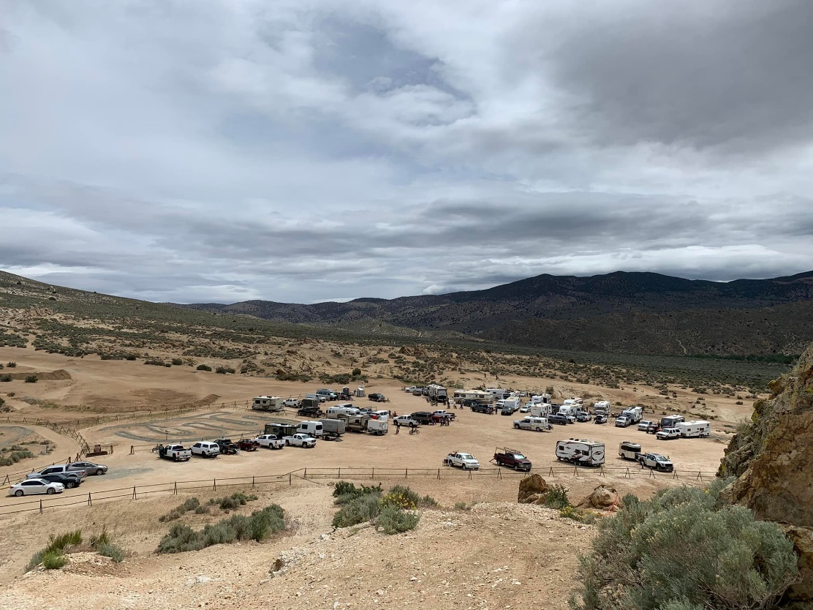

(8C-3) Photo Point: The photo shows the volunteers that helped with registration at the PITS event in June, 2022.

2022 Condition, photo taken June 5, 2022
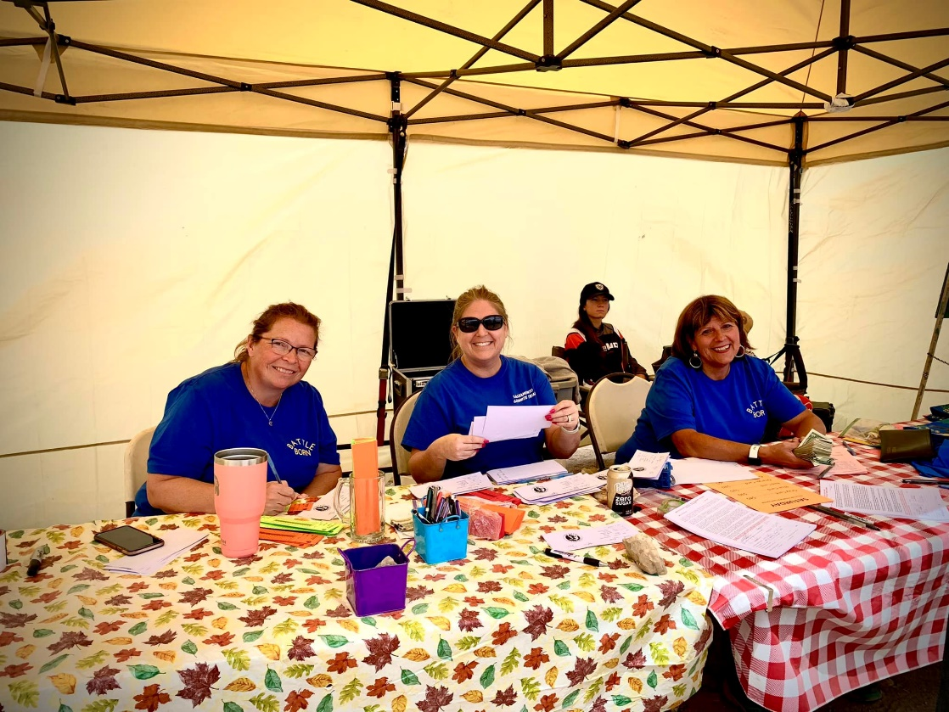

- Fire
While a fire broke out on the north section of Prison Hill on July 2, 2021, burning 171 acres, the fire did not affect the OHV Area. Over the last year on red flag warning days (e.g. winds greater than 15 mph, relative humidity less than or equal to 25%, and temperatures greater than 75ᵒF), PHRA OHV Area has been closed to prevent potential wildfire incidences.

Summary:
The results of the 2022 audit of the Prison Hill Motorized Area by Carson City demonstrate that the property made several large improvements over the last year. Further construction will take a pause in the upcoming year, and staff time will be focused on maintenance (particularly cleaning the check dams). A new Volunteer Coordinator will be brought on in the fall of 2022, so more education and volunteer events will hopefully increase in 2023.

Carson City will continue to address and monitor over time the available resources in the Prison Hill Recreation Area Off-Highway Vehicle Area, and implement additional improvements to the conditions on the property as needed.

Written by:
Georgia Vasey, Senior Natural Resources Specialist Date

Reviewed by:
Lyndsey Boyer , Open Space Manager Date

Please indicate the number of the following attachments to this report. Be sure to date and sign all materials and provide a description or map showing where on-site photos and illustrations were taken:

____ Aerial photos
X Ground photos (digital or other)
- 35 ground photos – Within the Report
- 68 ground photos – Baseline Report Repeat Photo Documentation
- Digital photos taken, copied into a written report
X Maps and illustrations
- 2 maps included – In Appendix 1: Supplemental Information, Figure 1 for Map of Photo Points (Baseline Repeat Photo Documentation) and Figure 2, As-Built 2021/2022 Map
Other:

Photo Point 1A (view east): A photo point located at the boundary of the staging area.
2020 Baseline Condition, photo taken January 24, 2020:
(GPS coordinates: 39.104745, -119.733277)
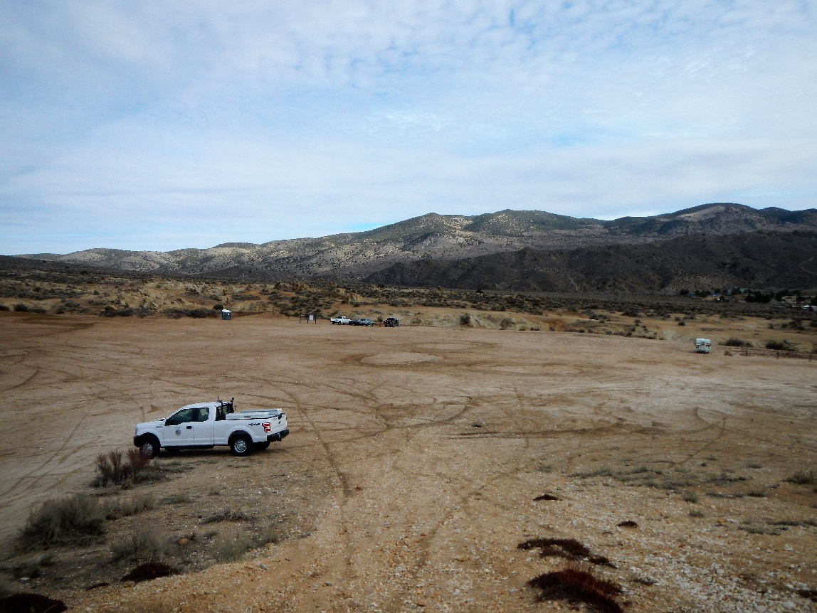

2022 Condition, photo taken June 17, 2022
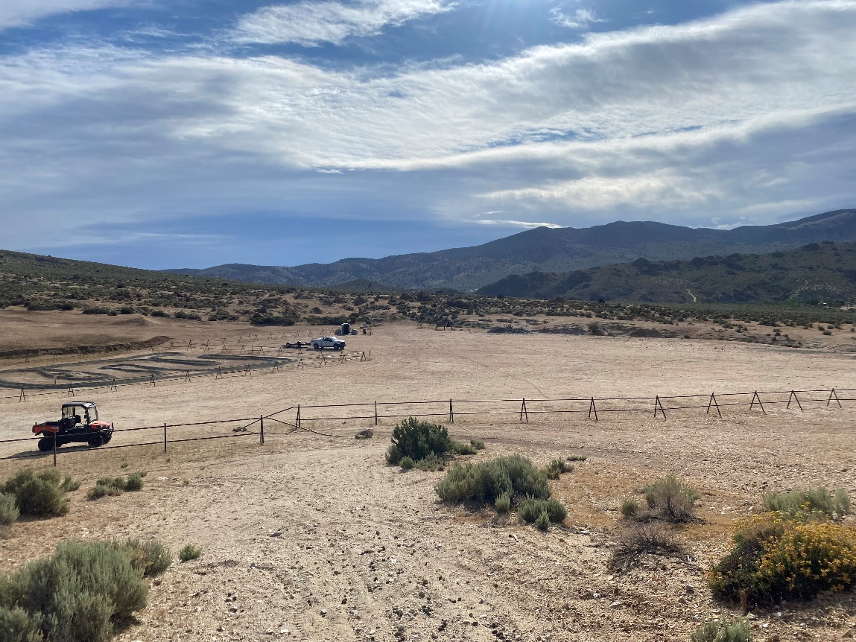

Photo Point 1B (view northwest): A photo point located at the boundary of the staging area.

2020 Baseline Condition, photo taken January 24, 2020:
(GPS coordinates: 39.104745, -119.733277)
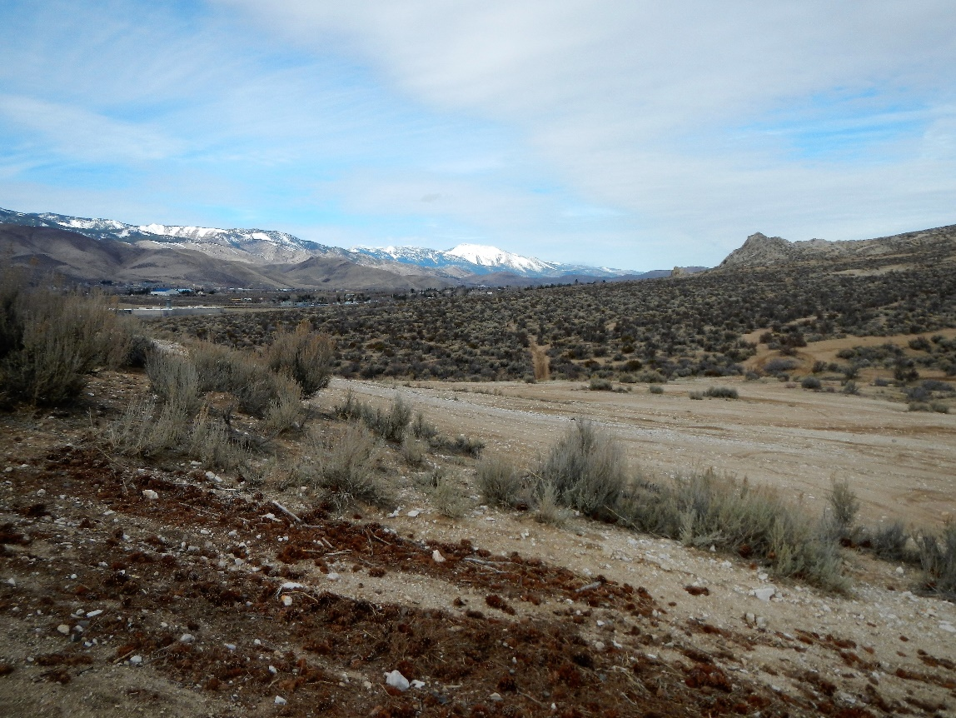

2022 Condition, photo taken June 17, 2022
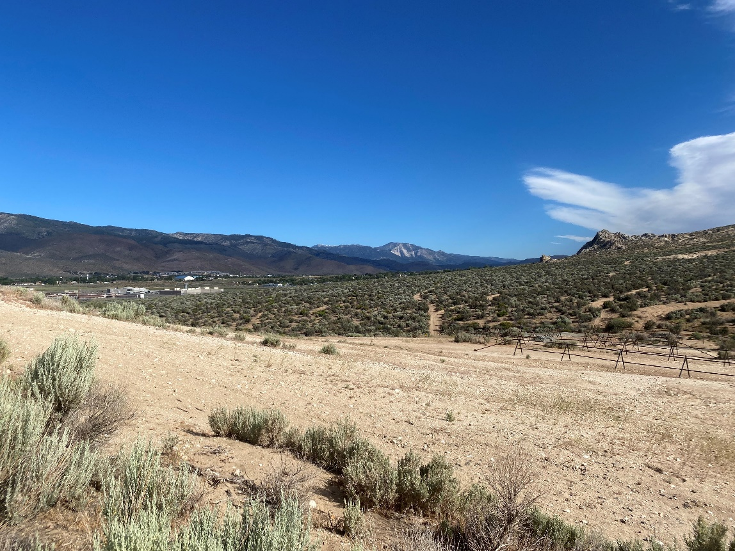
Photo Point 1C (view southeast): A photo point located at the boundary of the staging area.

2020 Baseline Condition, photo taken January 24, 2020:
(GPS coordinates: 39.104745, -119.733277)
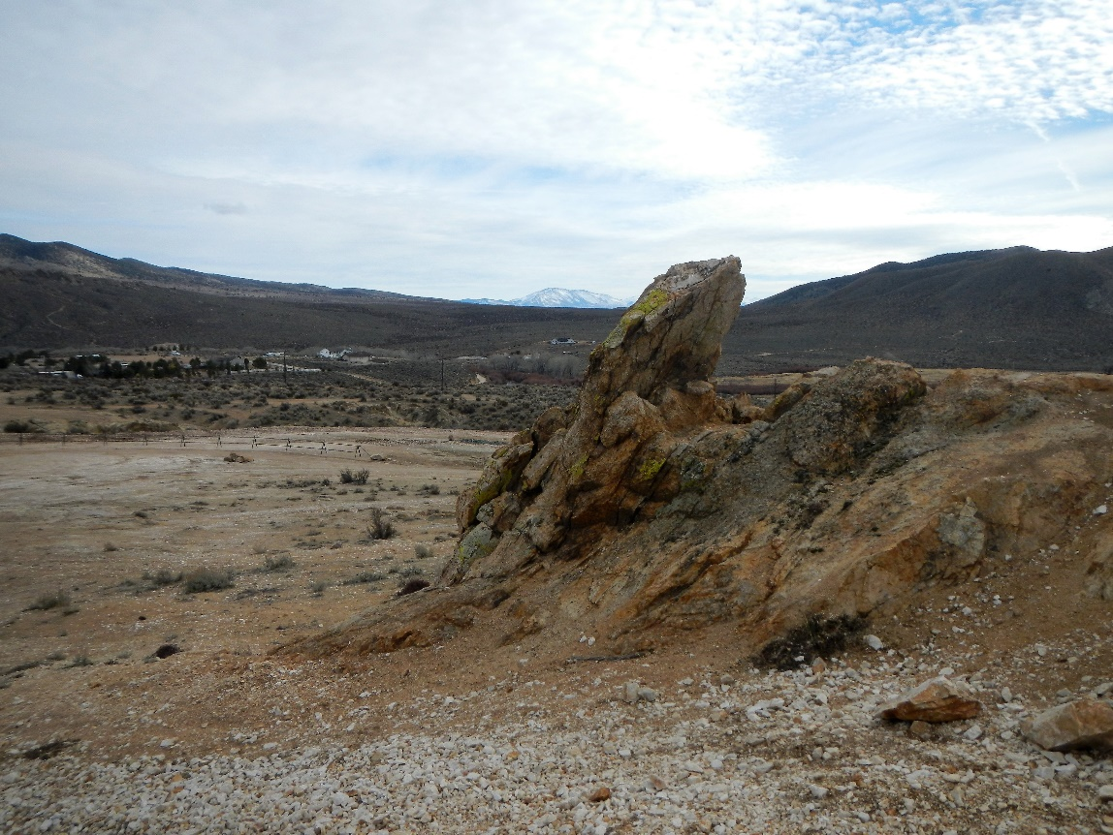

2022 Condition, photo taken June 17, 2022
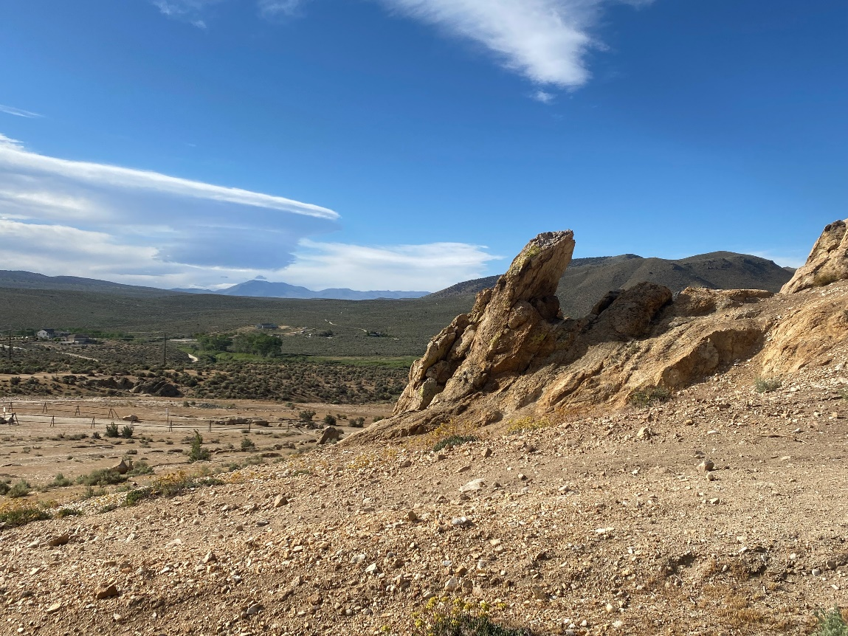
Photo Point 2 (view east): A photo point located in the open area east of the staging area.

2020 Baseline Condition, photo taken January 24, 2020:
(GPS coordinates: 39.105205, -119.731003)
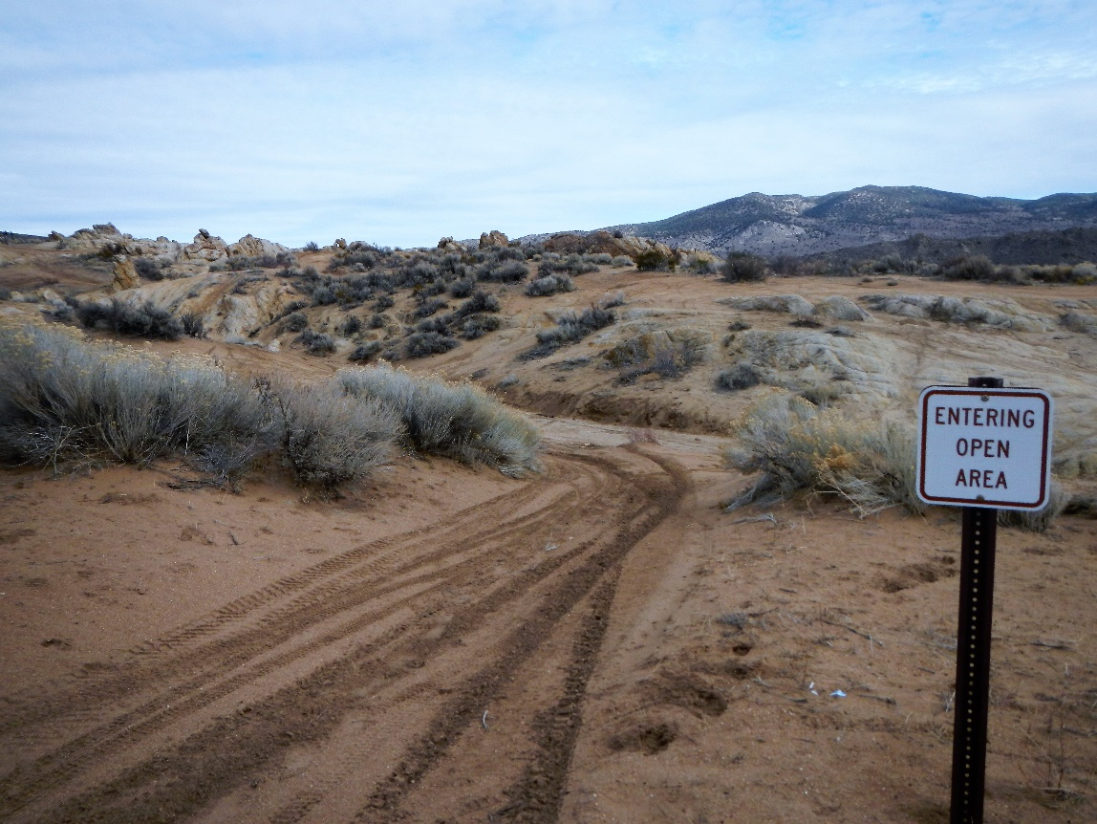

2022 Condition, photo taken June 17, 2022
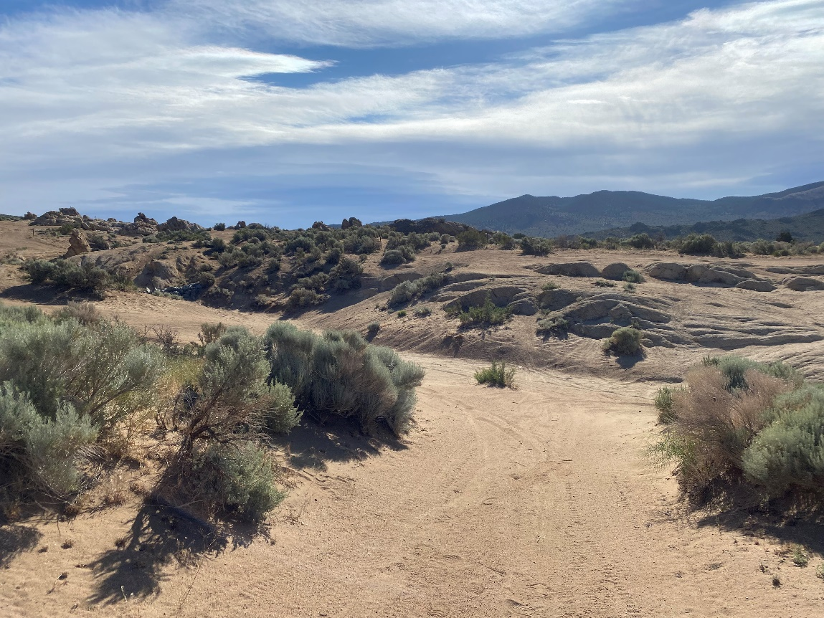
Photo Point 3 (view southwest): A photo point located north of the staging area on the east side of the road.
2020 Baseline Condition, photo taken January 24, 2020:
(GPS coordinates: 39.107231, -119.730827)
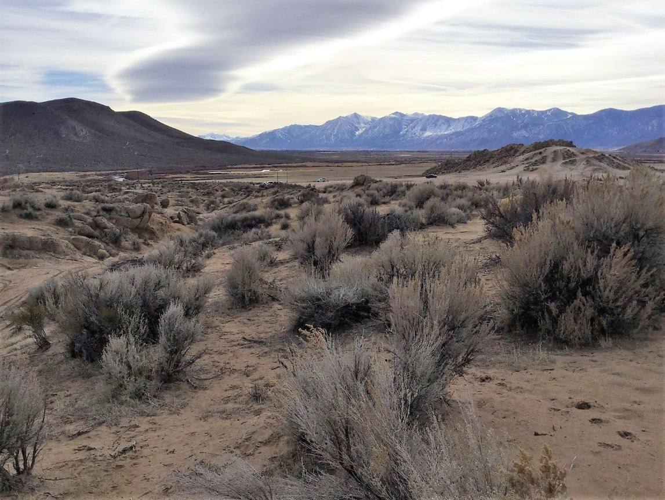

2022 Condition, photo taken June 17, 2022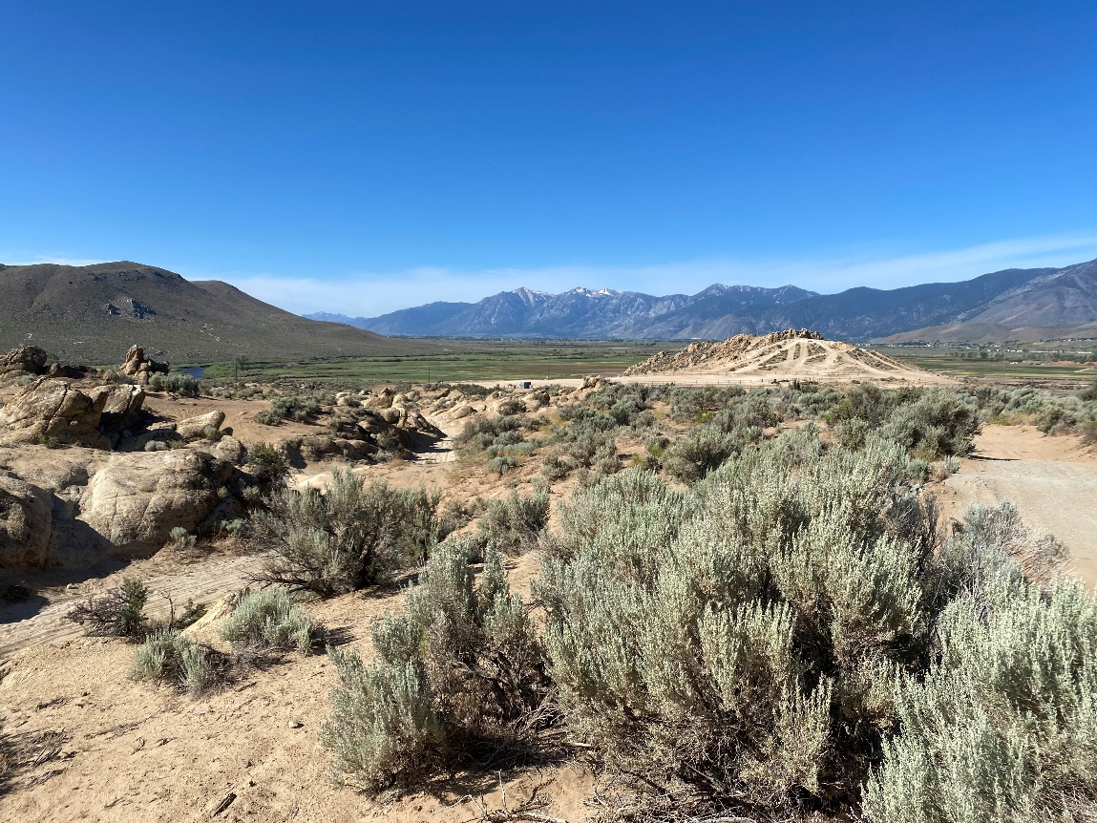
Photo Point 4 (view south): A photo point located west of Gunslinger Wheeler Trail.

2020 Baseline Condition, photo taken January 24, 2020:
(GPS coordinates: 39.111562, -119.733702)
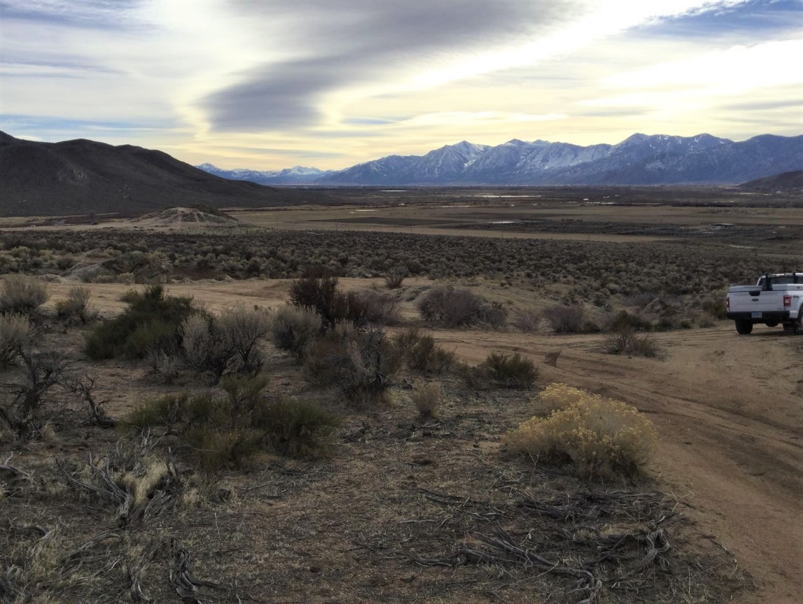

2022 Condition, photo taken June 17, 2022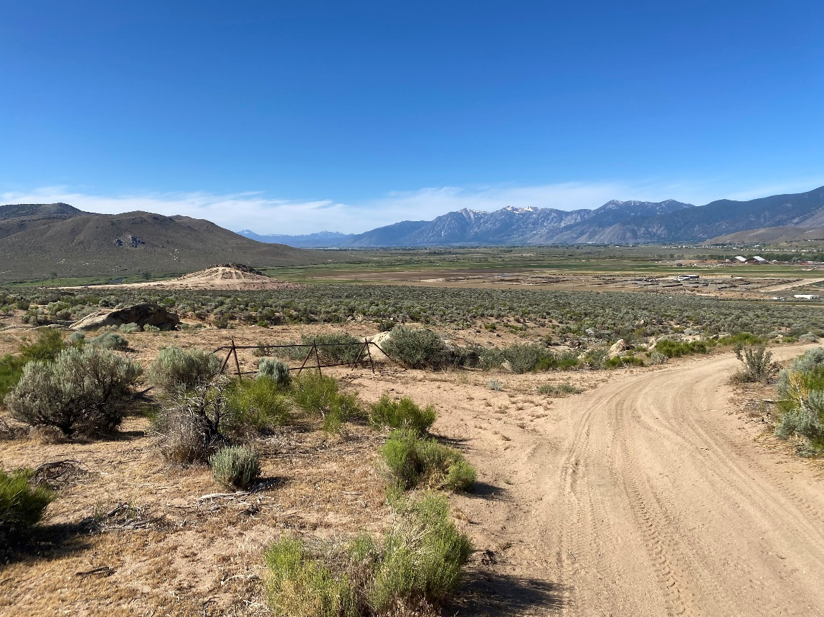
Photo Point 5A (view north): A photo point located at Rubber Side Up Wheeler Trail.

2020 Baseline Condition, photo taken January 24, 2020:
(GPS coordinates: 39.113363, -119.735607)
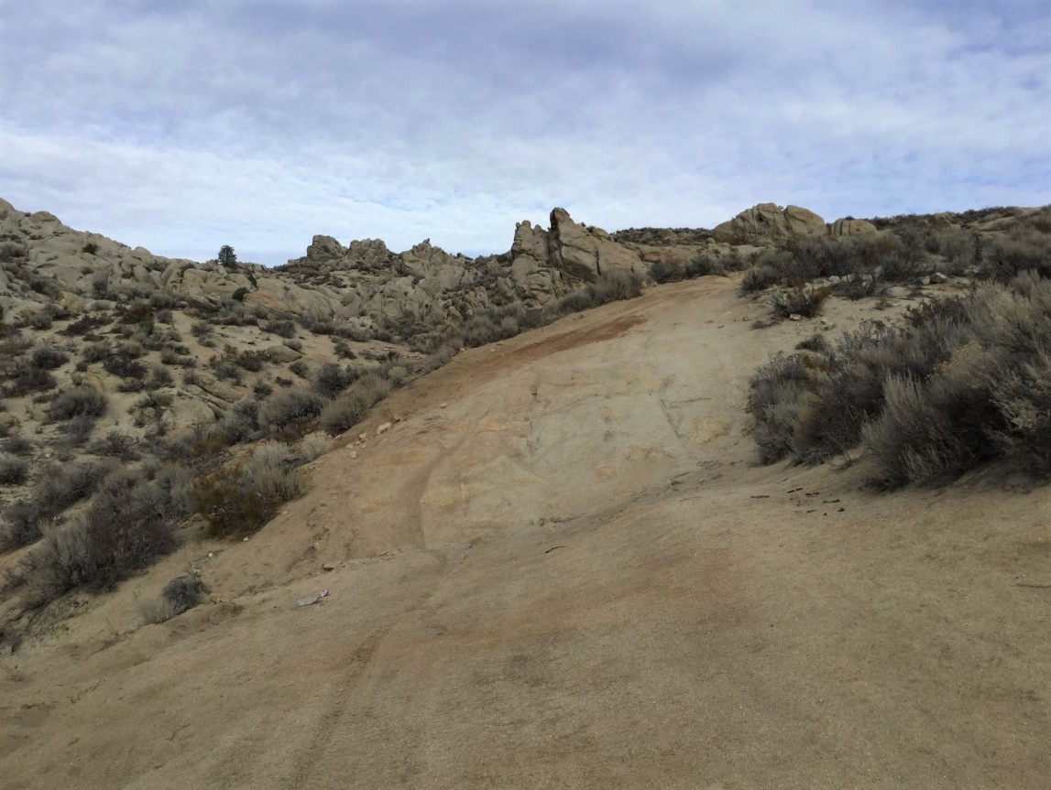

2022 Condition, photo taken June 17, 2022
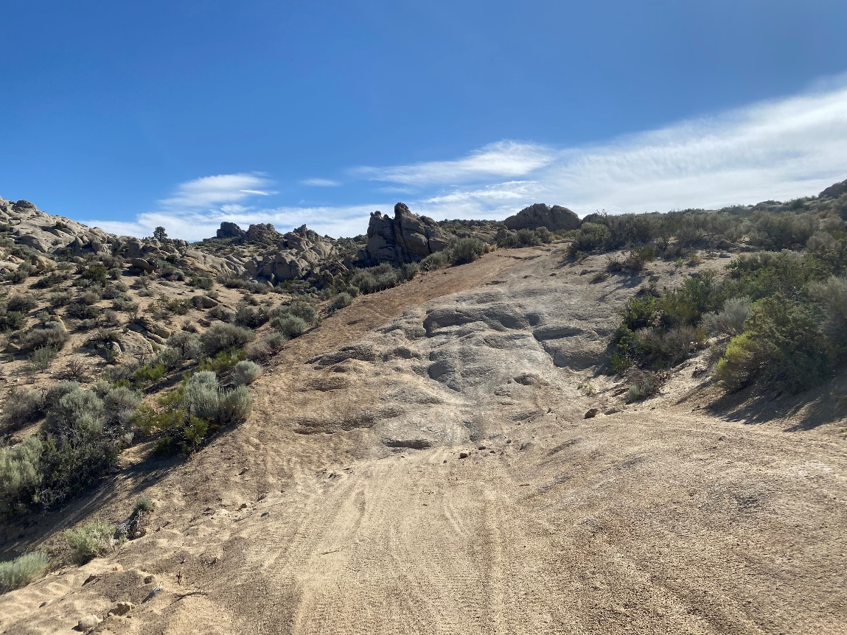
Photo Point 5B (view southwest): A photo point located at Rubber Side Up Wheeler Trail facing the prison.
2020 Baseline Condition, photo taken January 24, 2020:
(GPS coordinates: 39.113363, -119.735607)
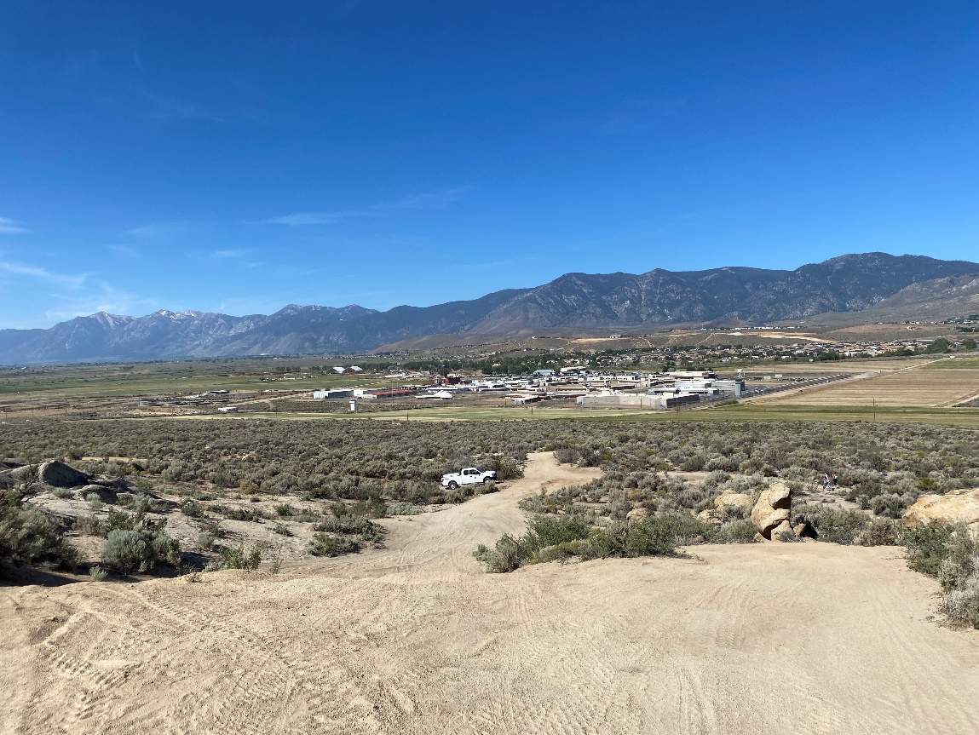

2021 Condition, photo taken June 21, 2021
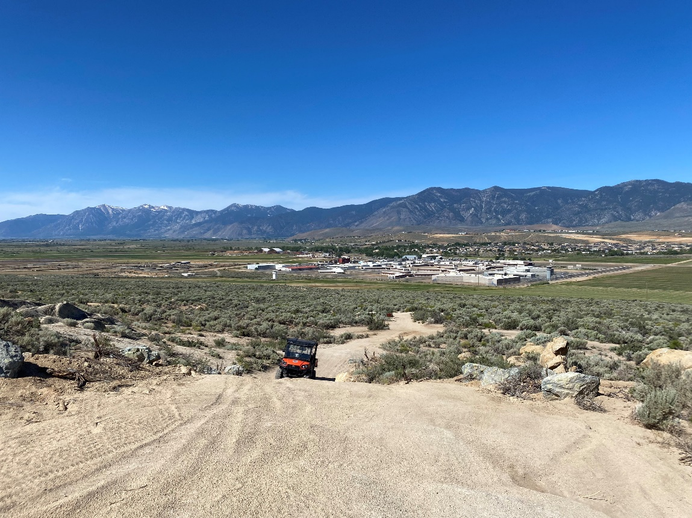
Photo Point 6 (view north): A photo point located at Rhino Rock.

2020 Baseline Condition, photo taken January 24, 2020:
(GPS coordinates: 39.111322, -119.735470)
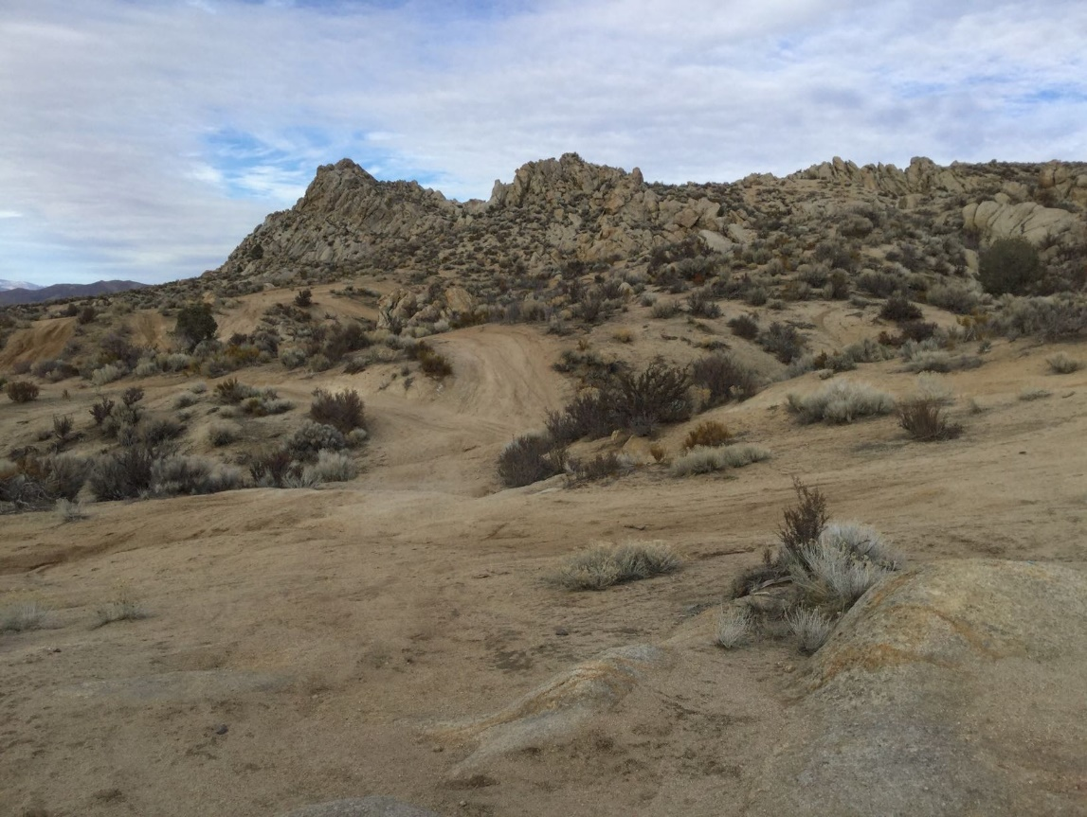

2022 Condition, photo taken June 17, 2022
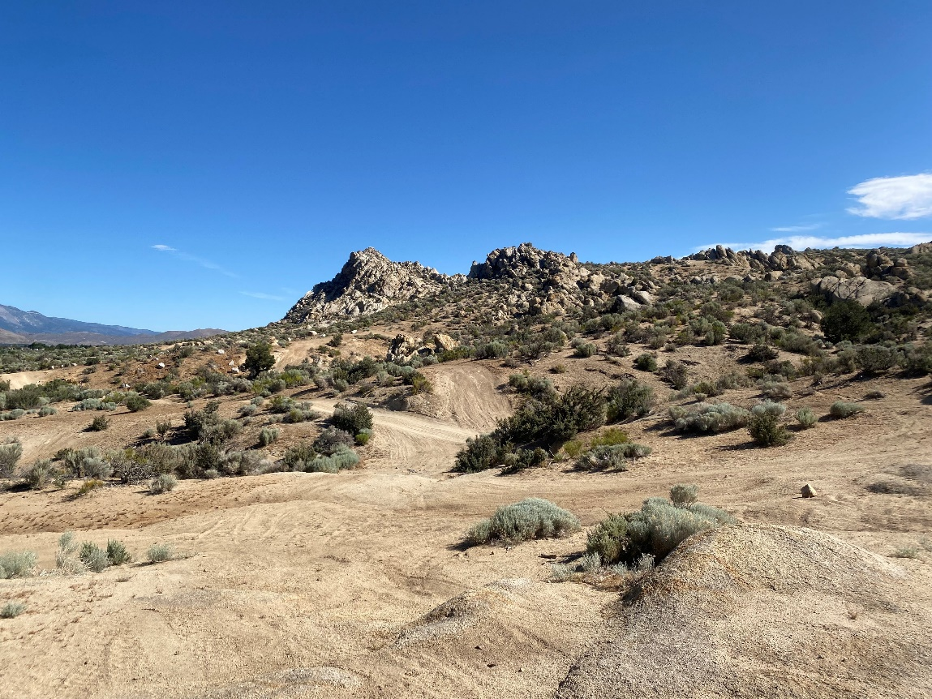
Photo Point 7A (view north): A photo point located at the entry way to the open area north of Cable Road.
2020 Baseline Condition, photo taken January 24, 2020:
(GPS coordinates: 39.110377, -119.728973)
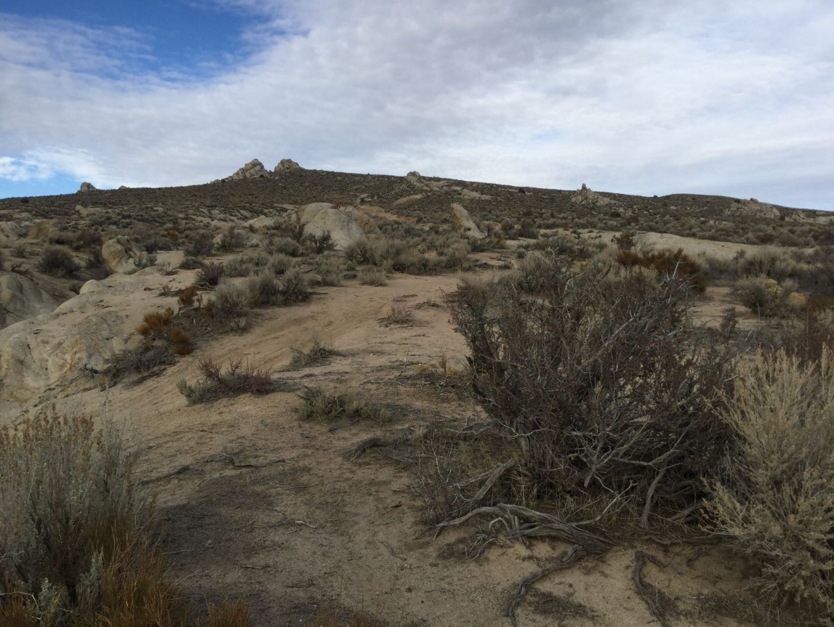

2022 Condition, photo taken June 17, 2022
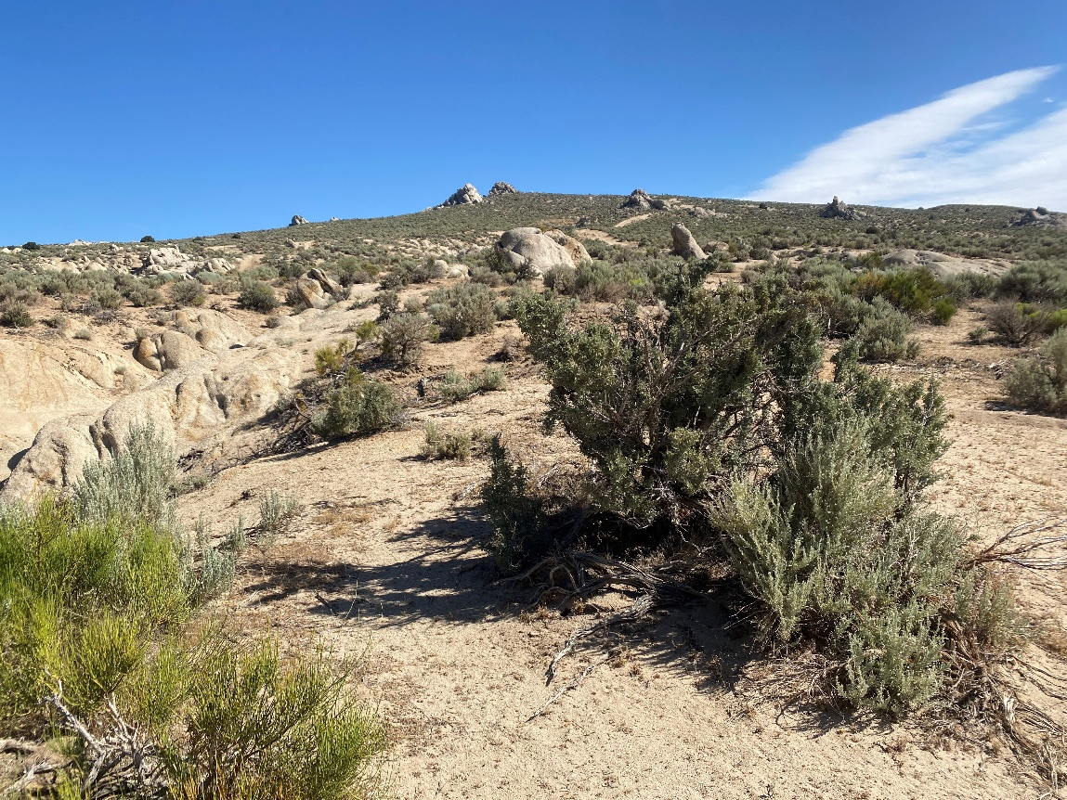
Photo Point 7B (view south): A photo point located at the entry way to the open area north of Cable Road.
2020 Baseline Condition, photo taken January 24, 2020:
(GPS coordinates: 39.110377, -119.728973)
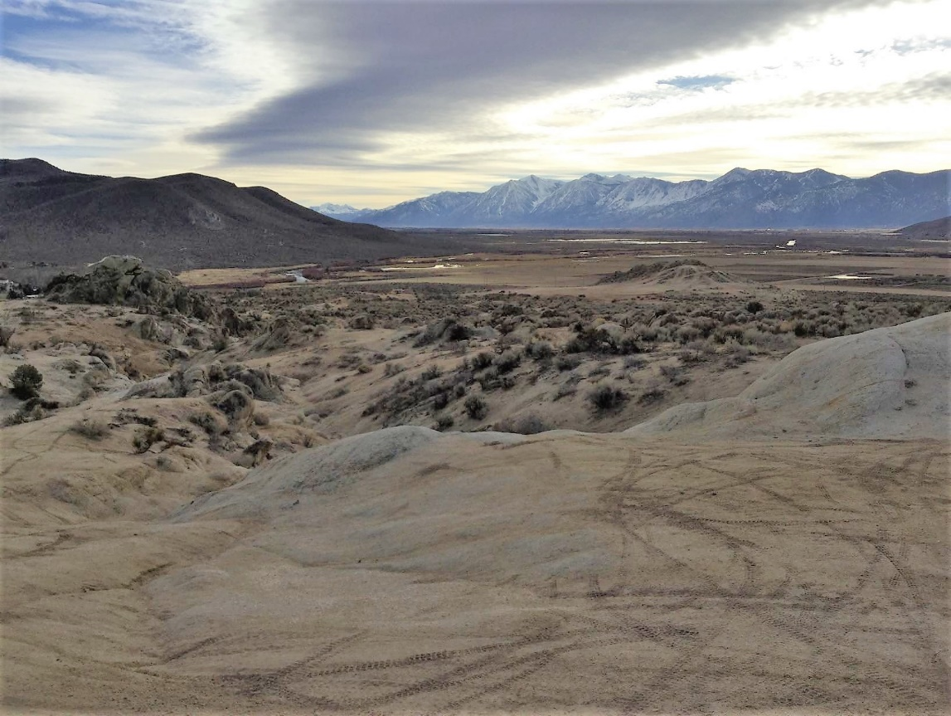

2022 Condition, photo taken June 17, 2022
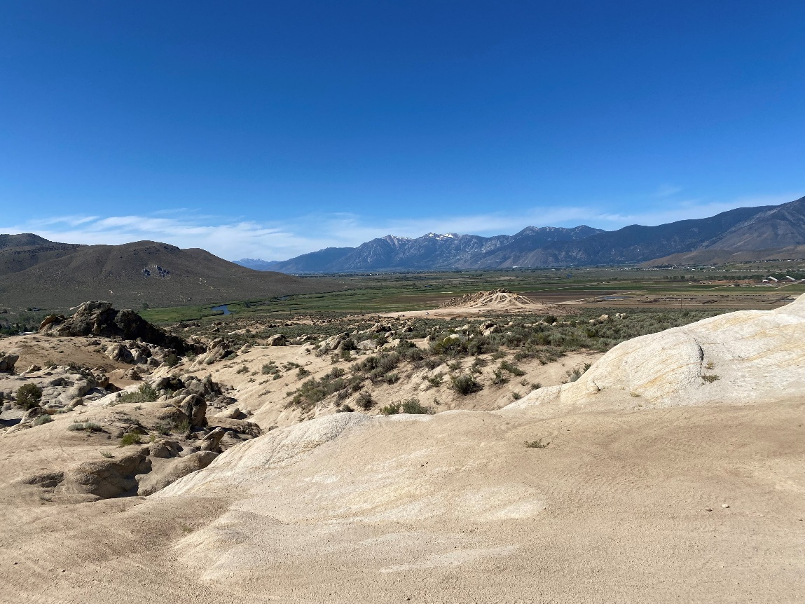
Photo Point 8A (view west): A photo point located at Golden Eagle Rock.

2020 Baseline Condition, photo taken January 24, 2020:
(GPS coordinates: 39.118457, -119.728973)
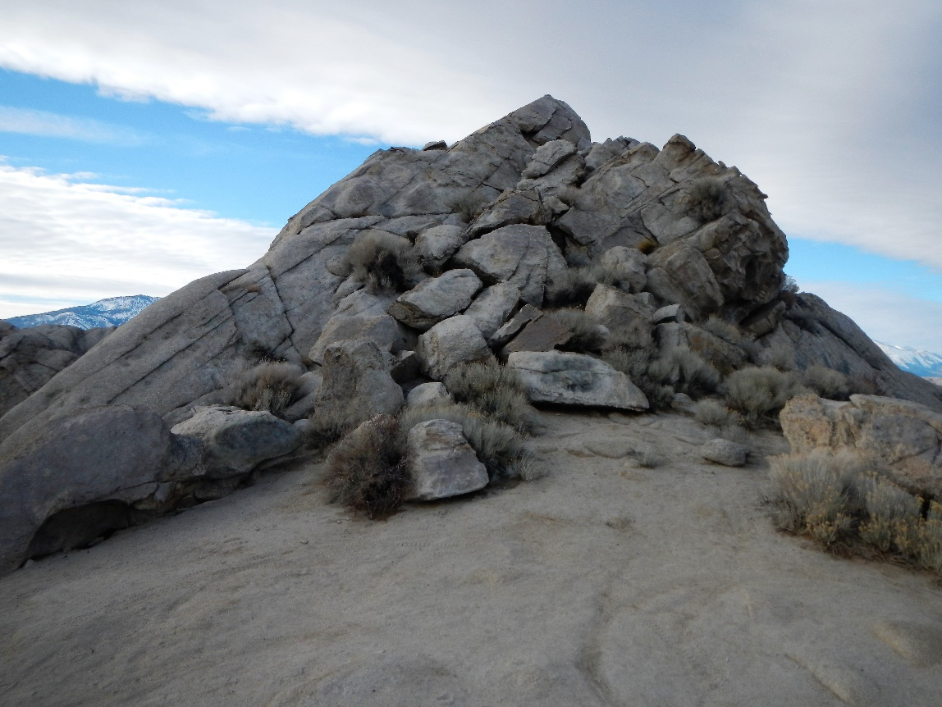

2022 Condition, photo taken June 17, 2022
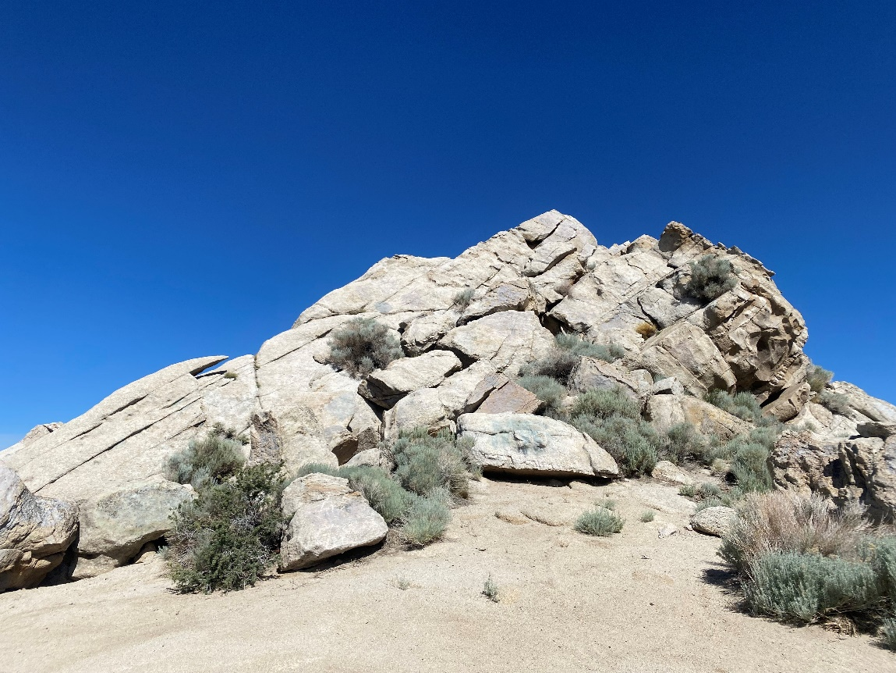
Photo Point 8B (view east): A photo point located at Golden Eagle Rock.

2020 Baseline Condition, photo taken January 24, 2020:
(GPS coordinates: 39.118457, -119.728973)
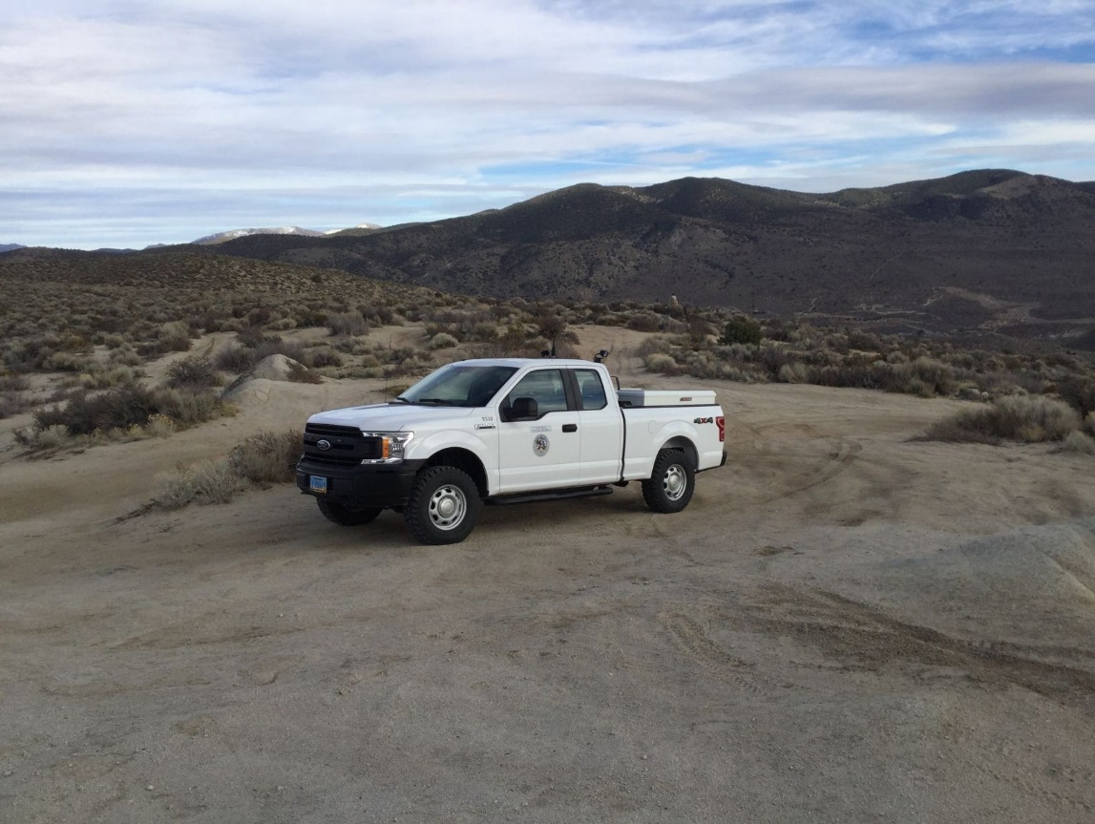

2022 Condition, photo taken June 17, 2022
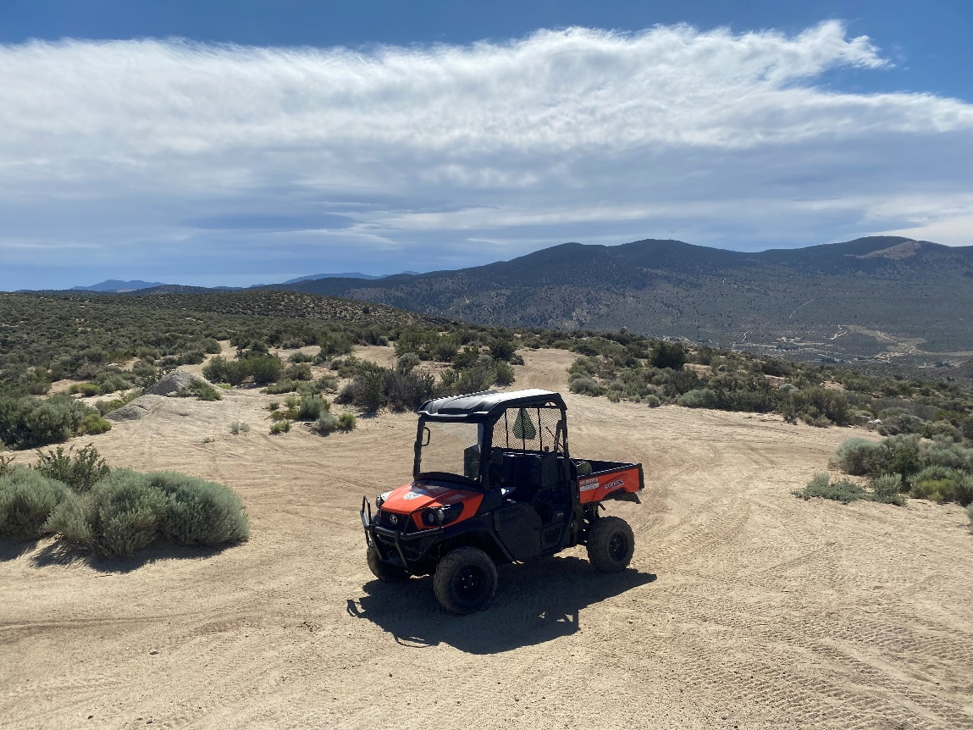
Photo Point 8C (view south): A photo point located at Golden Eagle Rock.

2020 Baseline Condition, photo taken January 24, 2020:
(GPS coordinates: 39.118457, -119.728973)
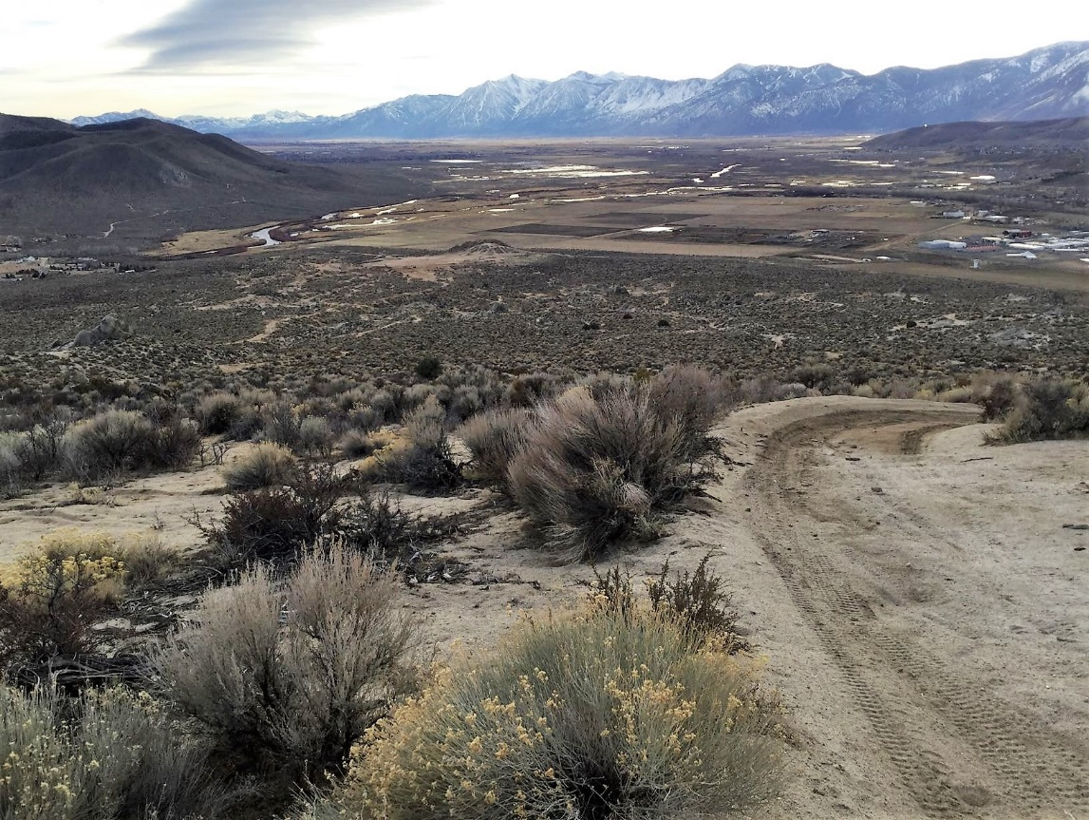

2022 Condition, photo taken June 17, 2022
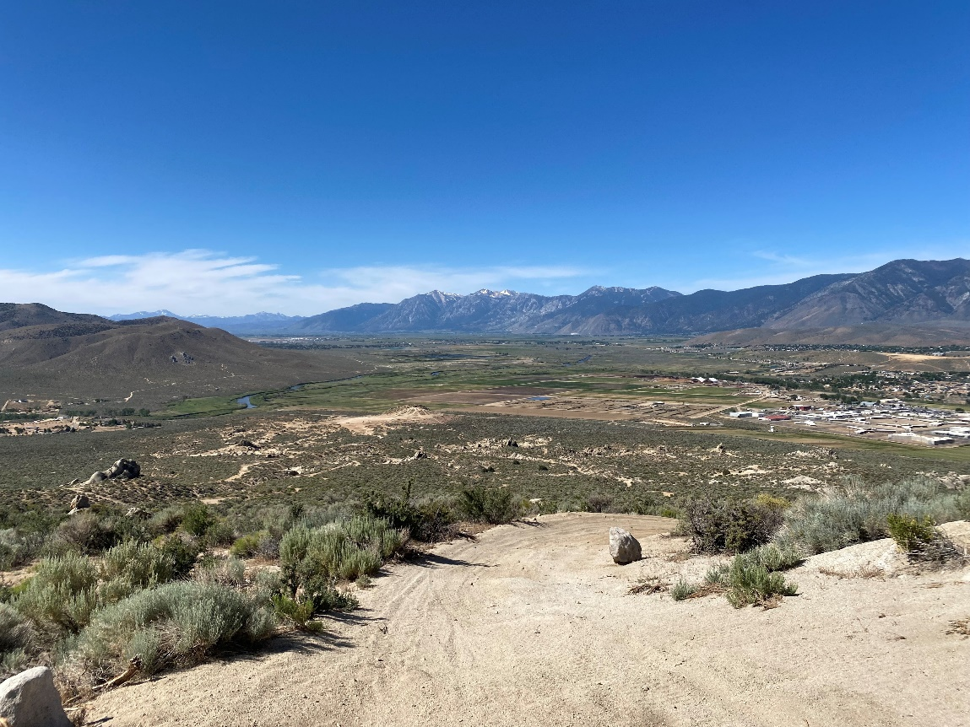
Photo Point 9A (view west): A photo point located at the Prison Hill Summit.

2020 Baseline Condition, photo taken January 24, 2020:
(GPS coordinates: 39.126752, -119.722705)
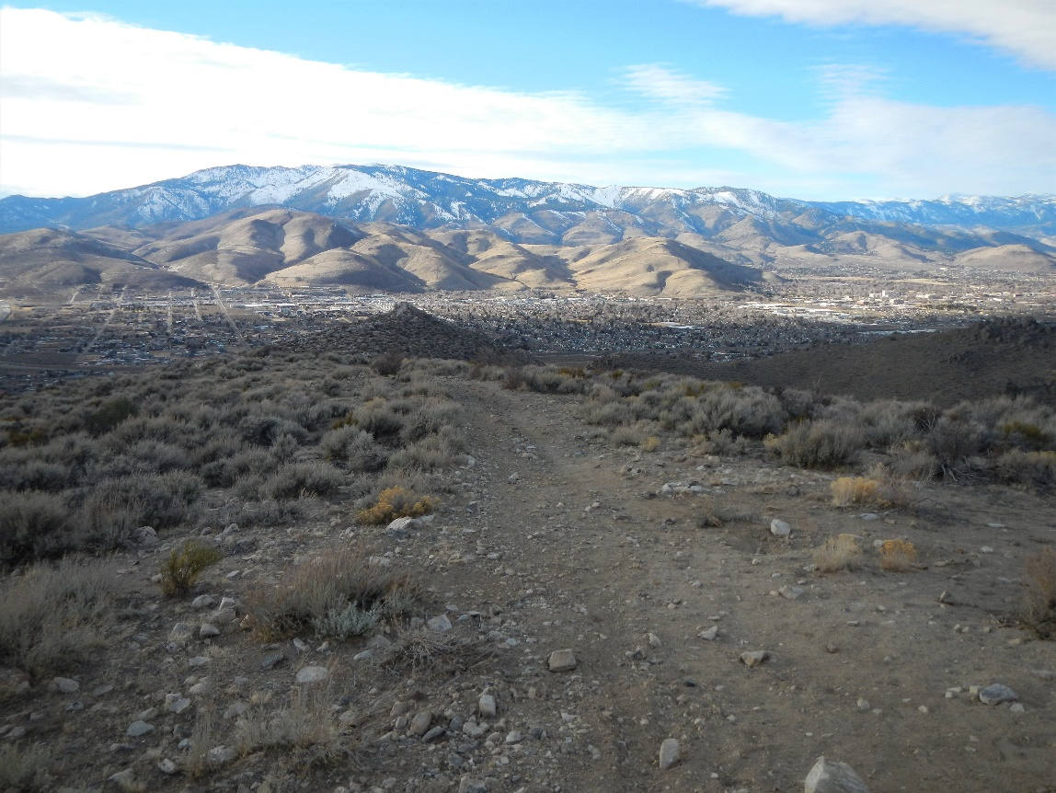

2022 Condition, photo taken June 17, 2022
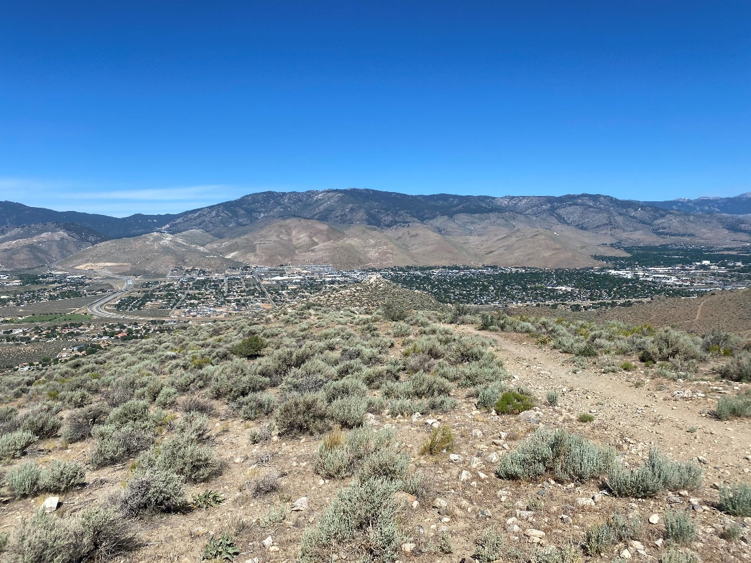
Photo Point 9B (view south): A photo point located at the Prison Hill Summit.

2020 Baseline Condition, photo taken January 24, 2020:
(GPS coordinates: 39.126752, -119.722705)
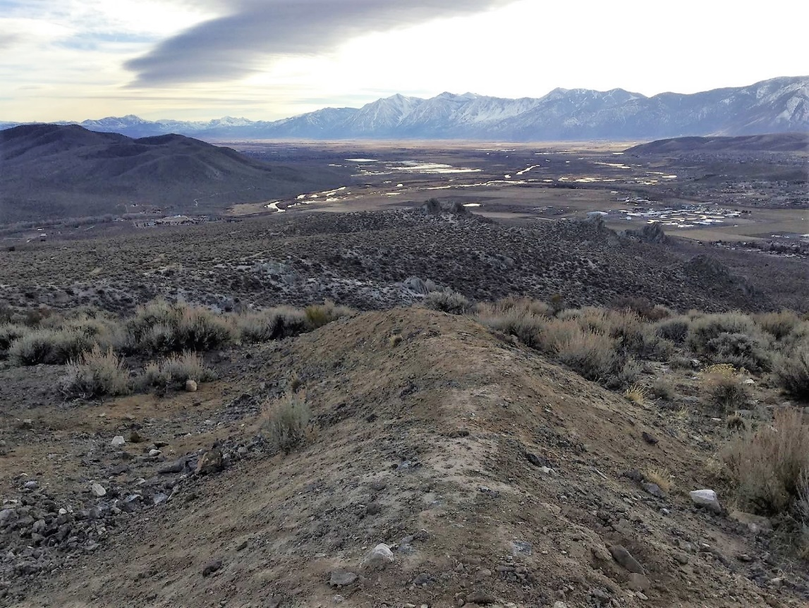

2022 Condition, photo taken June 17, 2022
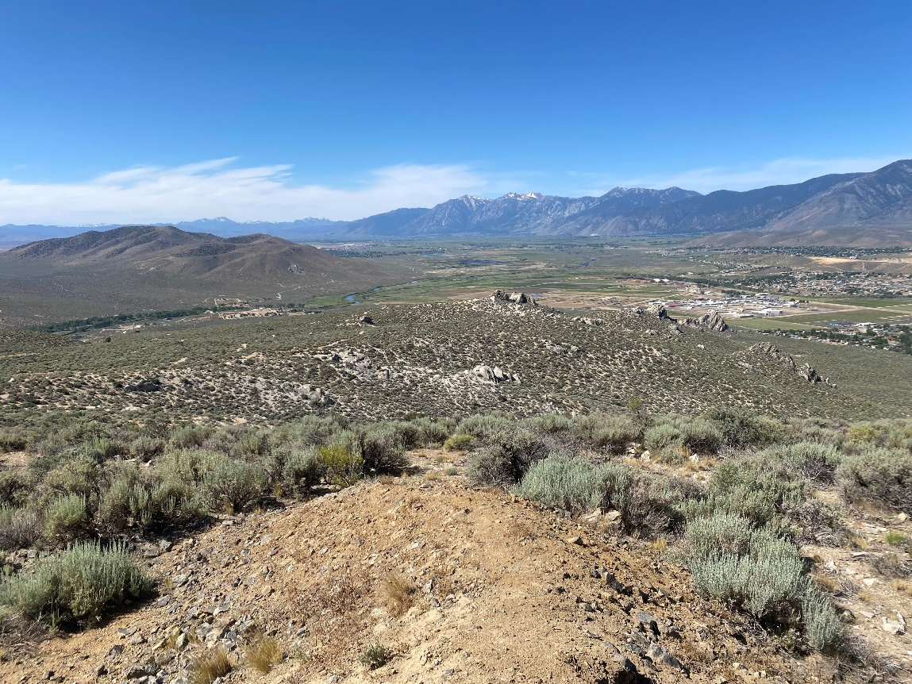
Photo Point 9C (view east): A photo point located at the Prison Hill Summit.

2020 Baseline Condition, photo taken January 24, 2020:
(GPS coordinates: 39.126752, -119.722705)
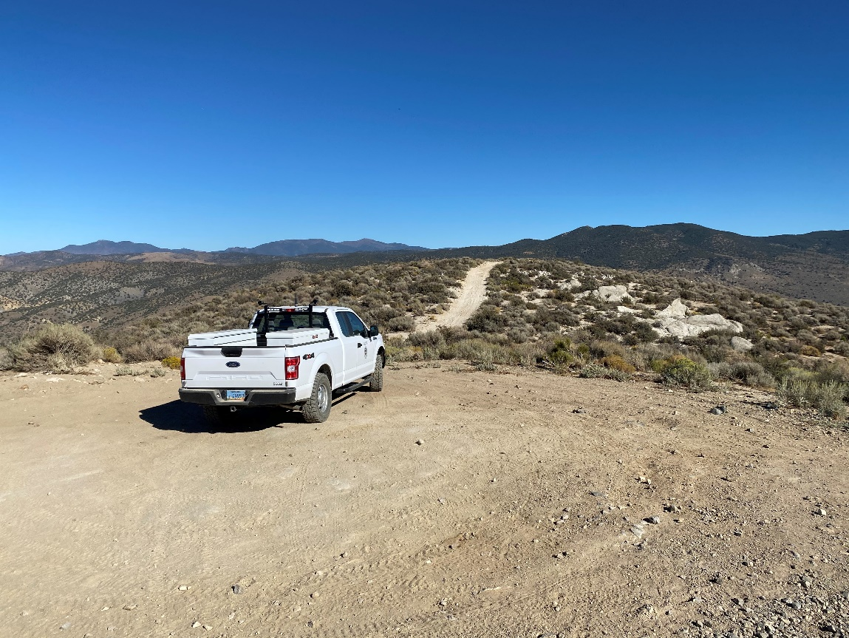

2022 Condition, photo taken June 17, 2022
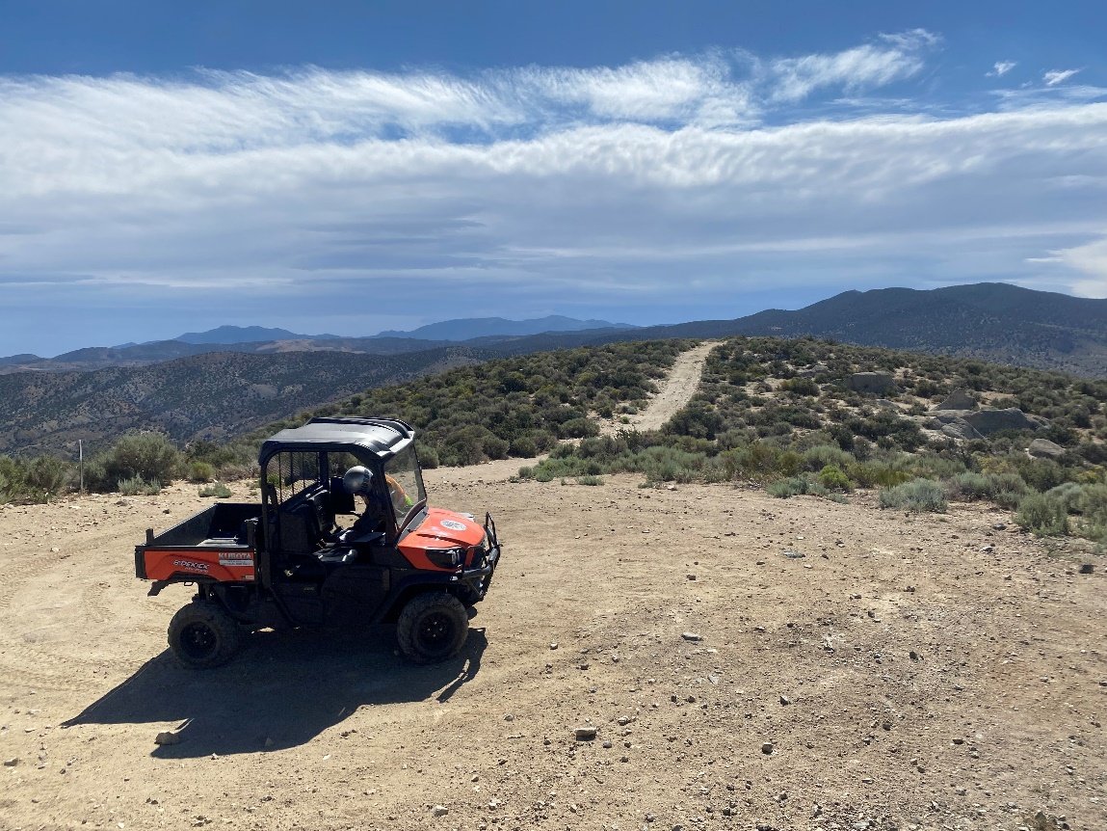
Photo Point 10A (view east): A photo point located above Golden Eagle Open Space and the erosion control project.
2020 Baseline Condition, photo taken January 24, 2020:
(GPS coordinates: 39.108428, -119.716747)
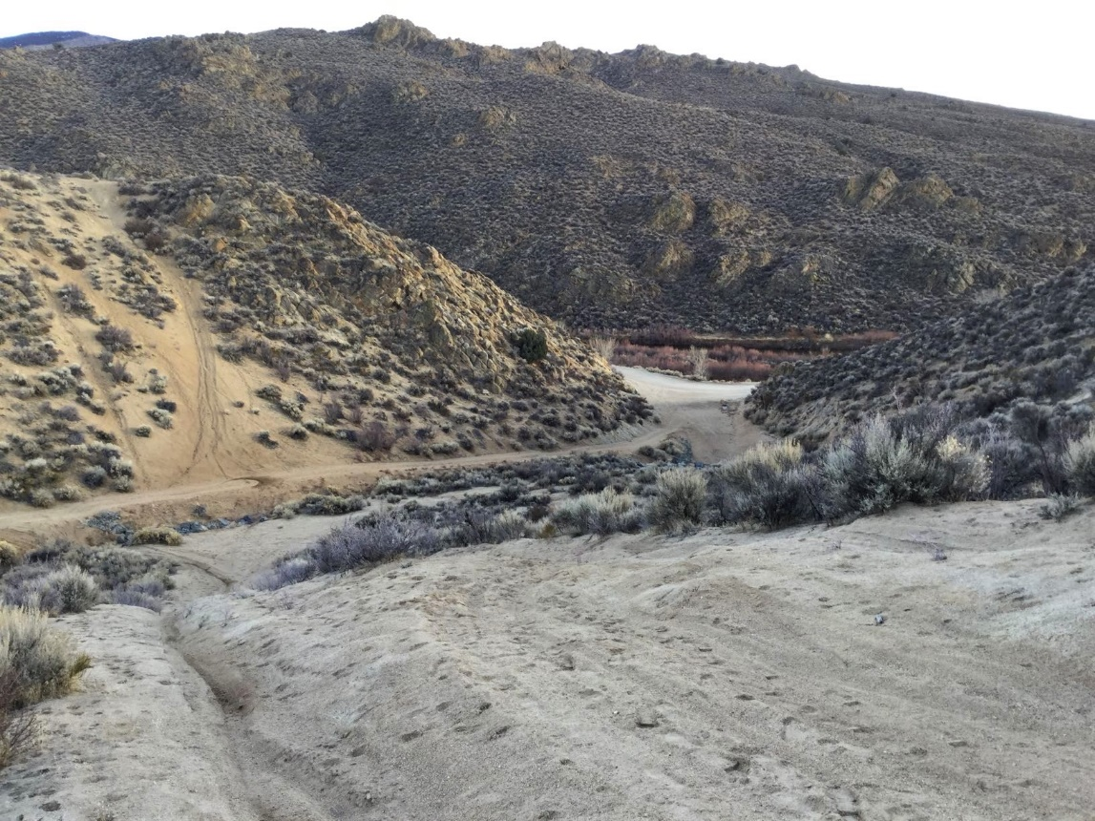

2022 Condition, photo taken June 17, 2022
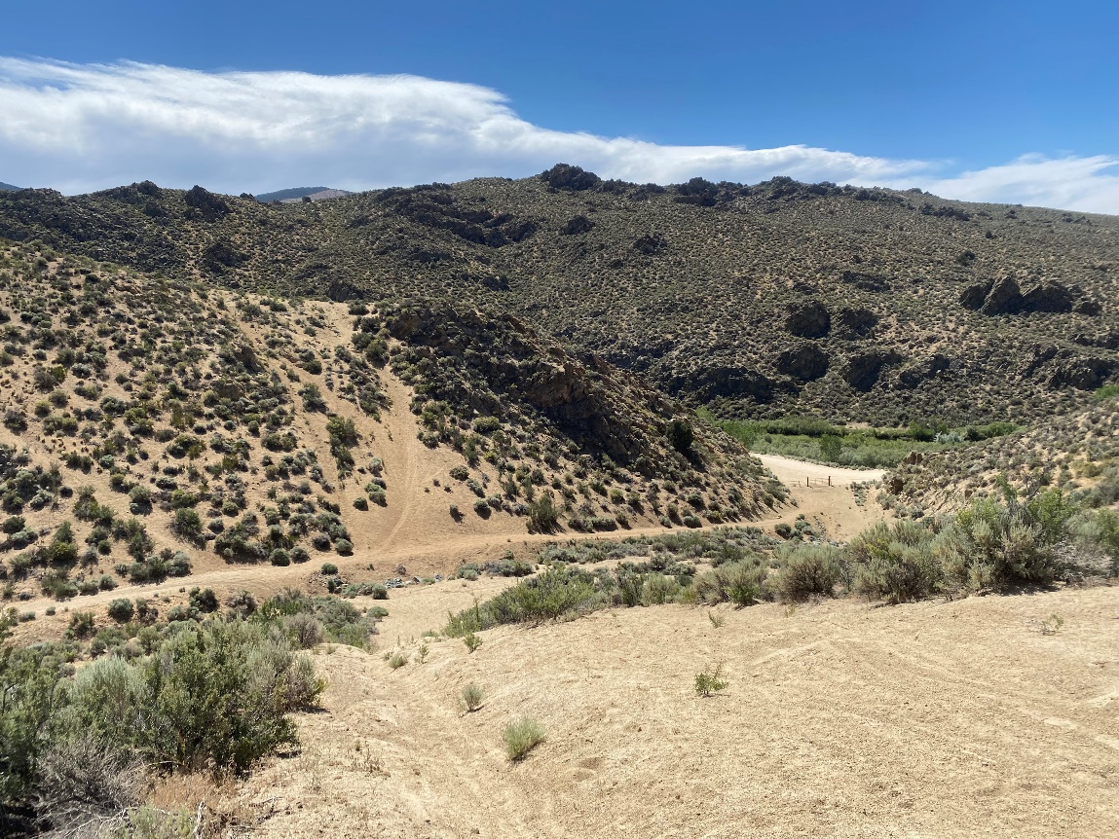
Photo Point 10B (view north): A photo point located above Golden Eagle Open Space and the erosion control project.
2020 Baseline Condition, photo taken January 24, 2020:
(GPS coordinates: 39.108428, -119.716747)
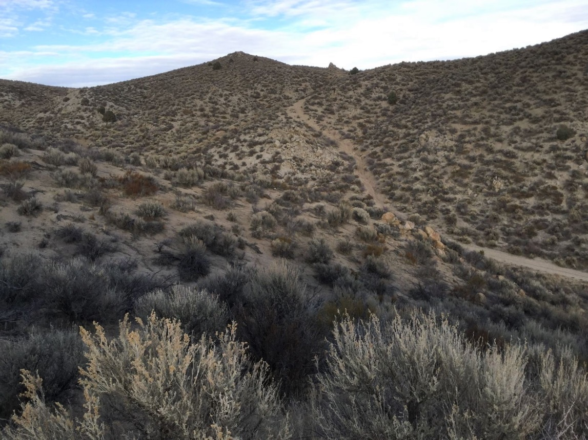

2022 Condition, photo taken June 17, 2022
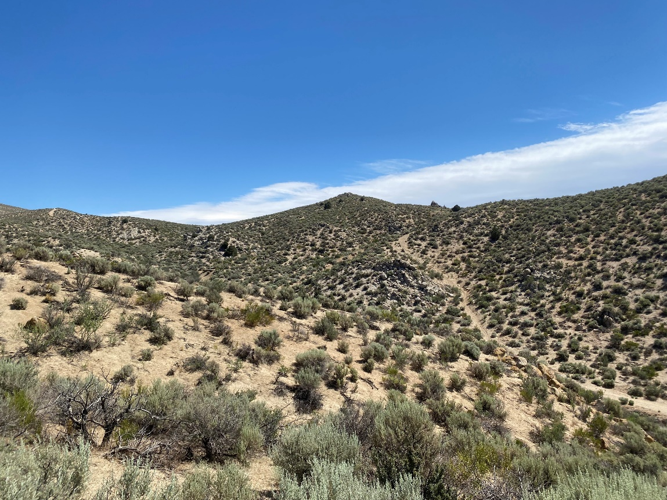
Photo Point 11A (view north): A photo point located in the largest open area, just south of Cable Road.
2020 Baseline Condition, photo taken January 24, 2020:
(GPS coordinates: 39.109063, -119.728908)
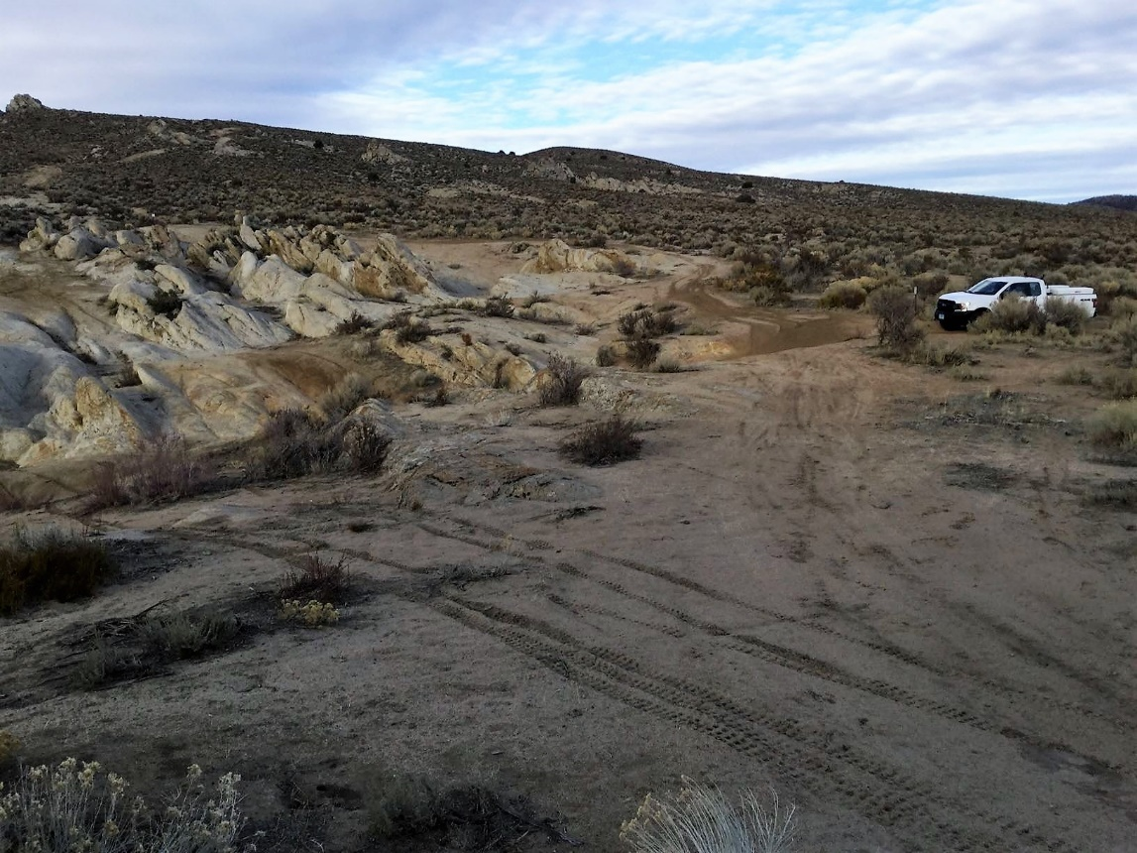

2022 Condition, photo taken June 17, 2022
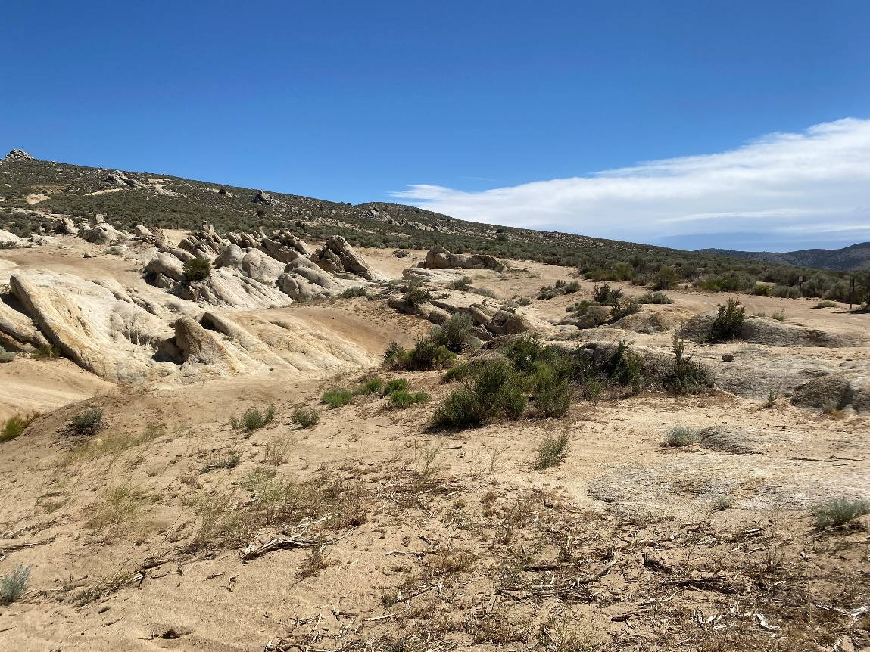
Photo Point 11B (view northwest): A photo point located in the largest open area, just south of Cable Road.
2020 Baseline Condition, photo taken January 24, 2020:
(GPS coordinates: 39.109063, -119.728908)
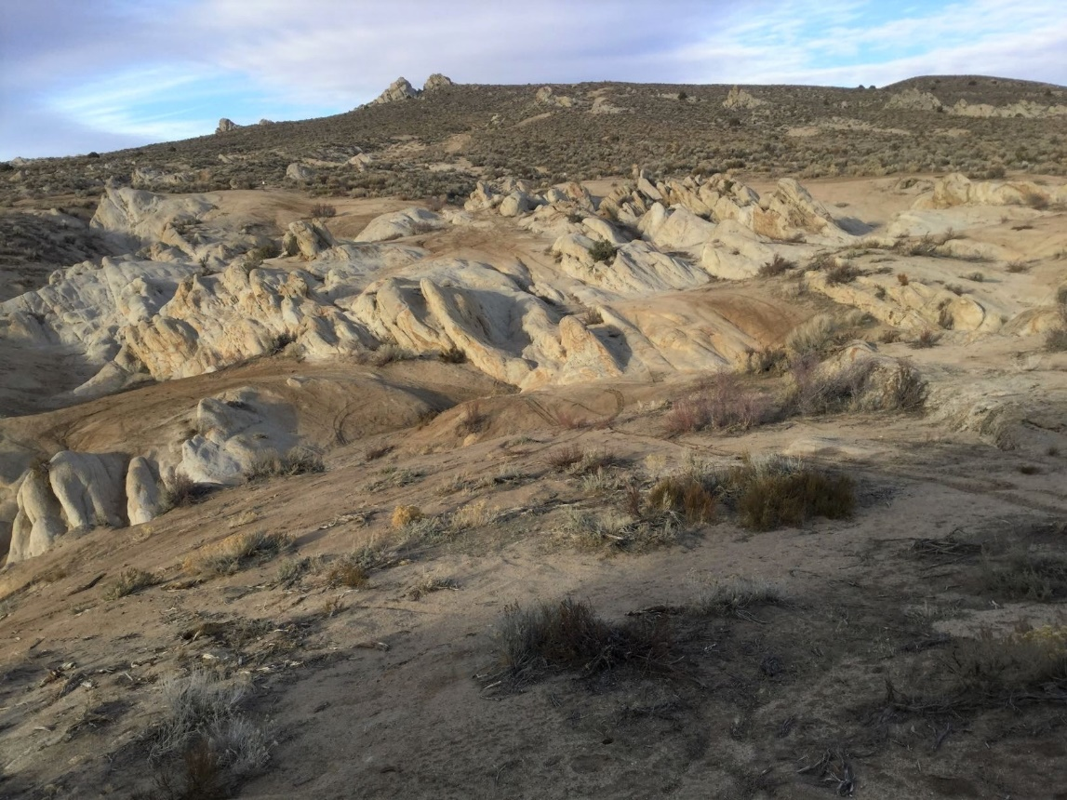

2022 Condition, photo taken June 17, 2022
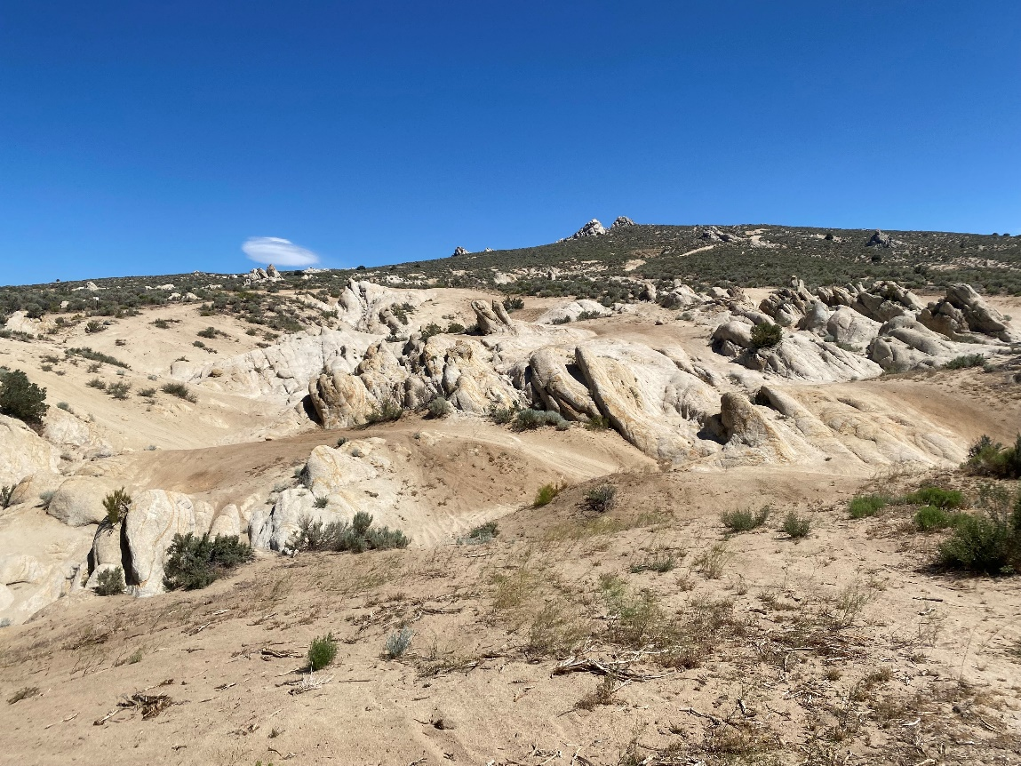
Photo Point 11C (view southwest): A photo point located in the largest open area, just south of Cable Road. Walk up to the lookout rock to frame photo correctly.
2020 Baseline Condition, photo taken January 24, 2020:
(GPS coordinates: 39.109063, -119.728908)
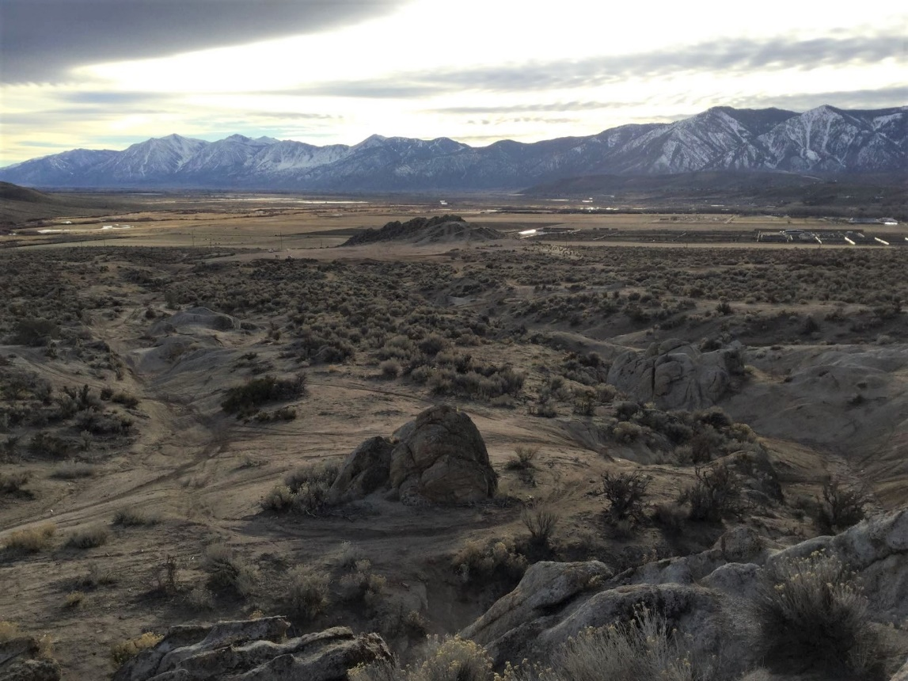

2022 Condition, photo taken June 17, 2022
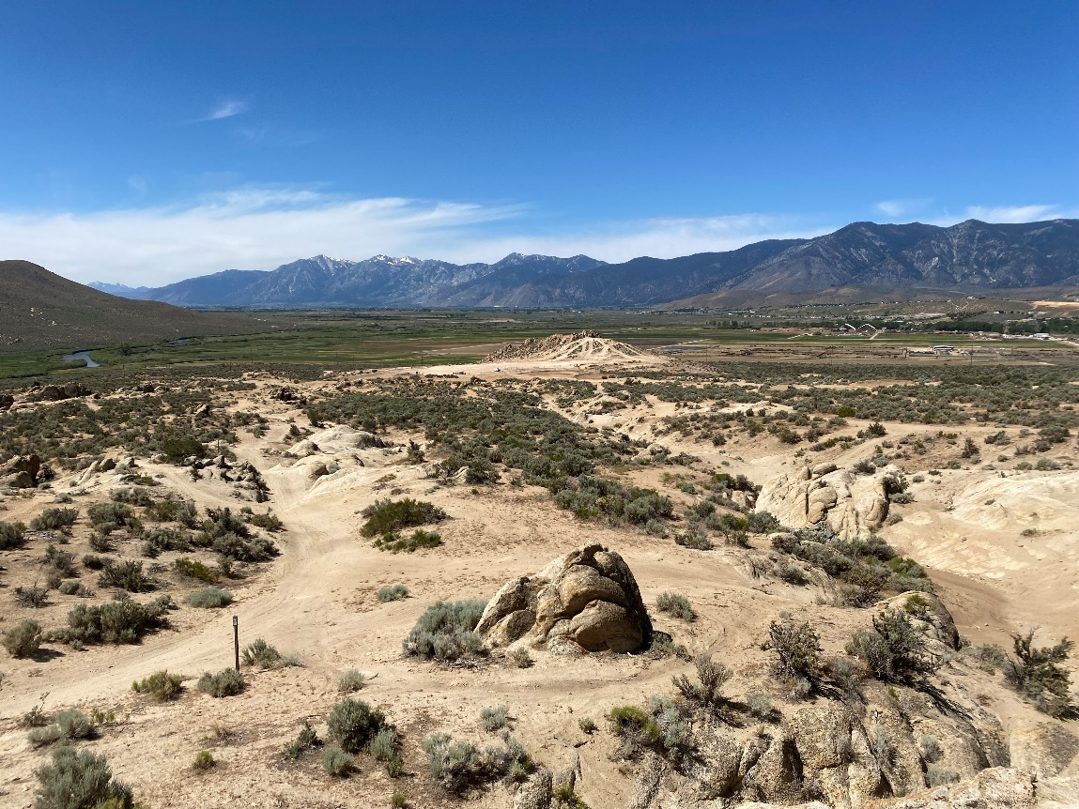
Photo Point 12A (view east): A photo point located south of the largest open area on the east side of the drainage.
2020 Baseline Condition, photo taken January 24, 2020:
(GPS coordinates: 39.103478, -119.731260)
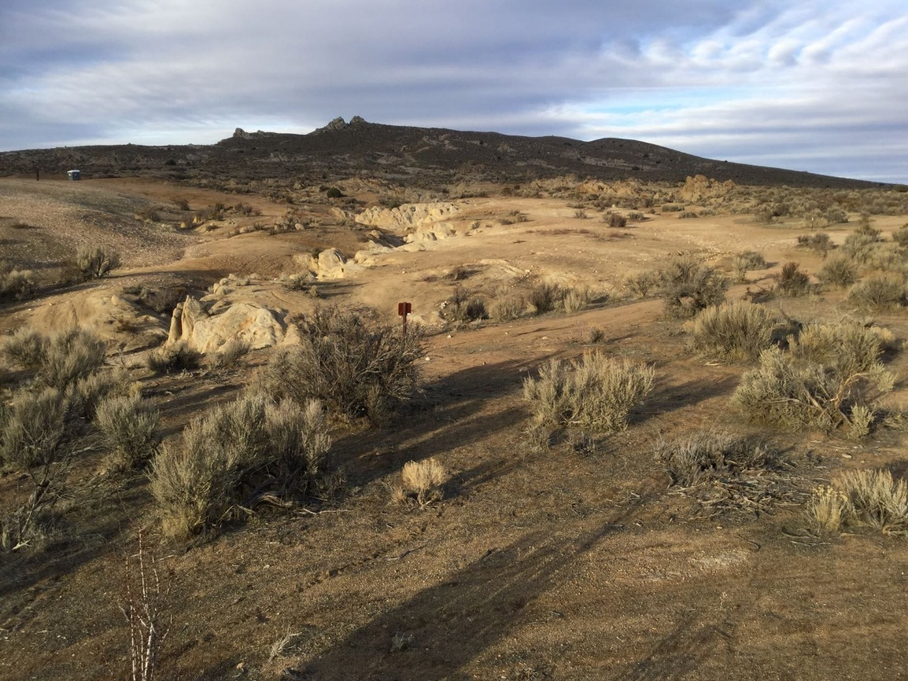

2022 Condition, photo taken June 17, 2022
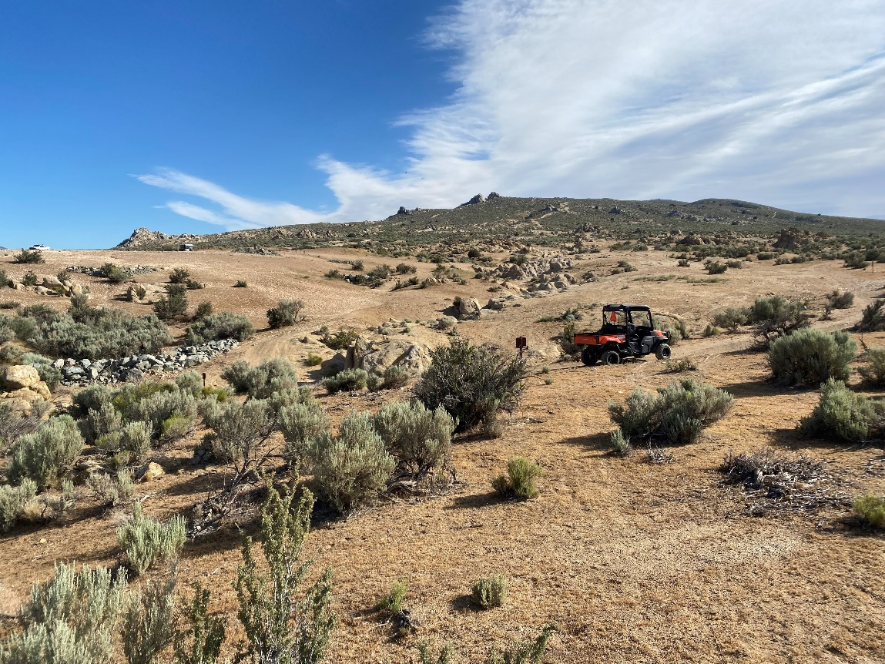
Photo Point 12B (view northwest): A photo point located south of the largest open area on the east side of the drainage.
2020 Baseline Condition, photo taken January 24, 2020:
(GPS coordinates: 39.103478, -119.731260)
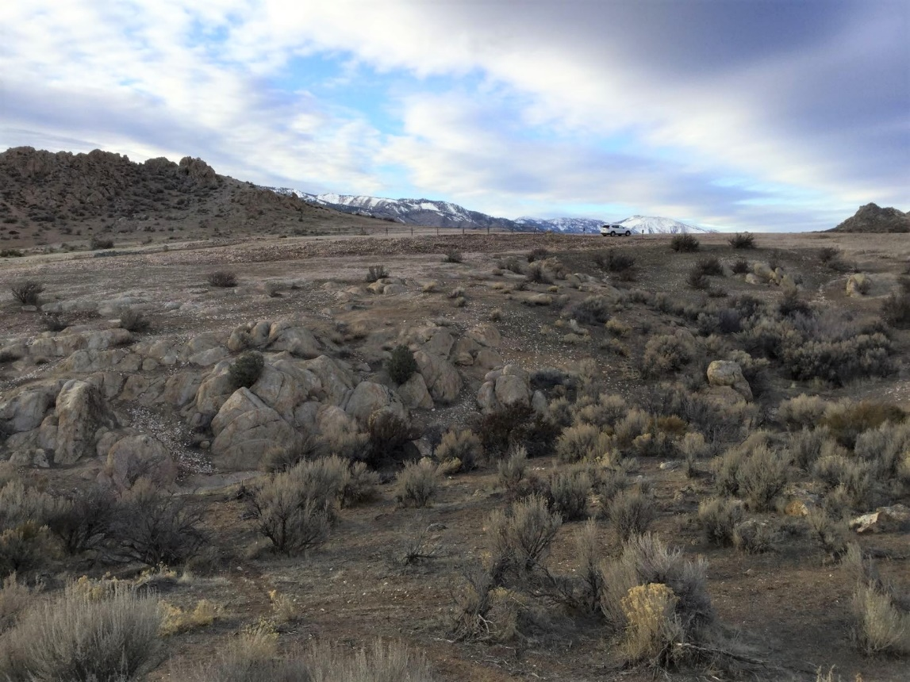

2022 Condition, photo taken June 17, 2022
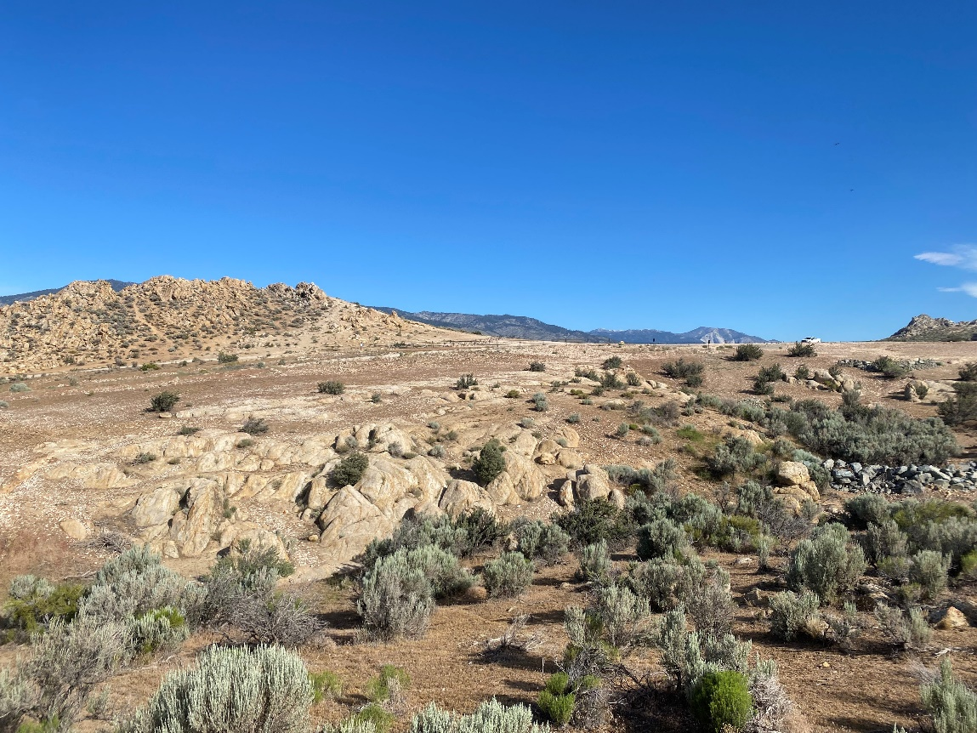
Photo Point 13 (view east): A photo point located at the closed-off western access point adjacent to Golden Eagle Lane.
2020 Baseline Condition, photo taken January 24, 2020:
(GPS coordinates: 39.104735, -119.735214)
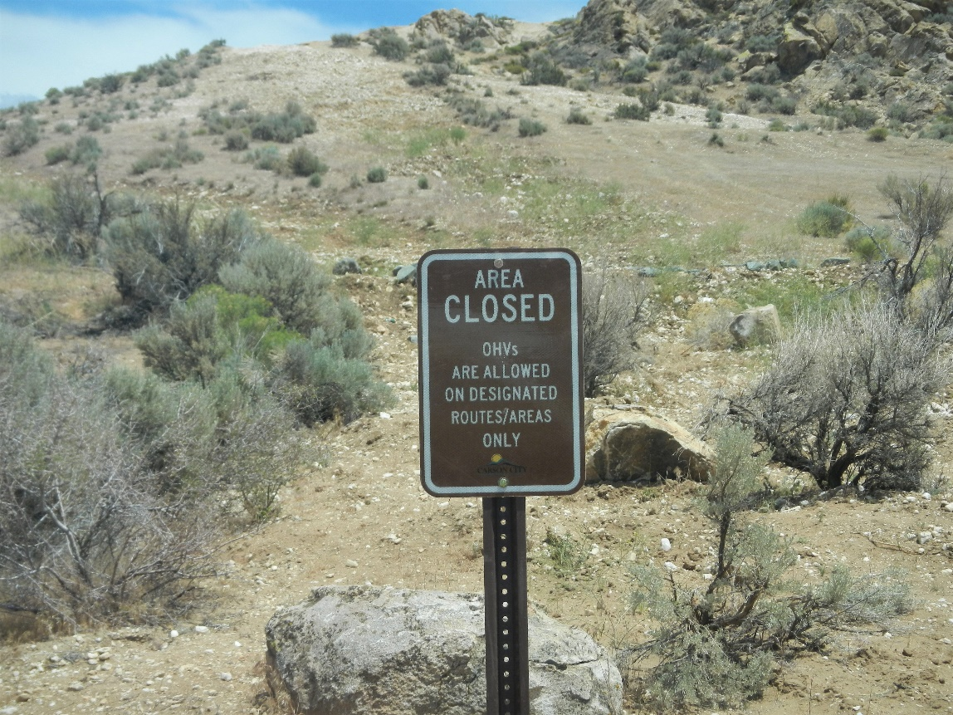

2022 Condition, photo taken June 17, 2022
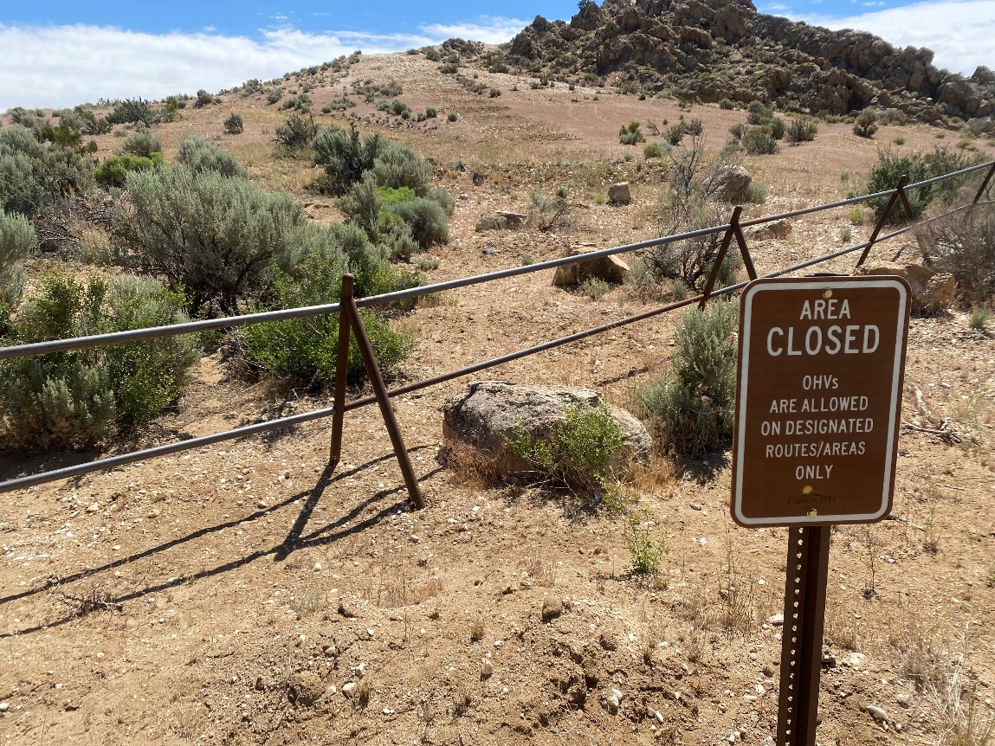
Photo Point 14 (view north): A photo point located at the closed section of the main road, north of Cable Road.
2020 Baseline Condition, photo taken January 24, 2020:
(GPS coordinates: 39.109900, -119.730203)
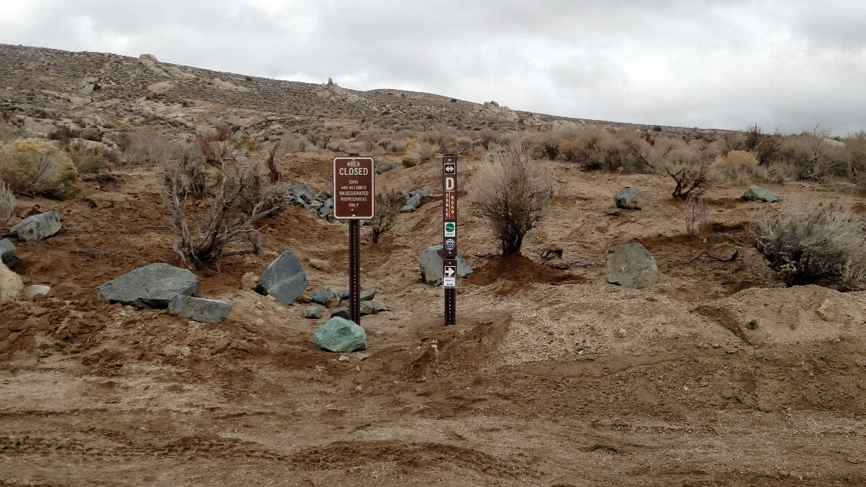

2022 Condition, photo taken June 17, 2022
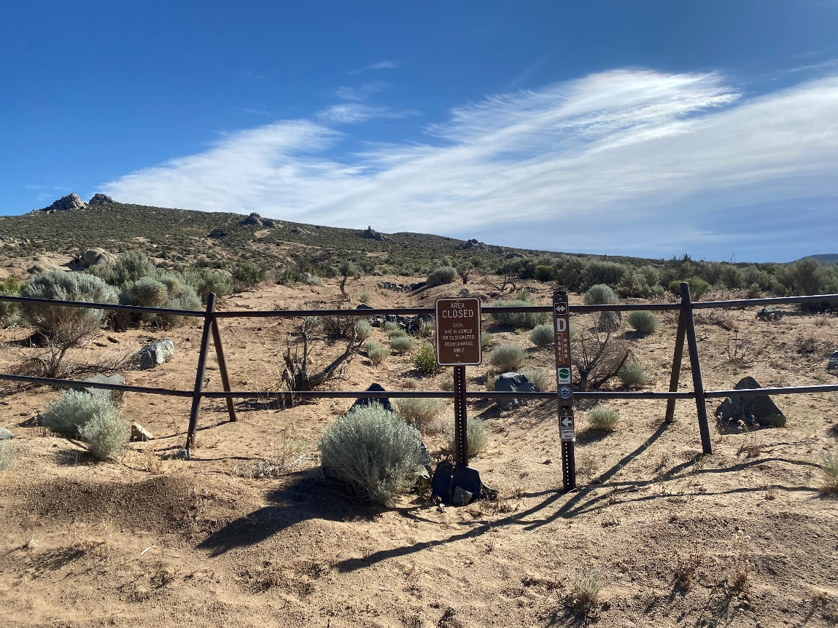

Photo Point 15A (view east): A photo point located off Topsy Lane above Center Drive to capture the full extent of the West Basin.

2020 Baseline Condition, photo taken February 1, 2020:
(GPS coordinates: 39.110186, -119.762719)
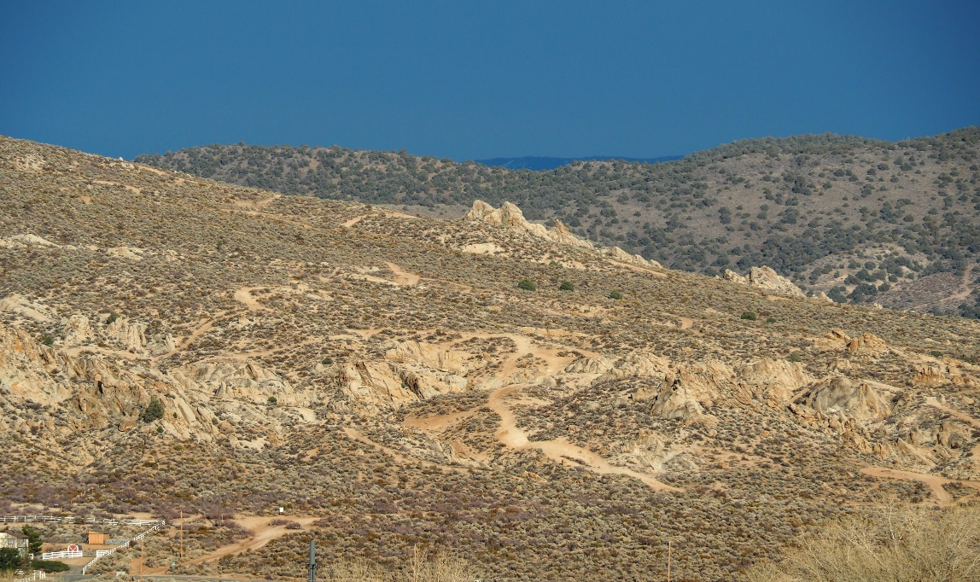

2022 Condition, photo taken June 22, 2022
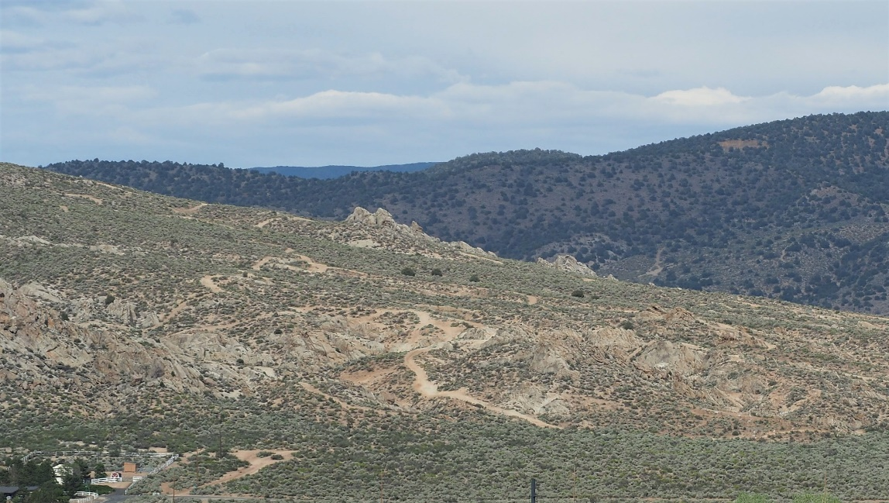

Photo Point 15B (view east): A photo point located off Topsy Lane above Center Drive that shows the entire west side of Prison Hill (panoramic).

2020 Baseline Condition, photo taken February 1, 2020:  (GPS coordinates: 39.110186, -119.762719)  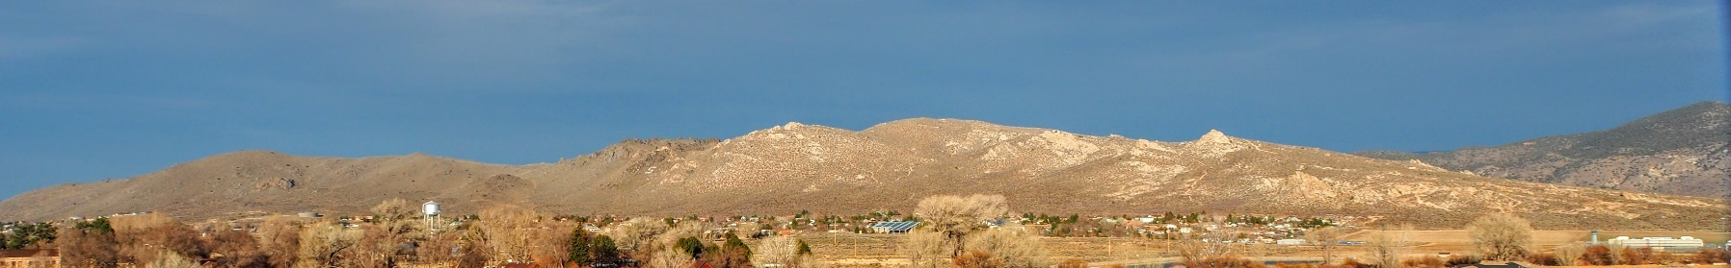 | 2022 Condition, photo taken June 22, 2022  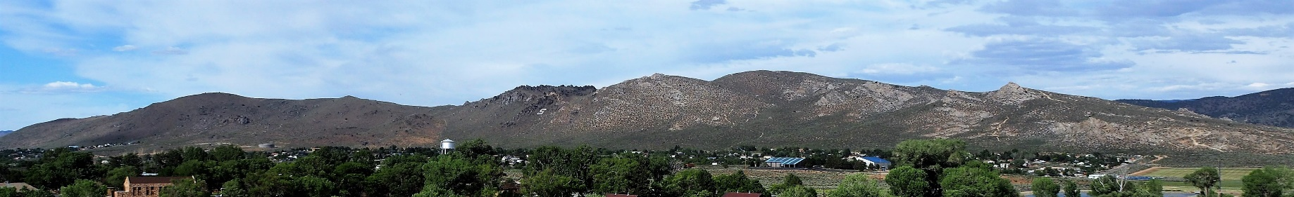

Photo Point 16 (view east): A photo point located at the Snyder Entrance taken from the mailboxes.
2021 Baseline Condition, photo taken June 17, 2021:
(GPS coordinates: 39.114, -119.739)
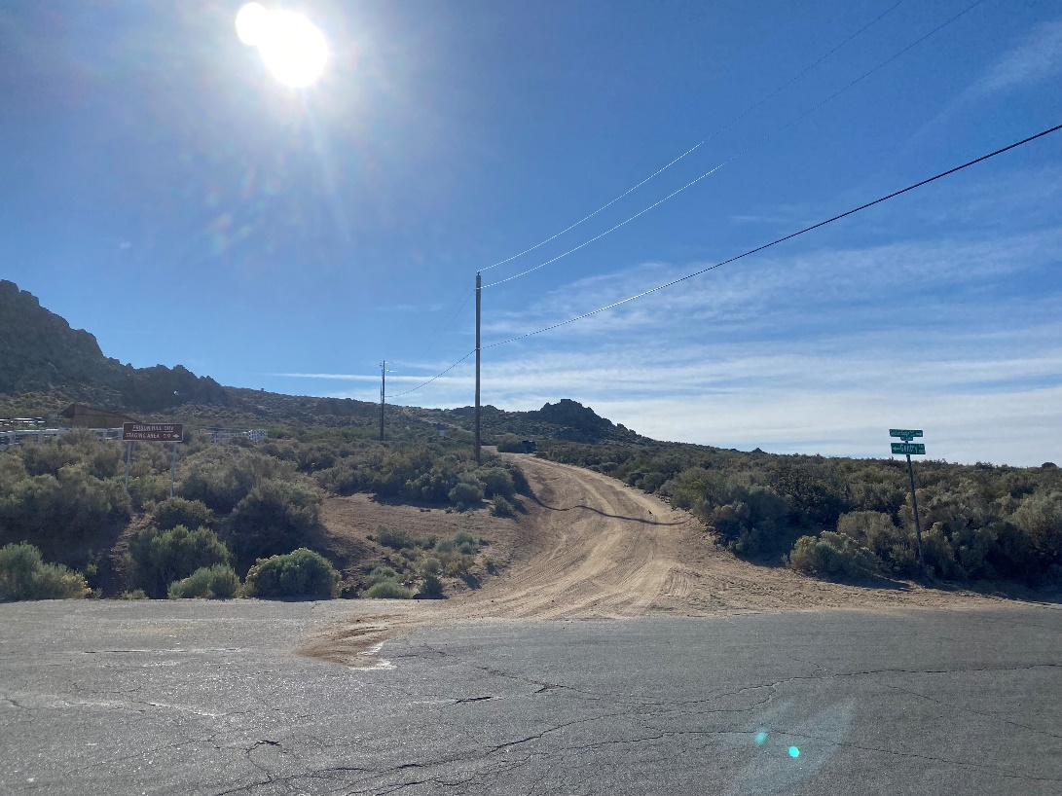

2022 Condition, photo taken June 17, 2022
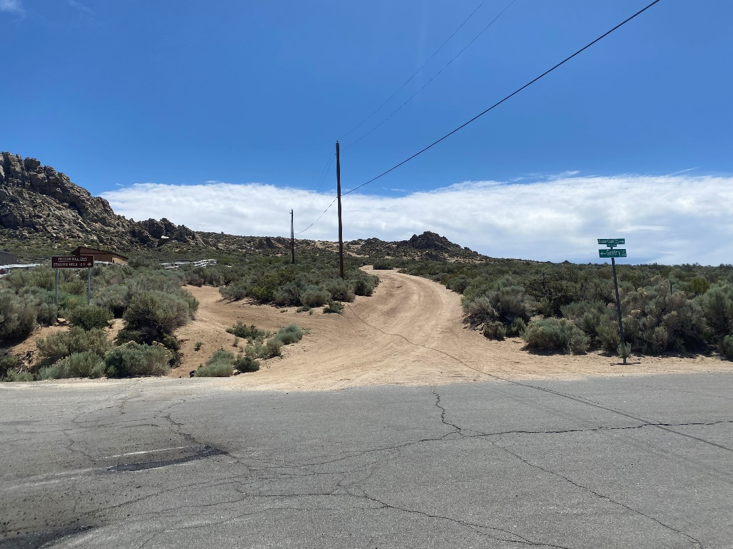

Photo Point 17 (view southwest): A photo point located at the new fire scar on Prison Hill.

2021 Baseline Condition, photo taken June 17, 2021:
(GPS coordinates: 39.122, -119.721)
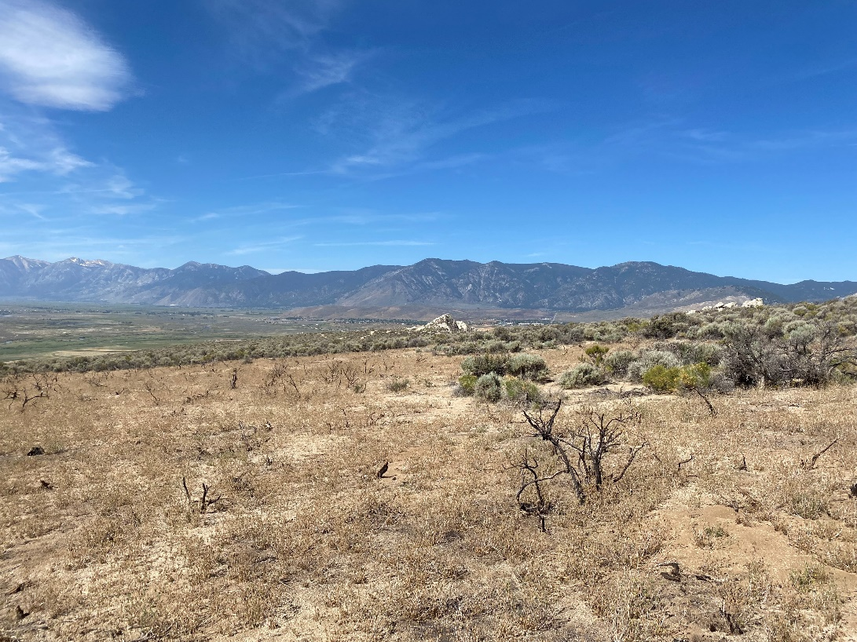

2022 Condition, photo taken June 17, 2022
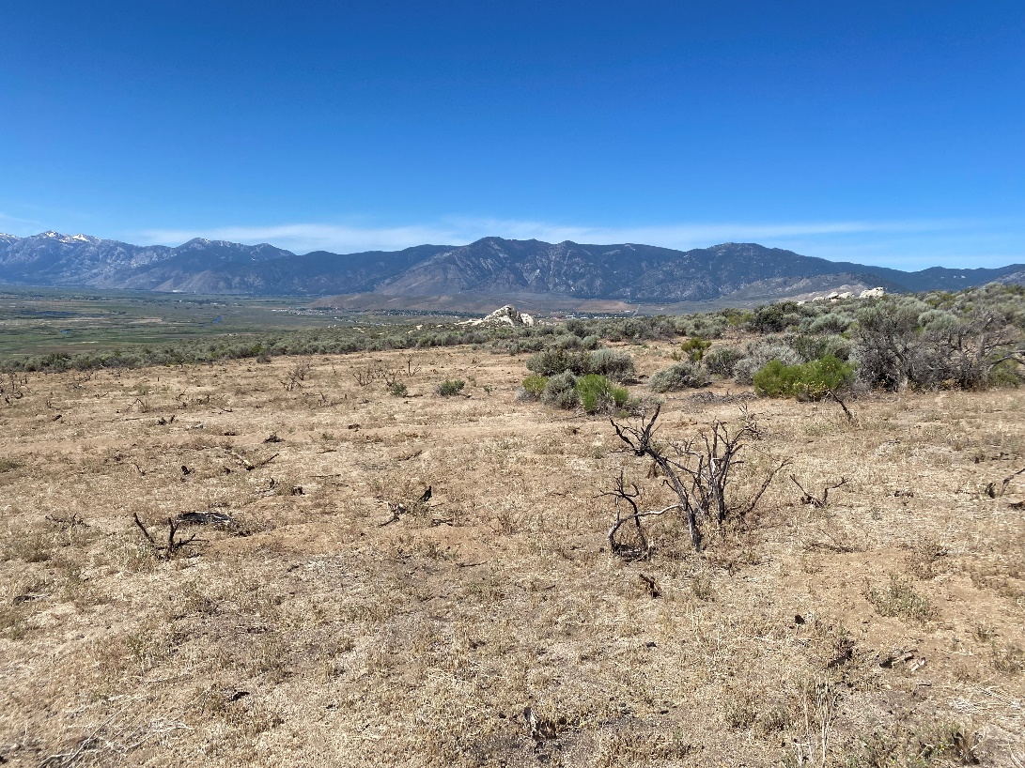

Photo Point 18 (view northwest): A photo point located near the viewpoint overlooking decommissioned trails in the Golden Eagle Open Space.

2021 Baseline Condition, photo taken June 17, 2021:
(GPS coordinates: 39.115, -119.714)
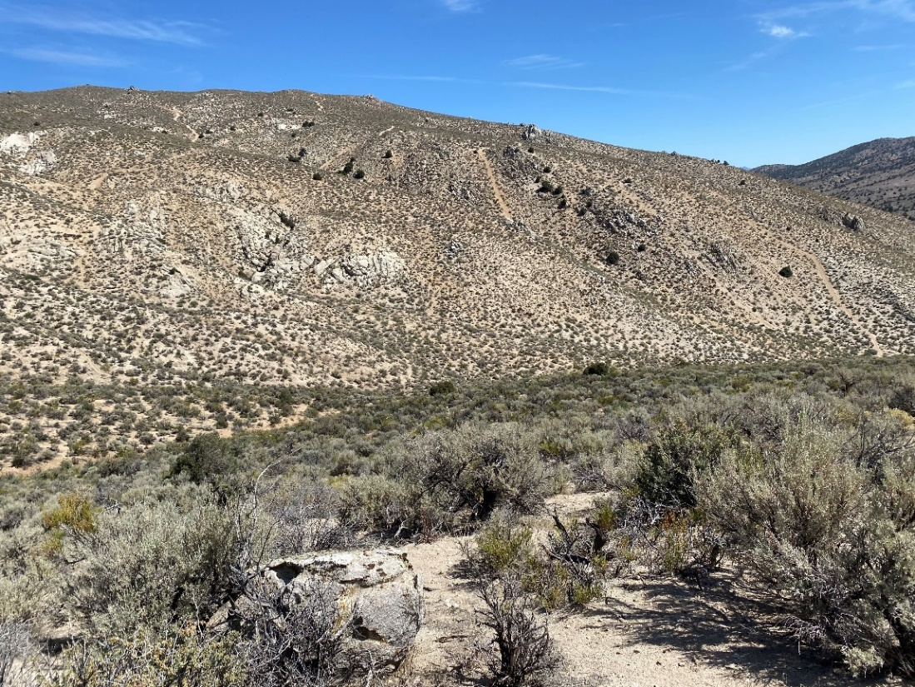

2022 Condition, photo taken June 17, 2022
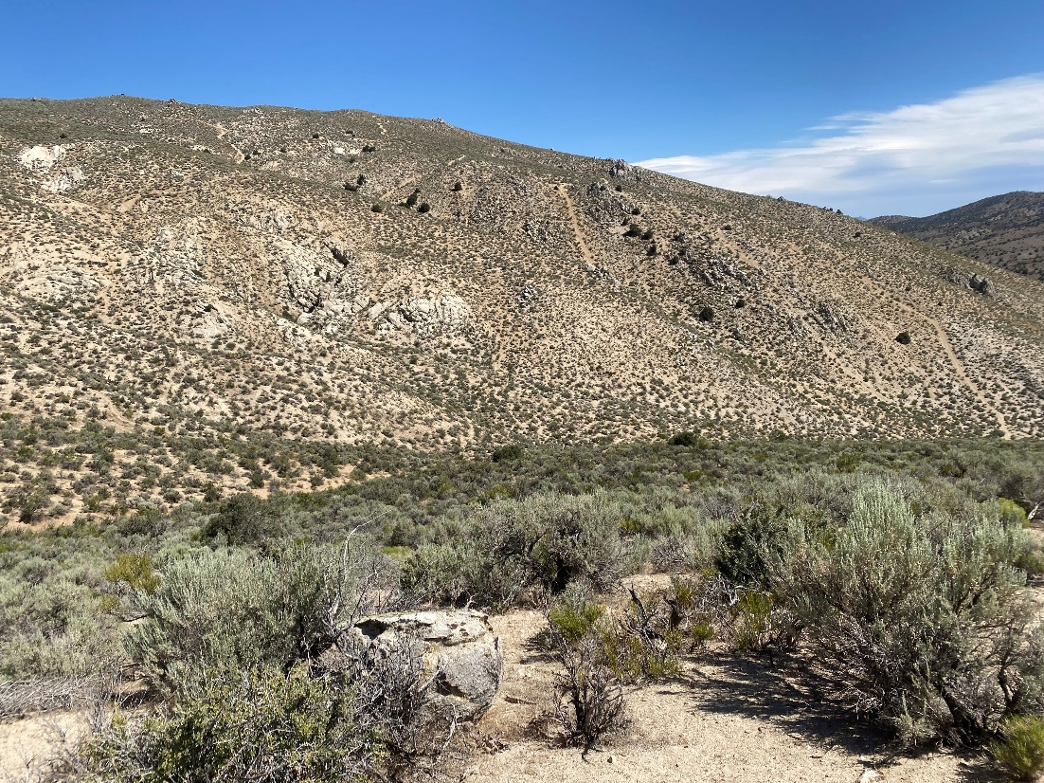

Photo Point 19 (view south): A photo point looking over Headlight Area Open Space.

2021 Baseline Condition, photo taken October 4, 2021:
(GPS coordinates: 39.1102, -119.7322)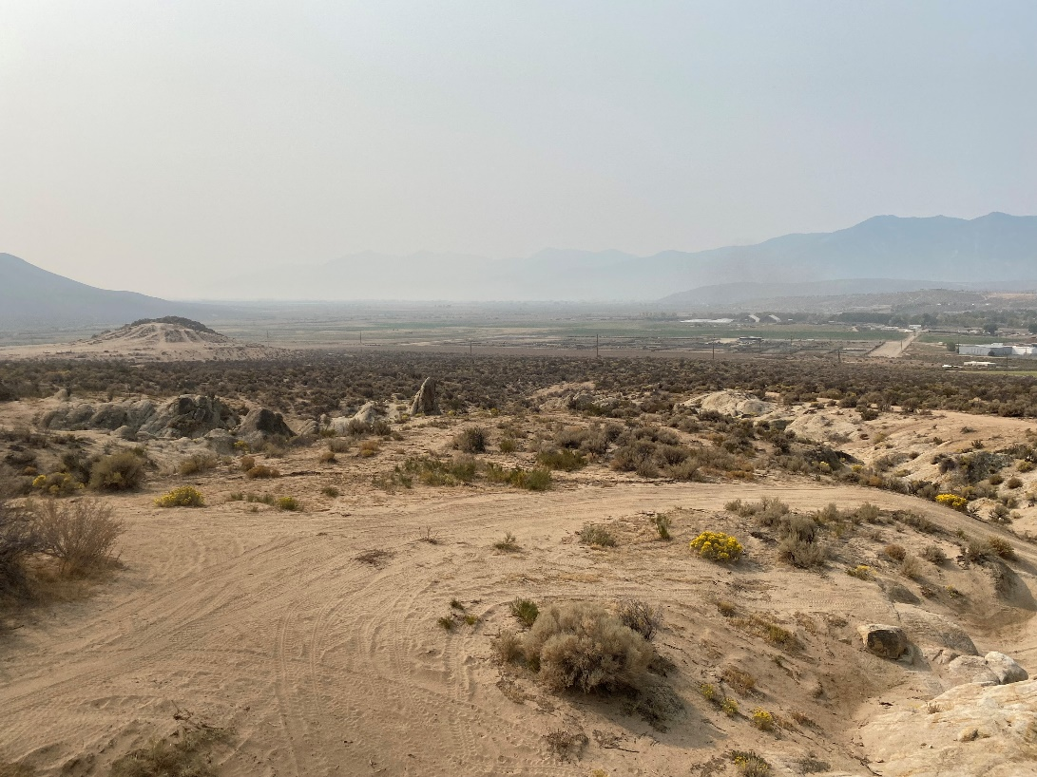

2022 Condition, photo taken June 17, 2022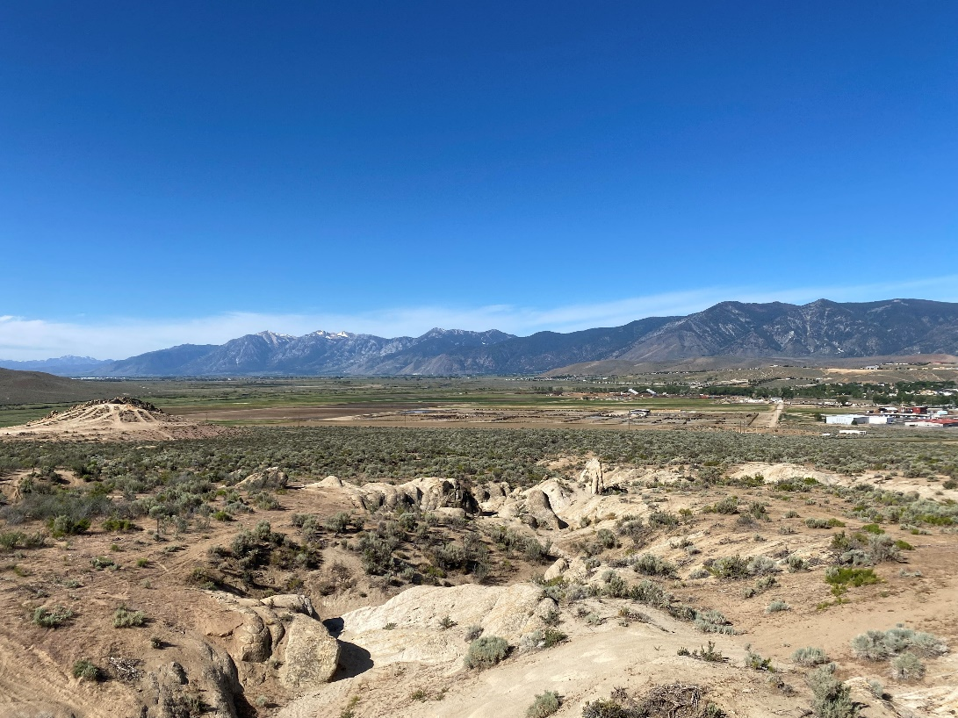
Photo Point 20A (view northwest): A photo point marking the end of the Headlight Open Space.

2021 Baseline Condition, photo taken October 4, 2021:
(GPS coordinates: 39.10925, -119.7337)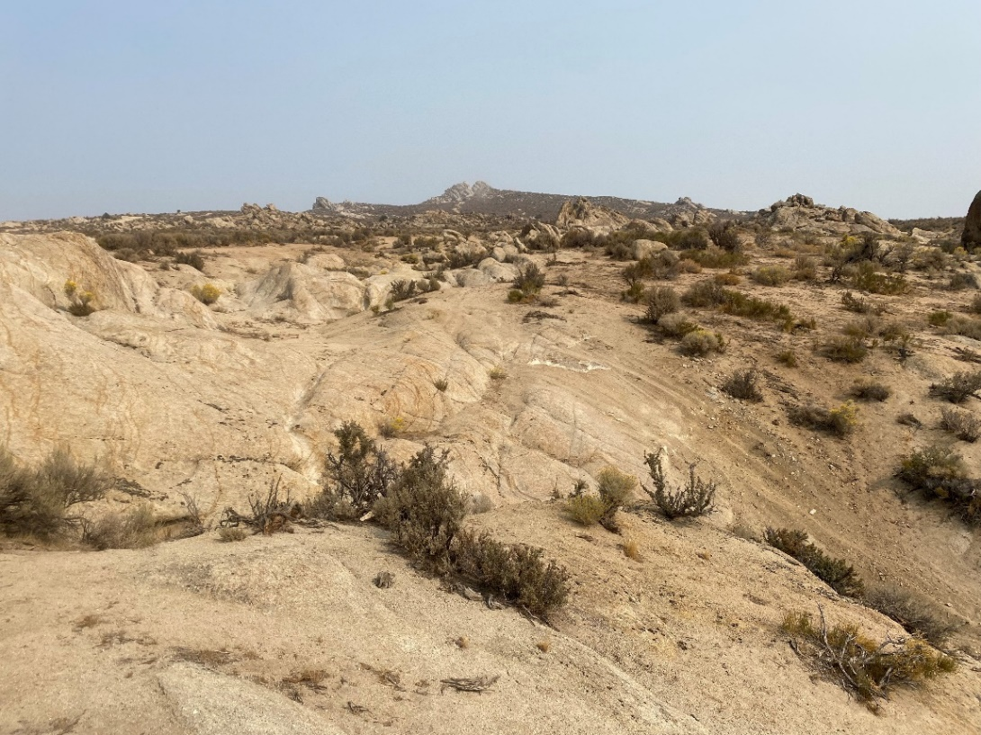

2022 Condition, photo taken June 17, 2022
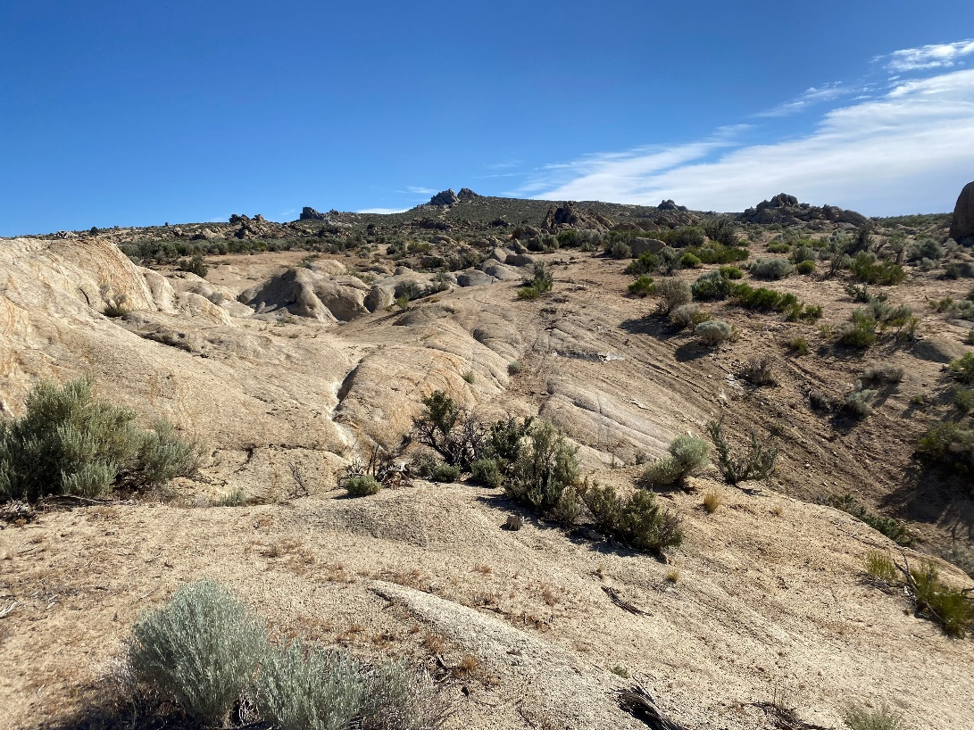

Photo Point 20B (view northeast). A photo point marking the end of the Headlight Open Space.
2021 Baseline Condition, photo taken October 4, 2021:
(GPS coordinates: 39.10925, -119.7337)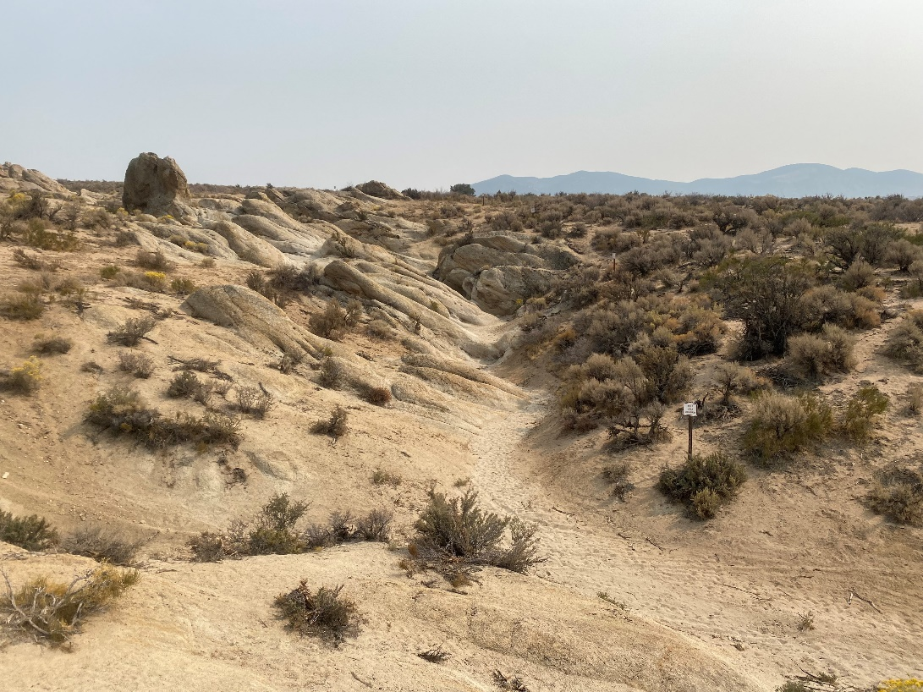

2022 Condition, photo taken June 17, 2022
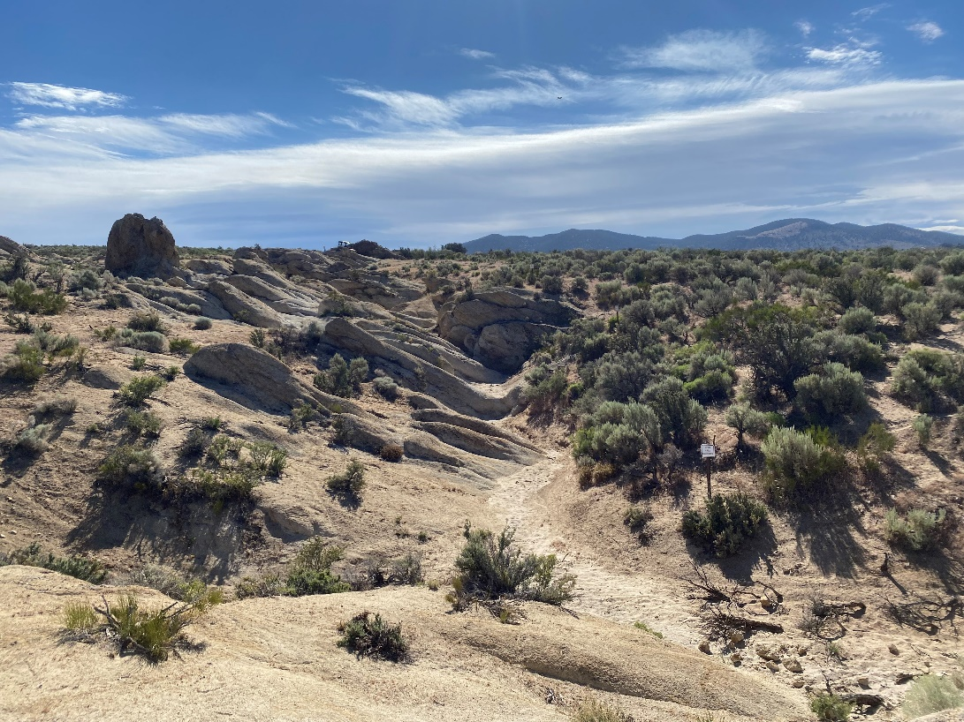
APPENDIX 1: Supplemental Information

Figure 1.
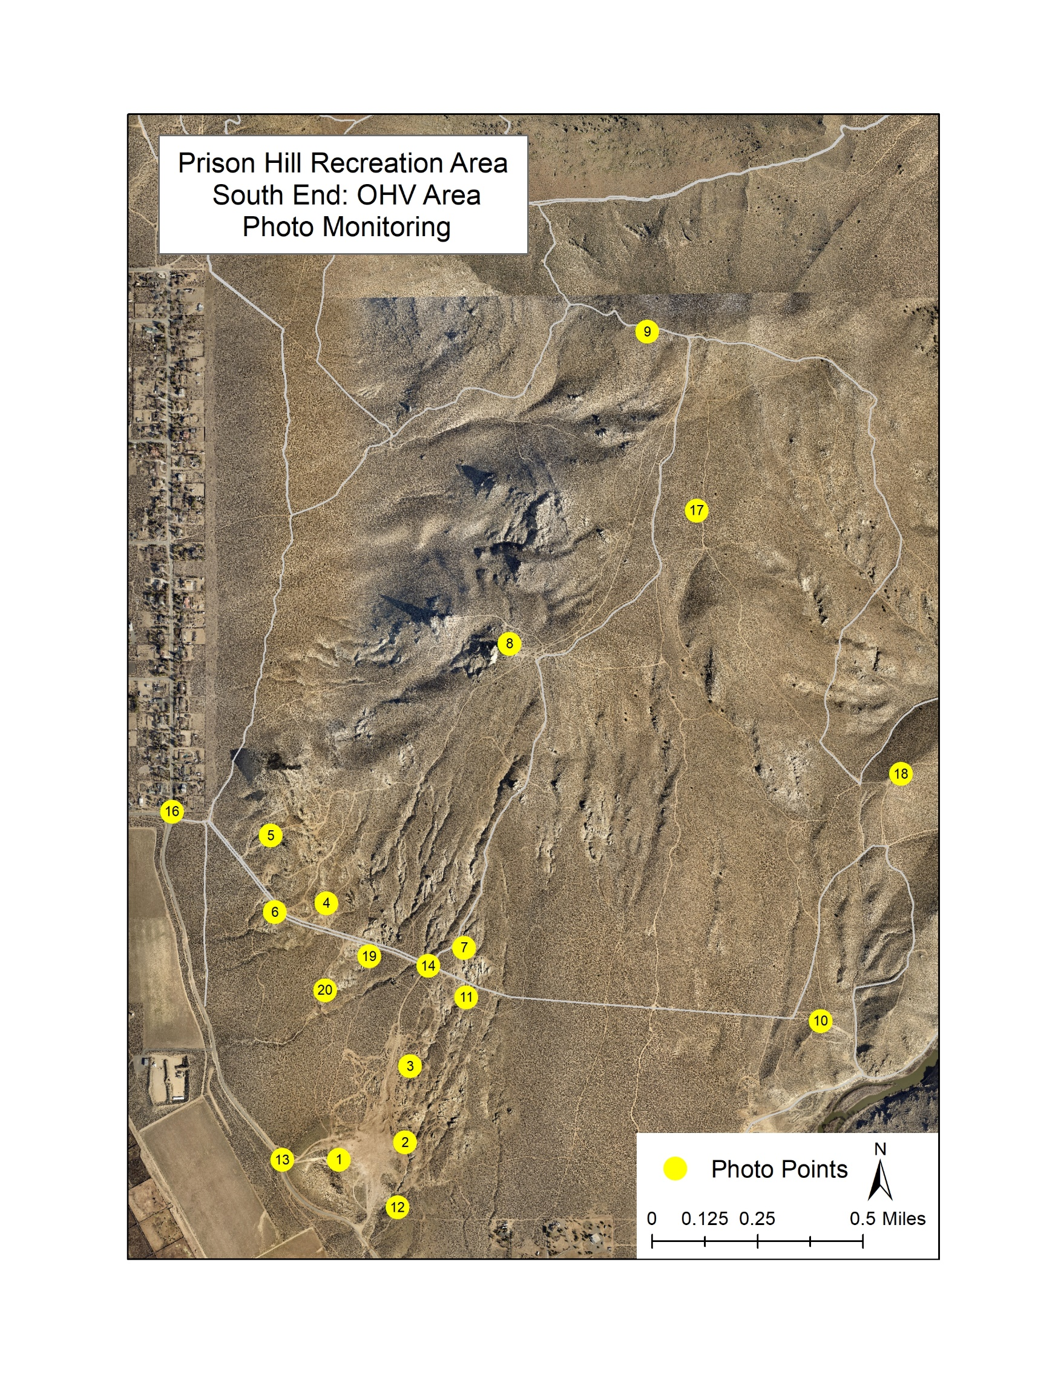
Figure 2.
